Progetto Erasmus
2018-1-EL01-KA229-047758
“Teaching and Learning through photography art”

GENERAL OBJECTIVES OF THE PROJECT:
In this project, photography is a valid tool to support teaching, through which students carry out laboratory experiences aimed at developing European key competences, such as, for example. digital and multilingual skills or in matters of citizenship, and specific disciplinary skills such as in Italian, art, history, sciences, geography, English language.

SPECIFIC OBJECTIVES OF THE THIRD PROJECT DEVELOPMENT PHASE:
Through this third phase of project development, disciplinary and interdisciplinary objectives are strictly connected to the general purpose of the project. Among these, the objective of fostering the birth and entrenchment of a shared sentiment that allows pupils to define a common sense of belonging, giving value to the cultural heritage of the territory through direct exploration, is particularly important. Photography in this sense is the perfect tool as it has the function of providing an immediate representation of reality.
From this point of view it is essential to equip students with the possibility of using tools and techniques to support the process of understanding and internalizing the value of cultural heritage through know-how. This support constitutes a valid strategy useful in order to allow the development of creativity and manual skills in students, to create the functional conditions for self-construction activities to support the curricular paths of the various disciplines.
In view of this approach, a positive attitude towards functional alphabetical competence, a key competence for lifelong learning, involves the availability for critical and constructive dialogue, the appreciation of aesthetic qualities and the interest in interacting with others.

The course was structured as follows:
REALIZATION OF NATURAL COLORS
History teaching and learning, "contribute to cultural heritage education and active citizenship. The teachers committed themselves to let the students discover the connection between the traces and the knowledge of the past, to use the archaeological, museum, iconic and archival sources to make their cultural heritage value appreciated. In this way cultural heritage education provides a fundamental contribution to active citizenship. In particular, teachers have highlighted the relationships between institutions and society, gender and generation differences, state forms, democratic institutions. "
Our students have made natural colors from flowers and leaves that have been used to paint their designs.
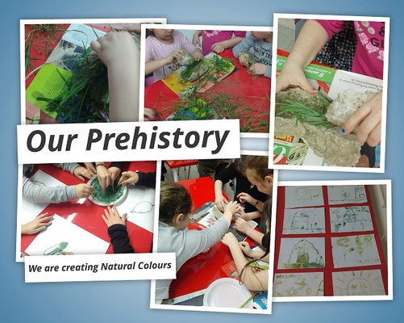

PREHISTORIC ORNAMENTS
Through laboratory experiences teachers have offered a specific contribution to the formation of a national, European and world citizenship in a perspective of continuous dialogue between present and past.
The students made necklaces with shells and clay.
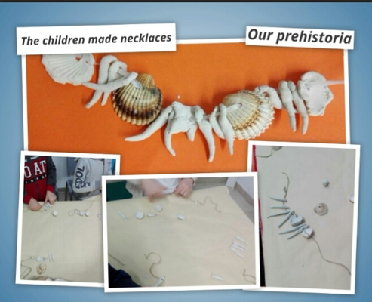

RATTLES
The student is educated to safeguard and conserve the artistic and environmental heritage starting from the territory to which he belongs. Familiarity with artistic languages, of all arts, which are universal, allows the development of intercultural relations based on communication, knowledge and comparison between different cultures.
The students made rattles with clay
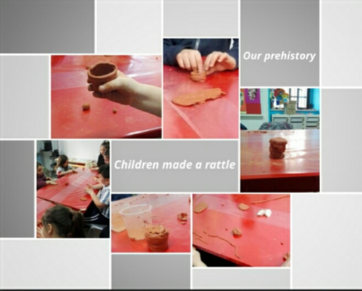

DINOSAUR EGG
The value of the arts is recalled for the integral development of the person and for cultural awareness and expression. Familiarity with art raises awareness and enhances creative, aesthetic and expressive abilities in the student, strengthens cultural preparation and helps educate him in active and responsible citizenship.
In this last step the students made dinosaur eggs with the papier-mache technique
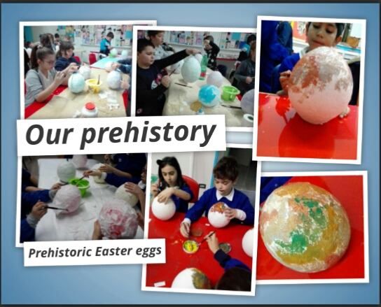

LAND ART
The artistic disciplines are fundamental for the harmonious development of the personality and for the training of a person and a citizen capable of expressing themselves in different ways, of making an informed use of artistic, environmental and cultural assets, recognizing their value for social identity and cultural and understanding the need for protection and protection.
Artistic creations made by our students with natural materials as part of the exit at the "Passo di Corvo"
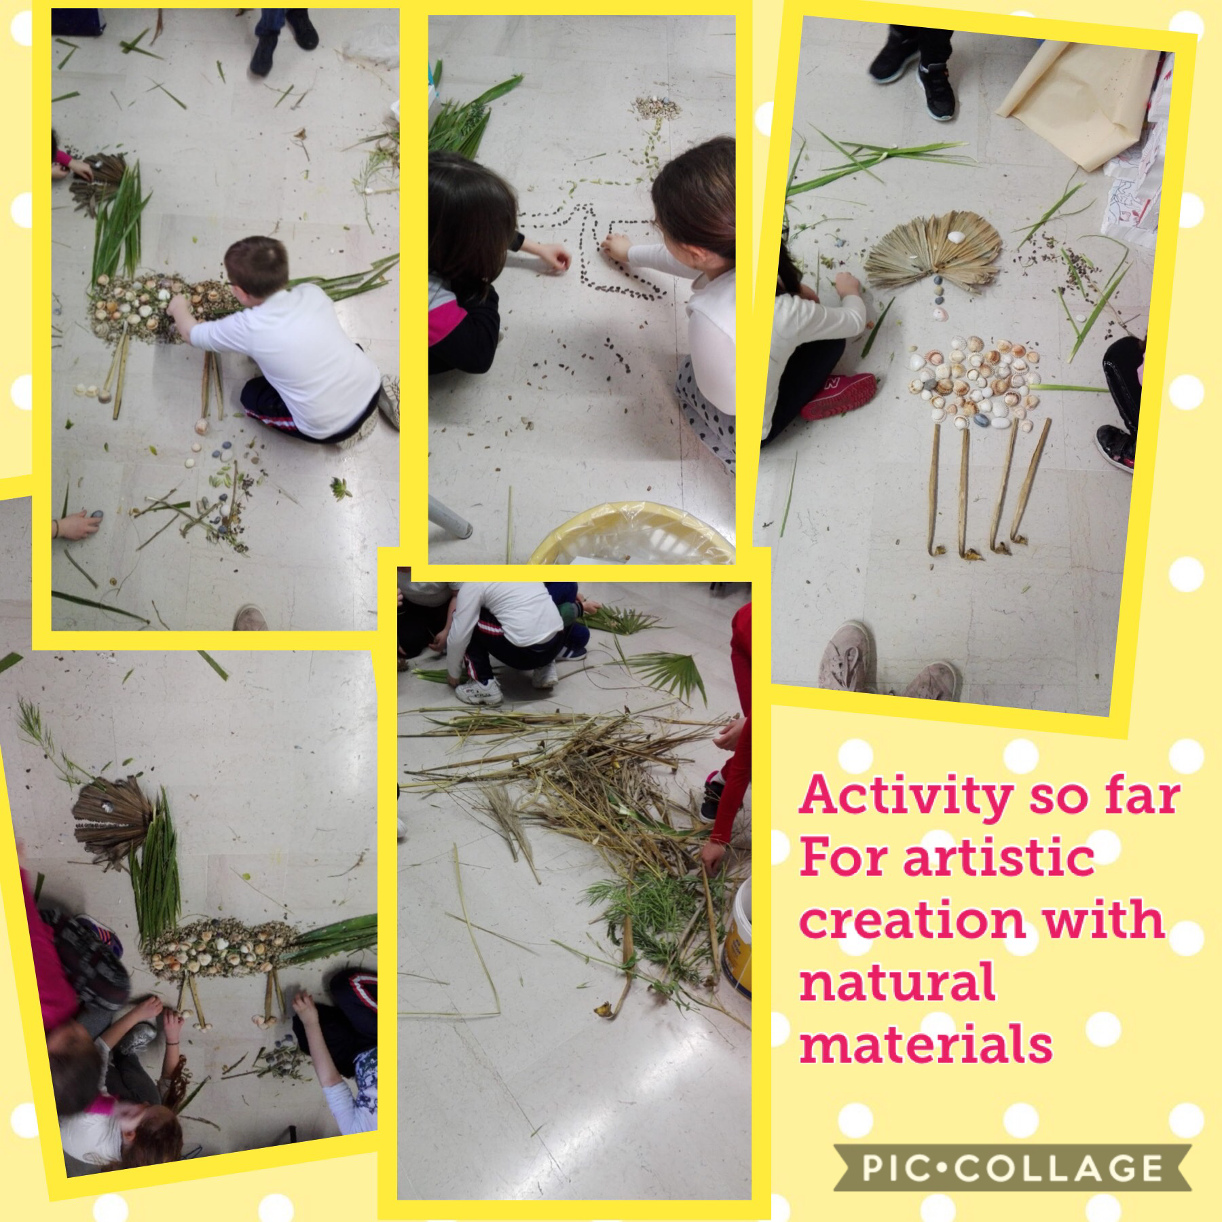

LANDSCAPE
The knowledge and enhancement of the cultural heritage inherited from the past, with its legible "signs", joins the study of the landscape, container of all material and immaterial memories, even in their future projection.
The pupils took panoramic photos during the exit at "Passo di Corvo" and "Borgo Celano-San Marco in Lamis".
