TRAIL RUNNING SPEED
Objective: to study constant and non-constant speed sections of a trail running GPS track.
First of all, find a GPS track of one of the races of the project.
Once there, select different parts of the race where: you run at approximately constant speed, you speed up and you slow down respectively.
  - Collect data points (position, time, altitude, speed) for each part and type them in an Excel/Open Office spreadsheet (around 5-8 data points each).
  - Draw the plots position/time/altitude and speed/time/altitude for each part.
  - Make brief comments about the shape of the data in each plot (constant/non-constant speed) and relate it with the race profile.
  - Draw only the plots position/time this time. Insert linear trend lines, copy their equations and the R-squared coefficient for all the plots. Compare the results and draw out conclusions. What does the R mean? What is the meaning of the slope of these straight lines?
Please, read before starting some information about trend lines: https://www.ncsu.edu/labwrite/res/gt/gt-reg-home.html
  - Take the equations with highest R-squared coefficients and predict the position for future times, for example “if the runner kept running at the same pace, after 5 minutes he/she would be travelled X metres”.
  - Do the same procedure as in the previous question, but now calculating the time that the runner takes to travel a certain guessed distance.

Filename: JfK_Speed_Gnumber

If you need some help, the image below shows the summary of the Kinematics Graphs.

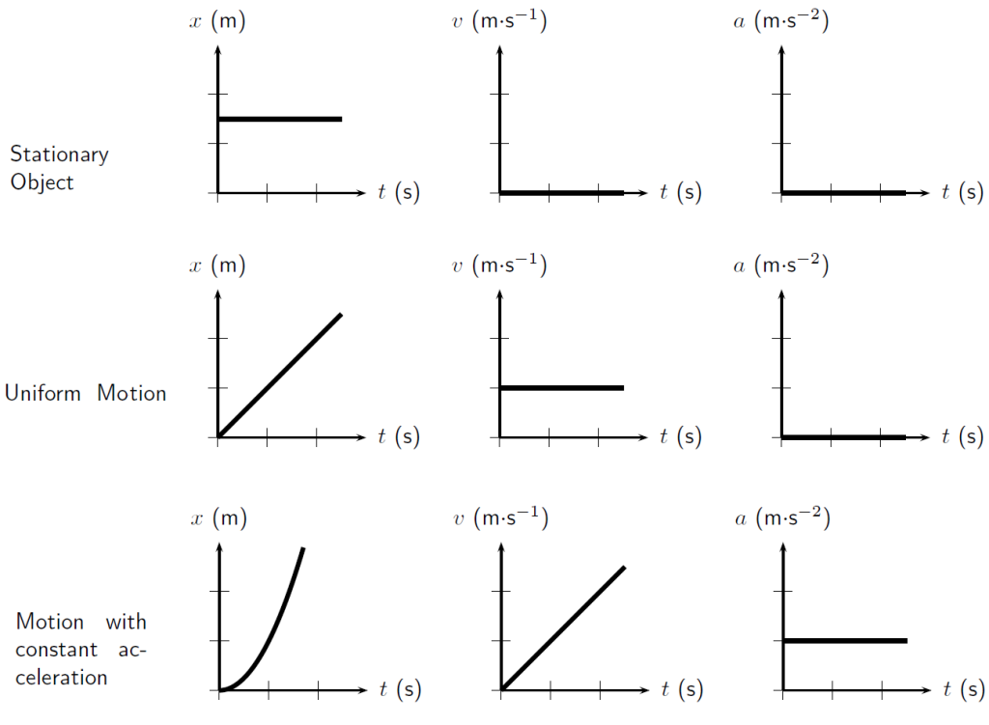
https://www.miniphysics.com/reading-kinematics-graphs.html [30/03/2018]

