LESSEN PLAN: BE SAFE ON INTERNET!
Discipline: Counseling and Guidance
Module: Quality of life
Lesson title: Be safe on Internet!
Class: 5th
Venue: classroom
Teacher: Marinescu Gabriela Antoaneta

Duration: | 2 teaching periods (50 minutes per period)
Summary  Description: | This activity is about raising awareness on issues of cyberbullying that students are facing during their life.  It is a 2-hour activity that requires students to work in groups of 3-4 in order to create a song about cyberbullying.  During this activity students will learn what cyberbullying is and how it is related to their life. They will also work together to express themselves in a creative way.
Tags: | Cyberbullying, Song, Music, Bullying
Aim: | The aim of this lesson plan is to raise awareness on cyberbullying by supporting creativity and the use of new technologies in education. These two elements will act as motivators in order to raise the students’ interest in participating in their classroom’s activity. During the activities students will be prompt to speak their thoughts and feelings and be aware of bullying practices in their life/school.
Objectives: | This lesson intends to enable students:  1. to develop their awareness on issues of bullying.  2. to iIdentify possible consequences of cyberbullying.  3. to develop their creativity by writing song lyrics against  cyberbullying.  4. to work in groups and collaborate for a common goal
Learning  outcomes: | With the completion of the lesson, students will be able:  • to list some consequences of cyberbullying to students.  • to express themselves in a creative way by writing  lyrics to a song against cyberbullying.  • to empower themselves by singing against cyberbullying.
Teaching strategies: | Methods: braimstorming, commenting on a video, presentation, film, discussions and analysis, group debate
 | Materials and means: WhiteBoard, Computer, Projector, Internet connection
 | Forms of organization: frontal, individual, groups of 4-5 students
 | Types of interactions: teacher-student, student-teacher, student-student
Activities
Activity 1 | Presentation of videos from Cyber4Kids (youtube):  (30 minutes)  At first students are being introduced to the meaning of the world bullying. The teacher, through the interactive material, shows students some interesting information about:  „Welcome to Cyber City!; We play safely; Secret personal data; Who is fooling you online?; Dangerous links; The Internet never forgets; Cyberbullying; WiFi or not?; Magic passwords.”  It is expected that all students know what this word means although some of them may not be aware of the extent to which cyberbullying can harm their lives. The audio visual form of presenting information and debates will enhance their understanding in a more realistic way.
Activity 2 | Brainstorming: What is cyberbullying for me? (20 minutes)  After an introduction of the word cyberbullying the theacher writes the word clearly on the flipchart and asks students to express their thoughts, feelings or experiences related to this term in the form of brainstorming by using only a few words. The theacher creates a type of diagram/concept map with all the answere.
Activity 3 | Working in Groups: Creating a Song Against Cyberbullying  (25 minutes)  The theacher divides pupils in groups of 3-4 and asks them to work together in order to create a song about cyberbullying. After the groups are created the teacher gives to each group a set of words to work with.  Each group will create about 4 sentences linked by Super Cyberheros, who must always have a good reputation, who does not click on any internet link, who does not appreciatte or forward bad messages, who protects others and himself.  Each group chooses the song that will be the musical background of the sentences or messages composed.  This activity will help them to relate better and develop their social skills.
Evaluation Activity | Song Against Cyberbullying (20 minutes)  Each group will sing their lyrics and the songs will be recorder to the computer (by  using Windows Media Player or another program).

The lesson focuses on the following key competencies:
- competence in communication in the mother tongue;
- competence in communication in a foreign language (English)
- digital competence;
- social and civic competences;
- competence of cultural awareness and expression;
- to learn to learn.
The lesson is conducted interdisciplinary, using knowledge of Romanian, English, civic education, social education, music education, ICT

Annexes:
1. Images:
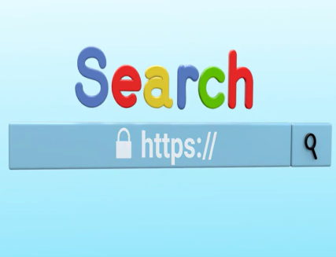 | 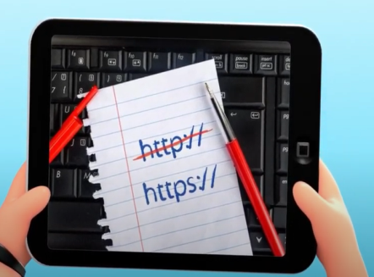 | 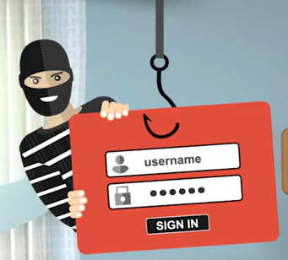
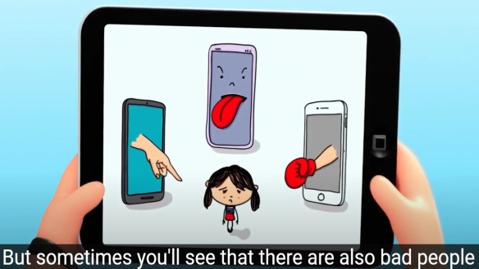 | 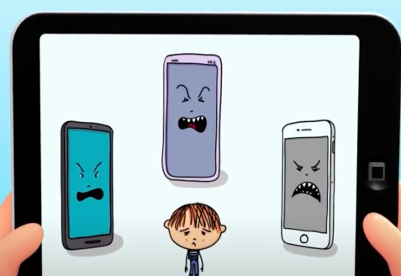 | 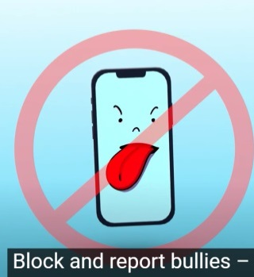
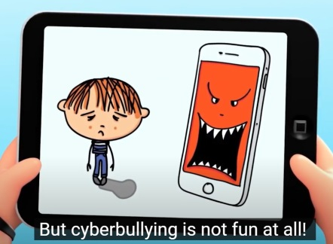 | 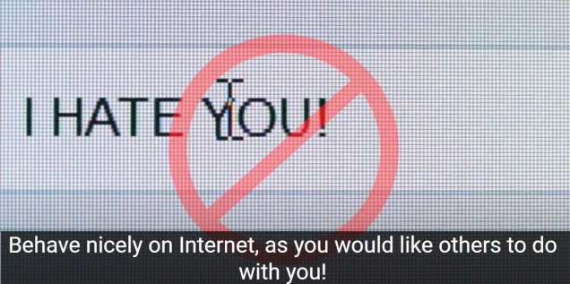

2. link-uri
0. Cyber4Kids. Welcome to Cyber City! (ep.0) https://www.youtube.com/watch?v=ldYHVhi4GUQ 1. Cyber4Kids. We play safely (ep.1) https://www.youtube.com/watch?v=Irobrzu9qwU
2. Cyber4Kids. Secret personal data (ep.2) https://www.youtube.com/watch?v=0BNr9bIgAzY
3. Cyber4Kids. Who is fooling you online (ep.3) https://www.youtube.com/watch?v=affu-bFKdeM
4. Cyber4Kids. Dangerous links (ep.4) https://www.youtube.com/watch?v=vy4_2vMjrRI&t=8s
5. Cyber4Kids. The Internet never forgets (ep.5) https://www.youtube.com/watch?v=nINV6bLM_9M&t=43s
6. Cyber4Kids. Cyberbullying (ep.6) https://www.youtube.com/watch?v=686eAFXTW5A
7. Cyber4Kids. WiFi or not? (ep.7) https://www.youtube.com/watch?v=OKtbTTv3fvg&t=3s
8. Cyber4Kids. Magic passwords (ep.8) https://www.youtube.com/watch?v=F4iTwb-3SBY

