WORLD FASHION BRANDS
In general, survey that we made was about world’s most popular fashion brands, but questions we included were very different. There were some questions about how much people my age are willing to spend on clothes only, for example. In our survey we chose to include different questions about this topic, because in that way we made survey more specified and also wider. The main purpose of this survey was to find out what brands other teenagers prefer and to compare them to Latvians and teenagers from other countries. 11 people answered the questions, most of them were from The Czech Republic and Greece, one from Italy, France and Latvia.
In the first two questionswei tried to find out the location and gender. Survey is about fashion that’s why it is not a surprise, that from 11 respondents only 3 where male respondents, rest of the people where females. We were glad thatweI received answers from different countries, because we can learn about teenagers from different world locations.
In the next question we wanted to find out about sports wear brands in different countries. A big majority of 72.7% of people which is 8 respondents answered that ‘’Nike’’ is the most popular sports wear brand in their countries. And only three of the respondents answered that the most popular sports wear brands is ‘’Adidas’’. Nobody as their answer mentioned ‘’Reebok’’ or ‘’other’’. These answers did not surprise us, because both of these brands are very popular in Latvia too.
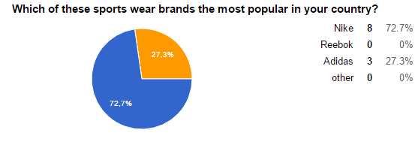

Further there was a question about how much are teenagers ready to spend on clothing on one purchase. 5 respondents answered that they are ready to spend less than 50 euros on one purchase. 2 teenagers answered that they are ready to spend 50-60euros, 3 respondents are ready to spend from 100 to 110euros, but only 1 respondent are willing to pay more than 110euros for one purchase. We were able to foresee the answers to this question, because respondents are from different countries and with different family status. Also teenagers are mostly maintained by their parents and it depends on the family when it comes to money.
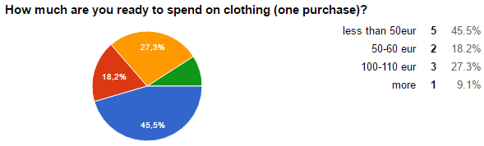

Next two questions were strictly about clothes. Firstly we wanted to know how many people who answered the survey buys clothes online. Majority of 90,9% of respondents prefer to go shopping and only one respondent prefers to buy clothes online. Our expectations about this question was a bit different, because I thought that many teenagers would prefer shopping online, because it saves a big amount of time, but on the other hand buying clothes online, does not give the opportunity to try clothes on.
Second question was about personal style and what sort of clothes teenagers prefer. 36,4% of respondents like street look and also 36,4% like casual-classy look. Small amount of respondents answered that they prefer glamorous look and even smaller amount, which is one person, responded that prefers heavily branded look. I think these answers are very usual, because if we compare these answers to styles that teenagers in Latvia prefer they are very similar.
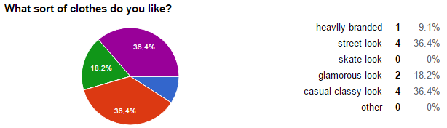

There are many teenagers who follows newest fashion trends and prefer not to make personal style but to dress like everybody else in order not to be shrouded. But we think in the future teenagers will more think about creating their personal styles. In my opinion this survey was kind of useful, because i learned some things about peers in other countries in Europe. Problem in this survey might be that we had only 11 respondents which is very small amount of people and I could not make an opinion based on only 11 responses.WeI think this topic is important, because our style says a lot about us and makes the first impression about a person. We even could say that ‘’I make shoe contact before eye contact.’’ Sense of style is very important nowadays and most of people comply and agree with my opinion.
Eva (with support from Kristaps ) from Latvia

