Josef Čapek – Biography
Josef Čapek, Czech painter and writer was born on March 23, 1887 in Hronov. For the first three years he lived with his family in Malé Svatoňovice. In 1890 they moved to Úpice. After completion school, he worked as a worker in a factory in Úpice. From the autumn of 1904 he began to live in Prague, where he studied at the School of Applied Arts. There he met his future wife Jarmila Pospíšilová. In 1910 he went to Paris, where later arrived his brother Karel. Here Josef attended Calarossi Academy. The brothers returned to Bohemia in 1911. After nine years , he married his love Jarmila. Later, their daughter Alena was born and he wrote and illustrated the book Povídání o pejskovi a kočičce for her.
In the years 1923 -1924, the architect Ladislav Marchoň had built a villa for Čapeks brothers in Prague 10. One part of the house was inhabited by Karel Čapek and his wife Olga Scheinpflugová and the other part by Josef Čapek and his family.
Josef Čapek was more a painter, but he too wrote a number of literary works. He created some books together with his brother Karel, for example Ze života hmyzu. He himself wrote Povídání o pejskovi a kočičce, Básně z koncentračního tábora, Povídejme si děti, Umělý člověk, Stín kapradiny and more.
In 1939 he was imprisoned by the Gestapo. He died of typhoid in 1945 in the Bergen-Belsen concentration camp.

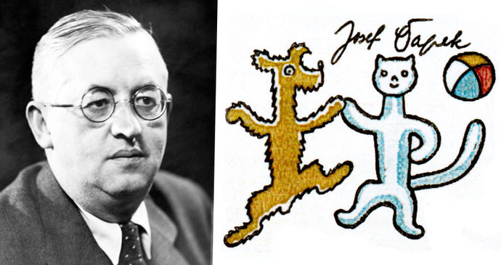

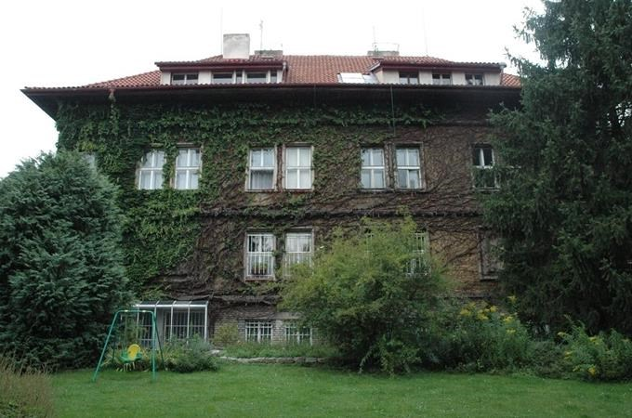House of the Čapeks brothers

