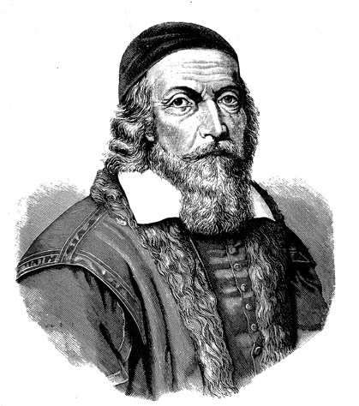
JOHN AMOS COMENIUS

John Amos Comenius was an educationalist and a teacher. He was born on 28th March 1592 in Moravia and he died on 15th November 1670 in Amsterdam. When he left the University in 1611, he started helping in the production of encyclopedias. In 1613 he visited Amsterdam, drove through Germany and he returned to Prerov as a Latin teacher. As a teacher, he wanted to teach with fun and not everything by memory. That’s why he started writing picture textbooks, which children understood. So the children learned and memorized all the materials . After the battle on white mountain (1620) and the execution of 27 leaders (1621) the Habsburgs ordered Catholicism as a mandatory faith. People who weren’t Catholics had to be rechristened or leave their land. John Amos Comenius went to different European countries for example to Sweden, where he continued as a teacher. He lived also in Amsterdam where he died in 1670.

Orbis Pictus, textbook for children, 1968
