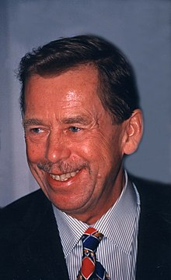
VACLAV HAVEL
Vaclav Havel was born on 5th October 1936 in Prague. He was Czech dramatist, essayist, dissident and critic of the Communist regime, later politician and statesman. He was Czechoslovak president from year 1989 to year 1992 and from year 1993 to year 2003 he was president only of the Czech republic.
His parents were Vaclav and Bozena Havlovi. His first wife was Olga Havlova and his second wife is actress, Dagmar Veskrnova.
Velvet revolution
Velvet revolution (also called a gentle revolution) was a marking in the period of political changes in Czechoslovak between 17th November and 29th December 1989, which led to the collapse of the Communist regime and the transformation of the political establishment.
Flag of the President of the Czech Republic. The national motto "Truth Wins"
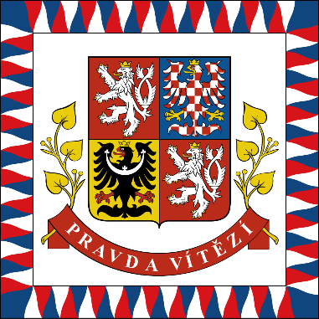
The true wins!

