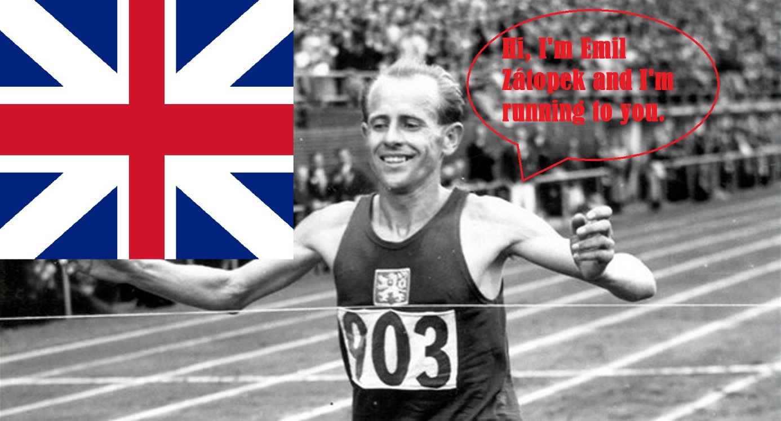
EMIL ZÁTOPEK
was the best Czechoslovak athlete – runner.
He was born 19th September 1922 in Kopřivnice.
When he was 16 he started to study and work in Baťa´s shoe factory in Zlín. And just there he ran his first running race because Baťa´s employees had to take part in it every year. At first Emil made excuses to his boss that he did not want to run. Finally he ran and reached second place. Fromt that time he started to like running and trained more.
Remarkableness
As the only one he ran quickly just from the beginning of the race to have it first behind.
…
Then he went to military and started to study military academy.
He was improving in running and got into Czech representation.
Remarkableness
Zátopek had his own training method. F.e.: he ran in combat boots instead of trainers or he carried his wife on his back when he was running.

Athlete
In 1952 in Olympic games in Helsinky he was able to win 3 running disciplines (5km, 10km and marathon). No one has succeeded so far.
He had nickname „Czech locomotive“ and company Škoda Transportation named one of its locomotive 109E according to him.
Writer Ota Pavel wrote one of his story about Zátopek called „How Emil Zátopek ran it“.
One miniopera was dedicated to him too.
Last year a movie was made about him and this year should hit the screens.

If you can´t, try more!!!

