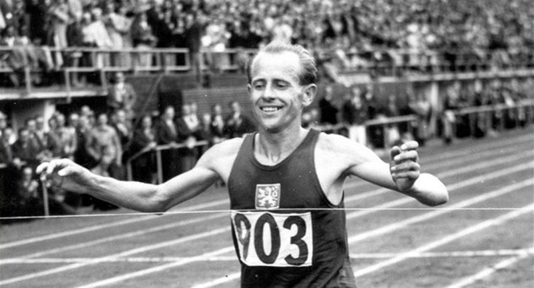
Emil Zátopek
Emil Zátopek was born on the 19th of September i1922 and passed away on the 21st of November 2000. He was a Czechoslovakian athlete. Zátopek won fourth times an Olympic gold medal and broke eighteen world records in long distance runs. He is considered as one of the greatest runners of all time. Zátopek was the originator of the interval training, and the first man who completed 10km race under 29 minutes. He was known for trash-talk against other athletes which made them uncertain. In 1968 he supported the Prague Spring and was sent to the uranium mine. In 1975 the Prime Minister Lubomír Štrougal allowed Emil back to Prague, where he worked as an archivist and a translator under Strahov stadium until his retirement. Zátopek was selected into the top ten athletes in XX century. Zátopek died in 2000 from the complications of a stroke. Emil Zátopek has the statue in Lausanne, Switzerland.
