Tomáš Baťa
/ 3.4.1876 - 12.7.1932 /
The biggest businessman of his time in the Czech Republic – the king of footwear

He came from a poor shoemaker's family.

In 1894 he founded a shoe company in Zlín with his brother Antonin and sister Anna
In 1904 he traveled to America to get new experiences
In 1908 - employed 300 people and produced 3,000 pairs a day
In 1911 - belt production employed 5,000 people and produced 100,000 pairs a day,
During the war, he made large profits from military boots.
Post-war crisis – he sold products 50 % cheaper, so he destroyed the competition.
Since 1945, Tomáš Baťa Jr. has run the company. - the only son of Tomáš Baťa
The Baťa price of 999 is also well-known, it always ends on the 9t
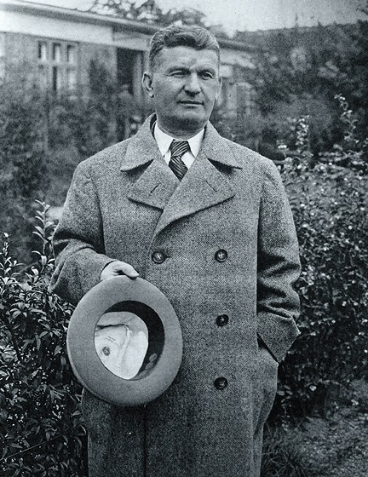
Known quotes:

- Don't tell me it doesn't work, tell me you can't do it.
- Cleanliness and order = quality.
- Our customer our master.
- You can do whatever you want.

