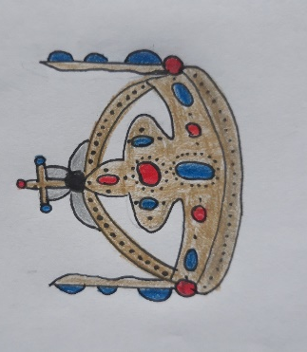
Charles IV.
Charles IV. was born on 14.5.1316 like Wenceslaus. Charles IV. was Czech king. He was in Luxemburg dynasty. His parents were Elizabeth of Bohemia and John of Bohemia. His first wife was Blanche of Valois, then Anne of Bavaria, Anna von Schweidnitz and the last one was Elizabeth of Pomerania. He took a part in lots of projects (Karlštejn Castle, University, Charles bridge and others…). He was highly educated and very smart, people liked him.
