Marie Terezie
Dominika 6.B
Marie Terezie Maria Theresa in English was born 13 May 1717 and died 29 Novenber 1780 in Vienna. Her full name is Maria Theresa Walburga Amalia Christina. She was Queen of Austria, Hungary, Bohemia and Margrave of Moravia. She was the only one ruling woman on the Czech throne. Her husband was Francis I. Stephen of Lorraine. She had 16 kids. In 1770 she introduced numbering of houses in towns and villages. She also introduced compulsory schooling. The single currency (1 tolar = 2 zlaté ) and the first paper money (bankocetle) were introduced.On November 8. 1780 she caught a cold. After21 days fight with disease she died.m-.

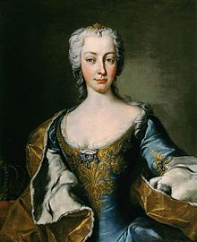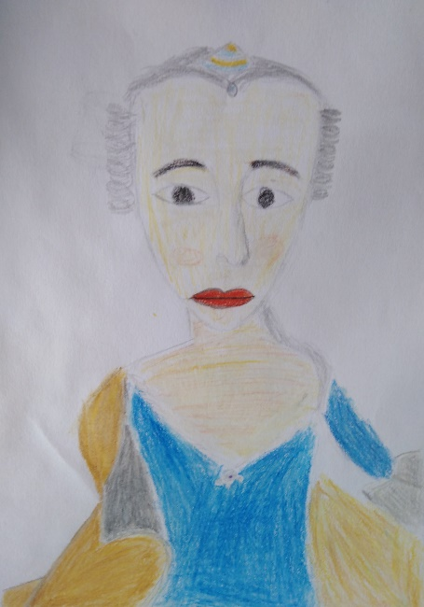
Maria Theresa Walburga Amalia Christina

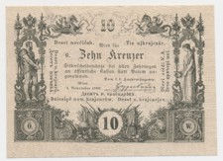
Bankocetle

