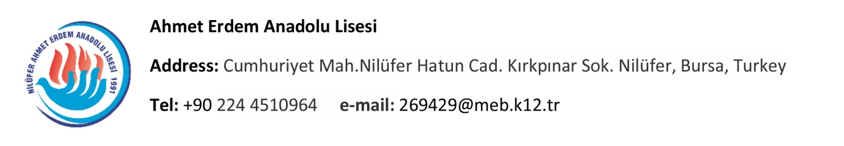

PORTUGAL MEETING EVALUATION REPORT
1st LTTA ERASMUS PROJECT MEETING

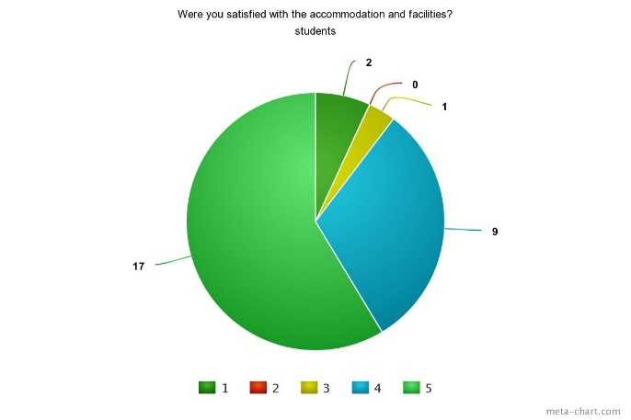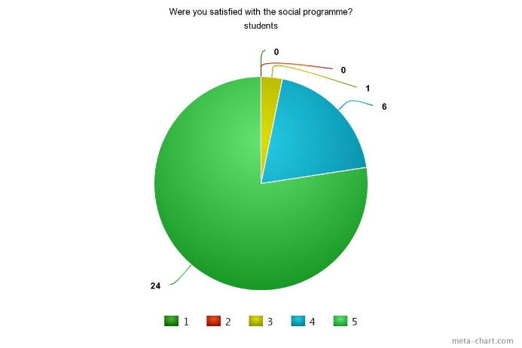

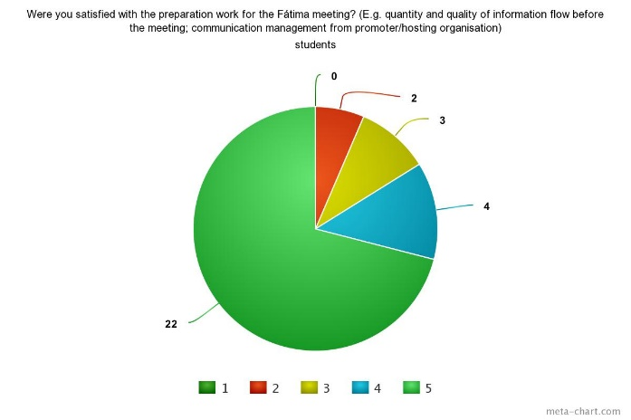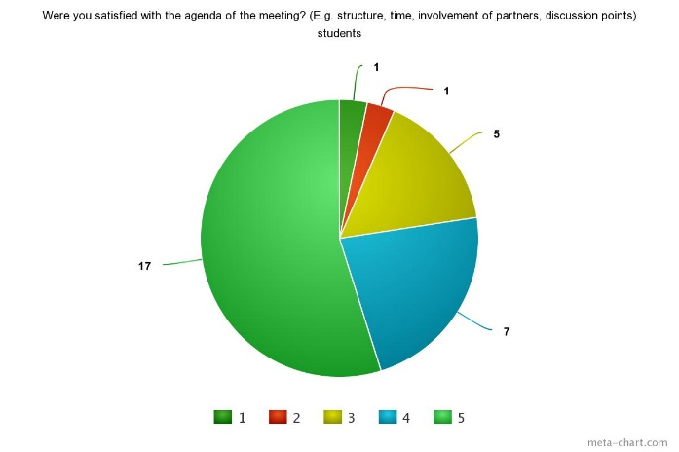
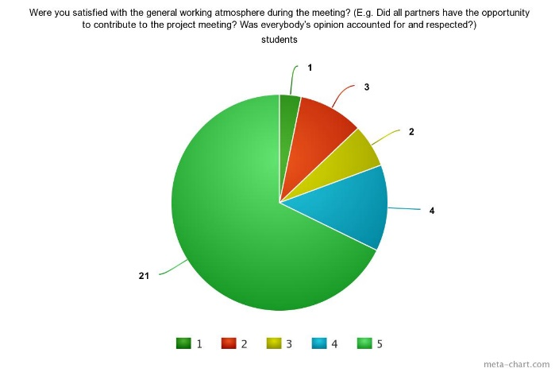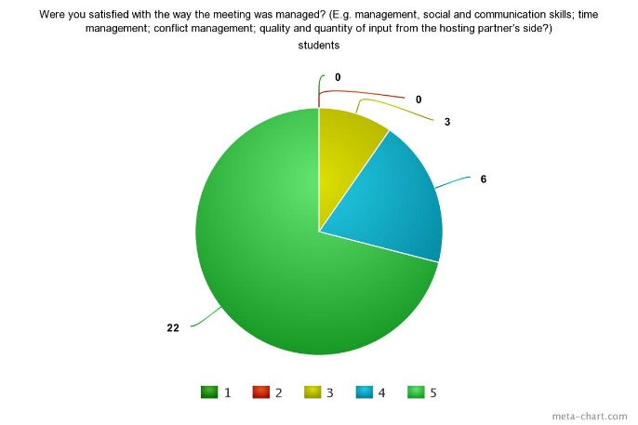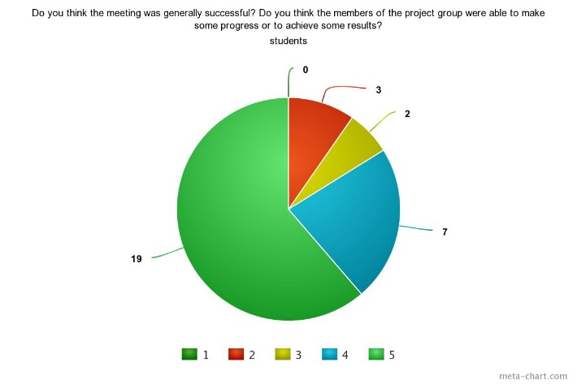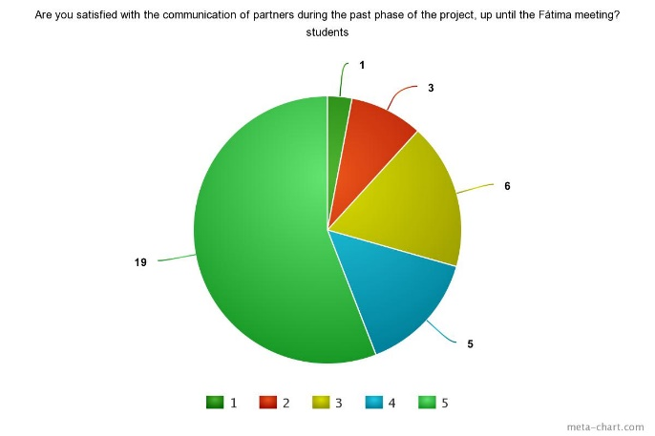
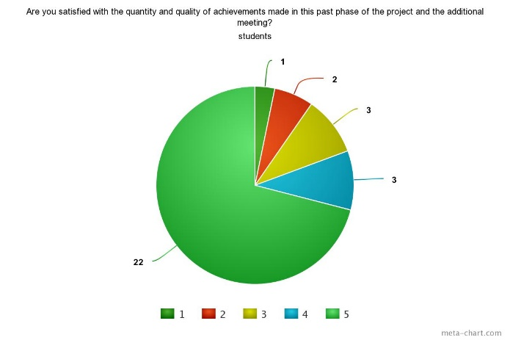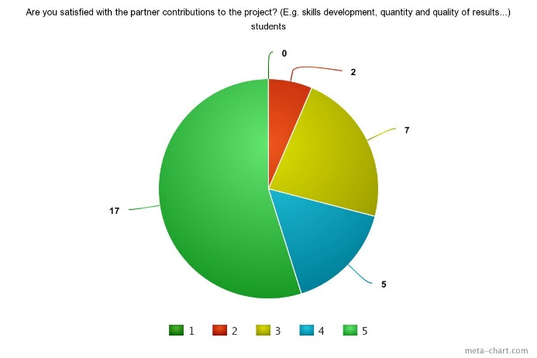
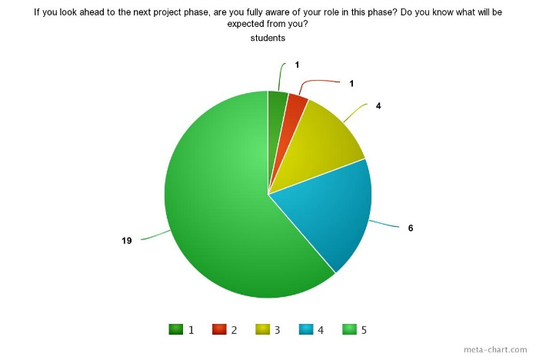

According to the survey, traditional foods and drinks, eating habits, traditional sports are the key aspects that the students have learnt about other countries.
Whereas almost all of the students were pretty satisfied with the accommodation and facilities, social programme, general working atmosphere during the meeting and communication of partners during the past phase of the project, up until the Fátima and the way the meeting was managed; a fair amount of students were satisfied with the preparation work for the Fátima meeting, the agenda of the meeting, the quantity and quality of achievements made in this past phase of the project and the additional meeting and the partner contributions to the project.
When the students look ahead to the next project phase, most of them think they are fully aware of their role in this phase and know what will be expected from them.

