DISSEMINATION OF ERASMUS+ PROJECT “YOUNGSTERS NOWADAYS. WHERE FROM, WHERE TO” IN ITT G. Malafarina- Soverato-Italy
In September the Council Board, the Students’ assembly and the technical staff of ITT G. Malafarina were informed about the approvation of YOUNGSTERS NOWADAYS. WHERE FROM, WHERE TO Erasmus plus project. In occasion of the Erasmus Day on 13th October at the presence of representatives from other schools, parents, municipality and regional political authorities, Ngos and representatives of two National Italian agencies (Indire and Inapp) the objectives of the projects were promoted: http://www.soveratiamo.com/component/k2/33972

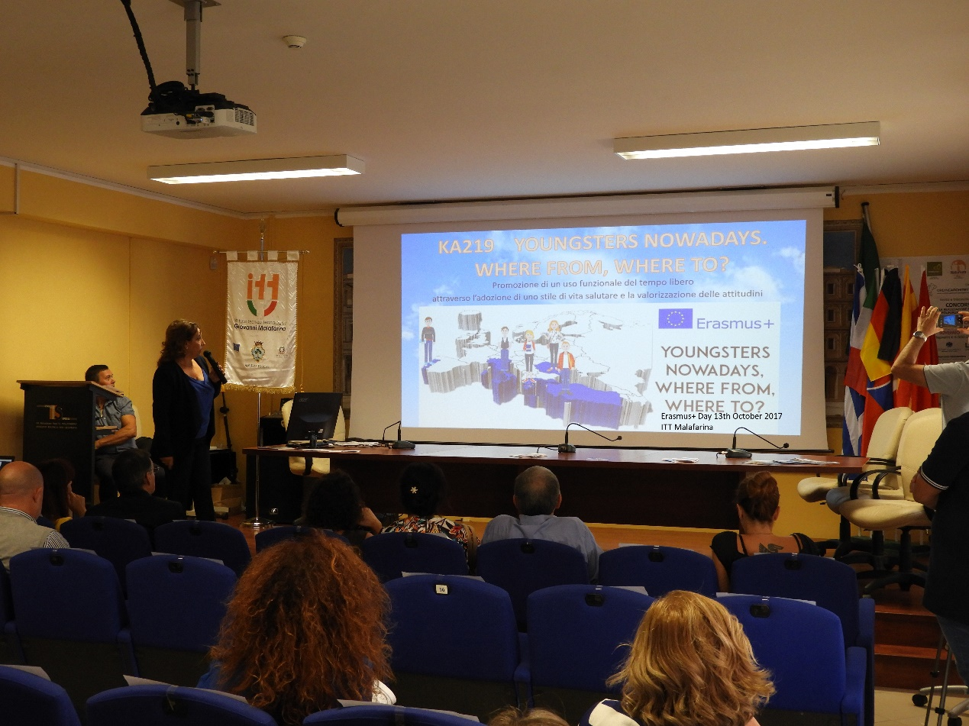The Italian coordinators together with the principal published a recruitment call complete with all the activities to be done were expressed: file:///C:/Users/ITT%20MALAFARINA/Downloads/Circolare%20n.09%20-%20Manifestazione%20di%20interesse%20Erasmus%20plus%202017-2018.pdf
Then the Erasmus corner was updated, the team joined the Yahoo community, the Facebook group and the eTwinning project. Furthermore a section was created in the school website: https://www.itmalafarina.gov.it/erasmus.
Mr Babbo Franco gathered info from all the partners and created a website to be updated for all the duration of the project: https://youngstersnow.wixsite.com/youngstersnowadays
Following the first Transnational Project meting in Greece an article was sent to all the journalists:
http://www.preserreedintorni.it/soverato-cz-in-grecia-per-valorizzare-attitudini-studenti/
https://www.calabriawebtv.it/mobilita-erasmus-itt-malafarina-soverato/
http://soveratiamo.com/component/k2/34763
http://www.soveratoweb.com/delegazione-di-docenti-dellitt-malafarina-di-soverato-in-grecia/
Furthermore, a meeting was organized with the staff in order to arrange the first C1 in Portugal and some outcomes such as a poster, an album and a video were produced.

