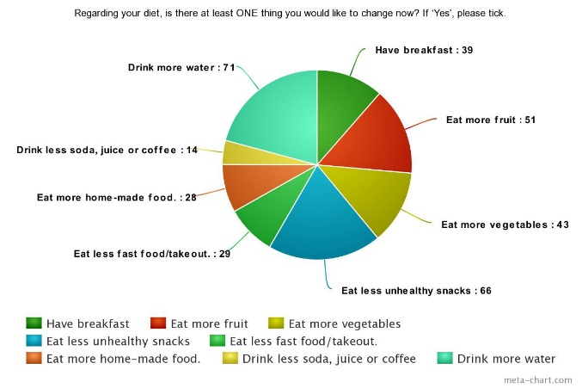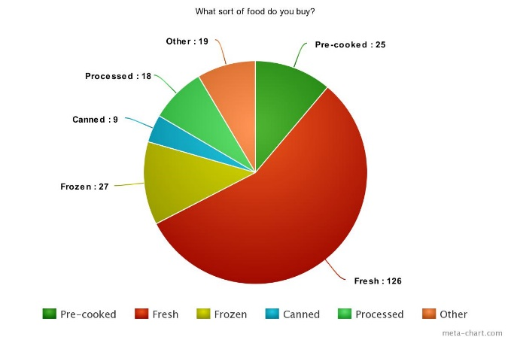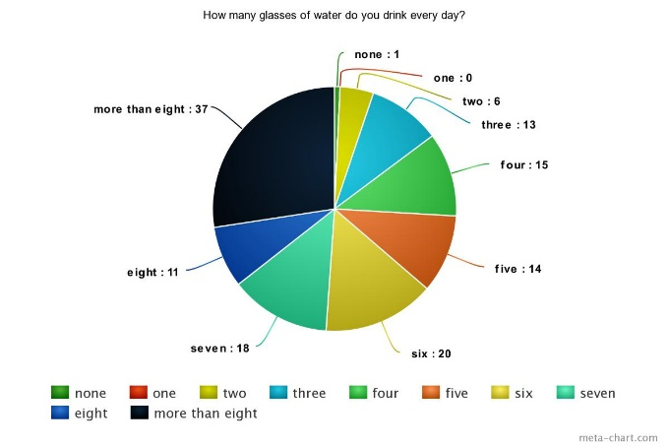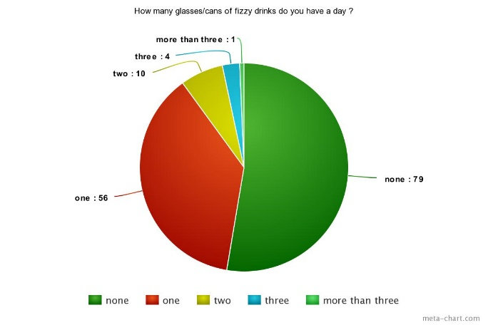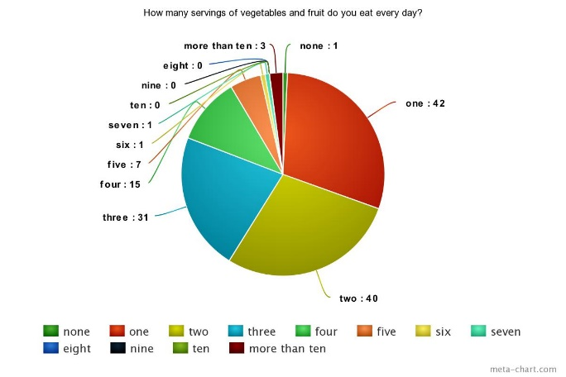

94 students would like to change their eating habits by eating either more vegetable or fruit, 95 students by eating less unhealthy food, 85 students by drinking either less soda or more water and 67 students by either having breakfast or eating more home-cooked food.

1/4 of the students drink 3-5 glasses of water, 1/3 of the students drink 6-8 glasses of water and 37 of 150 students drink more than 8 glasses of water per day.

most of the students prefer fresh food when they buy.

Most of the students drink either only one glass of fizzy drink or none.

Most of the students eat 1-3 servings of veggies and fruits.