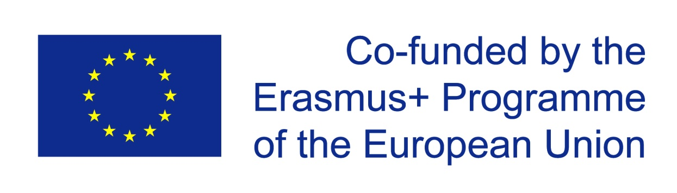

**MINUTES OF THE 1ST TRANSNATIONAL MEETING HELD IN GYMNASION ME LYKEIAKES TAXEIS ASOPIAS, GREECE**

The first transnational meeting of “Youngsters Nowadays. Where from, where to?” took place on 14th – 16th December 2017 in Assopia. It brought together representative participants from **Colegiul National “Ion Luca Caragiale’’- Moreni, Romania, Istituto Tecnico Tecnologico "G. Malafarina" Soverato, Insignare – Associacao De Ensino E Formacao - Ouerem, Portugal, Ahmet Erdem Anadolu Lisesi, Bursa, Turkey, Gymnasion Me Lykeiakes Taxeis Asopias**  institutions involved in this strategic partnership.

|  |  |  |  |  |
| --- | --- | --- | --- | --- |
|  | **Date** |  | 14-16 December 2017 | |
|  | **Venue** |  | Gymnasion Me Lykeiakes Taxeis Asopias | |
|  | **Objectives** |  | The main objectives of the First Transnational Meeting of the partners from “Youngsters Nowadays. Where from, where to?” were for all partners:   * Devising the project plan of implementation for the digital visualization of the project activities and results: * The proper functioning of the project website, the project Twin-space, the project (Facebook community; communication sessions via Skype (schedule, their evaluation and SWOT analyses) * Organization of the logo competition * **Discussing the responsibilities each team has, with deadlines and how to solve different problems that may appear** * Discussing the measures we will take to improve communication, realization of objectives and activities * Reallocation of responsibilities and tasks after the Croatian school's withdrawal. * **Monitoring/ Evaluation Plan**   - Establishing the monitoring/evaluation plan with the way/ frequency we will monitor the project process  - Establishing the plan for the strict budget control  - The report about each school project bookkeeping  - Designing the evaluation questionnaires that will be applied on the last day of each international project meeting, both for Learning/Teaching/Training  - Devising the project progress evaluation   * **The dissemination plan** * Schedule, deadlines, * Evaluation of the dissemination activities * **Preparation of the first Learning /Teaching/Training Activities (C1 held at the school in Portugal)** * How we will achieve the final products in C1; devising the questionnaires for food and sports habits that will be applied in C1 * Establishing the details and plan for the activities in C1 * How we will do the evaluation of C1 * How we will do the dissemination of results obtained in C1 * Details regarding the participants’ travel/ accommodation for C1 | |
|  |
|  |
|  | **Attendance** |  | **Teachers:**  1) Matei Mirandolina  2) Cracanel Doina | from Colegiul National “Ion Luca Caragiale”, Moreni, Romania |
|  |
| **Teachers**:  1) Savina Moniaci  2) Franco Babbo | from Istituto Tecnico Tecnologico “G. Malafarina”, Soverato, Italy |
| **Teachers:**   1. Zeki Avsar 2. Aylin Pedal 3. Rusen Donmez | from Ahmet Erdem Anadolu Lisesi, Bursa, Turkey |
| **Teachers:**   1. Sergio Fernandes | from Insignare-Associacao de Ensino e Formacao, Ouerem, Portugal |
| **Teachers:**   1. Ioannis B. Bourantas 2. Evangelia Konsta 3. Efthimia Koufadi 4. Paraskevi Goulitsa | from Gymnasion me Lykeiakes Taxeis Asopias, Asopia, Greece |

Decisions reached

1st Day

The project Website, the Twin-space and the Facebook community were revised for proper functioning and some changes were made towards improving and facilitating communication. Skype sessions schedule, which will take place once a month, was fixed as well as its evaluation and SWOT analyses determined. The organization of the Logo competition was also discussed, implementation details were co-decided and deadlines were fixed. Each partner-country will conduct an internal vote on its own logo to participate in the final vote and each country’s entry will be uploaded on the 9th February. The final logo of the project will be decided after a google survey has been conducted on Tuesday 13th February, in which 30 students per country will participate. There were also discussed the measures to improve communication, exemplification and realization of the objectives of the activities. After Croatian school’s withdrawal, it was made a reallocation of responsibilities and tasks among the remaining partners. More specifically: the conduction of the logo contest was allocated to Italy, the initiations of Skype meetings will be a responsibility of Portugal, while the evaluation of the Skype meetings will be conducted by Turkey.

|  |  |  |  |
| --- | --- | --- | --- |
| **Attendance** |  | **Teachers:**  1) Matei Mirandolina  2) Cracanel Doina | from Colegiul National “Ion Luca Caragiale”, Moreni, Romania |
|  |
| **Teachers**:  1) Savina Moniaci  2) Franco Babbo | from Istituto Tecnico Tecnologico “G. Malafarina”, Soverato, Italy |
| **Teachers:**   1. Zeki Avsar 2. Aylin Pedal 3. Rusen Donmez | from Ahmet Erdem Anadolu Lisesi, Bursa, Turkey |
| **Teachers:**   1. Sergio Fernandes | from Insignare-Associacao de Ensino e Formacao, Ouerem, Portugal |
| **Teachers:**   1. Ioannis B. Bourantas 2. Evangelia Konsta 3. Efthimia Koufadi 4. Paraskevi Goulitsa | from Gymnasion me Lykeiakes Taxeis Asopias, Asopia, Greece |

2nd Day

An explicit implementation and evaluation plan was devised and agreed upon. The dissemination of activities and project work made both on a school-local level and on a project level will be monitored through an online platform that all partners are to fill in on a regular basis. An explicit schedule plan with deadlines concerning the evaluation of the dissemination activities was devised which would be closely monitored by the project coordinator who is responsible for the final evaluation of the dissemination activities.

A plan concerning the budget control was devised and a report on behalf of each country will be sent to the coordinator of the project so as to monitor each participant country’s budget. According to National Agencies’ requirements, each country is obliged to keep a fully-informed archive with all necessary files.

Evaluation questionnaires to be applied on the last day of each international project meeting were prepared towards evaluating the Transnational Project Meetings and a draft for the Learning, Teaching and Training activities and results that are to be changed according to the topic of each meeting.

An explicit plan concerning the project progress evaluation was devised and agreed upon.

|  |  |  |  |
| --- | --- | --- | --- |
| **Attendance** |  | **Teachers:**  1) Matei Mirandolina  2) Cracanel Doina | from Colegiul National “Ion Luca Caragiale”, Moreni, Romania |
|  |
| **Teachers**:  1) Savina Moniaci  2) Franco Babbo | from Istituto Tecnico Tecnologico “G. Malafarina”, Soverato, Italy |
| **Teachers:**   1. Zeki Avsar 2. Aylin Pedal 3. Rusen Donmez | from Ahmet Erdem Anadolu Lisesi, Bursa, Turkey |
| **Teachers:**   1. Sergio Fernandes | from Insignare-Associacao de Ensino e Formacao, Ouerem, Portugal |
| **Teachers:**   1. Ioannis B. Bourantas 2. Evangelia Konsta 3. Efthimia Koufadi 4. Paraskevi Goulitsa | from Gymnasion me Lykeiakes Taxeis Asopias, Asopia, Greece |

3rd Day

A discussion was held on the dates of the two forthcoming meetings. As decided, the 1st LTTAs will be held at the school in Portugal from 4th March to 10th March 2018 (activities between 5th-9th) and as proposal the 2nd TPM should take place in Bursa from 2nd May to 6th May 2018.

A thorough discussion on the Learning, Teaching and Training Activities of the 1st C1 meeting in Portugal was held. Specific activities were decided and allocated to the participant countries. Ways to achieve the final products in C1 were discussed and questionnaires on food and sports habits were devised for the 1st C1 meeting. Implementation details were arranged and an explicit planning of the activities was prepared.

The exact process to be followed and tools to be used for the evaluation of the C1 meeting, as well as the dissemination of the results were discussed and devised.

The final details regarding the participants’ travel and accommodation for C1 were discussed.

|  |  |  |  |
| --- | --- | --- | --- |
| **Attendance** |  | **Teachers:**  1) Matei Mirandolina  2) Cracanel Doina | from Colegiul National “Ion Luca Caragiale”, Moreni, Romania |
|  |
| **Teachers**:  1) Savina Moniaci  2) Franco Babbo | from Istituto Tecnico Tecnologico “G. Malafarina”, Soverato, Italy |
| **Teachers:**   1. Zeki Avsar 2. Aylin Pedal 3. Rusen Donmez | from Ahmet Erdem Anadolu Lisesi, Bursa, Turkey |
| **Teachers:**   1. Sergio Fernandes | from Insignare-Associacao de Ensino e Formacao, Ouerem, Portugal |
| **Teachers:**   1. Ioannis B. Bourantas 2. Evangelia Konsta 3. Efthimia Koufadi 4. Paraskevi Goulitsa | from Gymnasion me Lykeiakes Taxeis Asopias, Asopia, Greece |