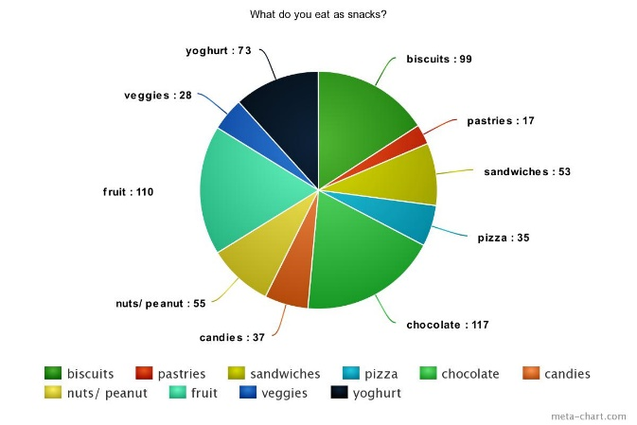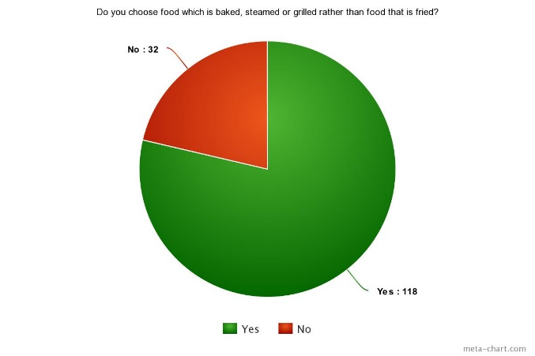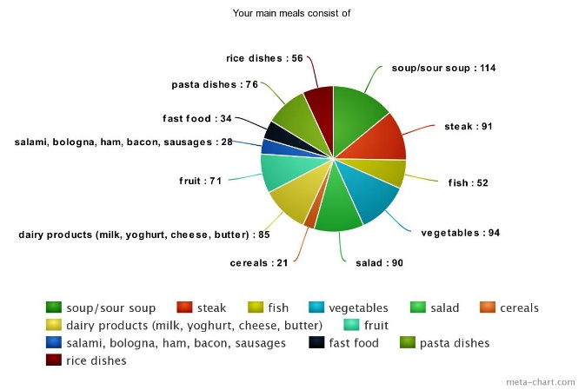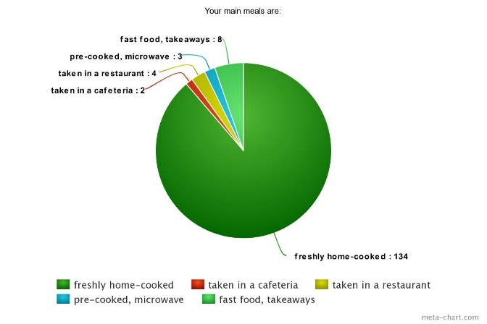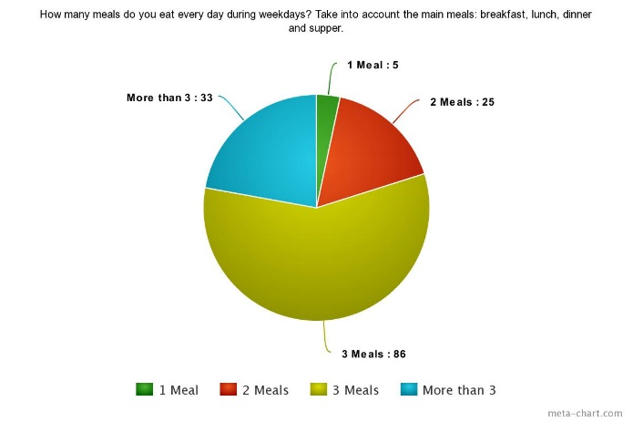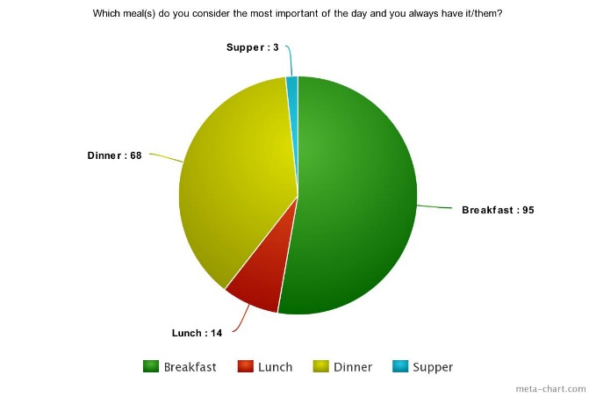

On average 2/3 of the students eat biscuits, chocolate and fruit as snacks and half of them eat sandwiches, nuts and yogurt.

118 of 150 students prefer baked, steamed or grilled food, whereas 32 do not when they can.

The meals Turkish students eat usually consist soup, steak, salad, vegetables, dairy products, fruit and pasta dishes.

The main meals of the students are freshly home- cooked.

Most of the students believe that the most important meal of the day. is either breakfast or dinner.

Most of the students eat three meals a day during weekdays.