Vegetables with music, a theory to confirm

We are going to present you our project.
Our project is about vegetation. We want to mix the dance, the music, sciences and the theater. We are four girls, two cellists and two dancers. we want to do a stage play about their communication and their capacity to survive with the natural selection. the most important is about music who can maybe help the plants to grow up. One character will be Jean Jacques Rousseau, a famous French writer, phylosoph and musician. We need three of you. Then you have to choose one of the biggest scientifics of your countries to represent him, one of you need to do J.J. Rousseau : who can do the connection between the artistic part and the sciences.
Our conclusion is that the plant have a lot of capacity to survive without deplacement. Whereas the music isn't bad of her but maybe beneficial.
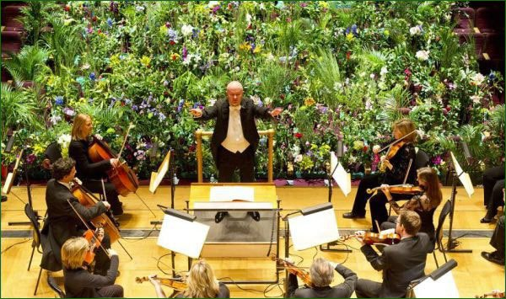
Thank you for reading and we hope you are going to choose us.
Salomé, Rachel, Juliette and Zélie.

