NATURAL SELECTION PROJET 8, GROUPE 4

Hello ! We're from Paris, from Georges Brassens school. We're musicians and we love music. We hope you like it too! If you don't want to sing but you play an instrument, welcome! Those who want to dance, join us too ! In fact, everybody can participate...
We're going to create a song about natural selection. We'll write the lyrics and the musical arrangement. Behind us, there will be a video with images of the subject. ♥
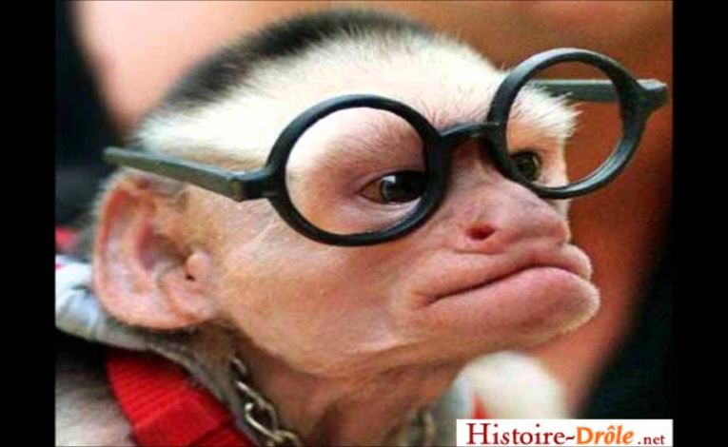

And a new idea came up : showing a "draw my life" in relation with natural selection while playing music or singing a song. Please if you have any other ideas, tell us what are they.
See youuuu ♥
We're waiting for you. mouahahaa.

