Top 5 by district
We gathered and analized the data from all the districts from the last four years and made a list of the Top Five most frequently found species (pictures correspond to order of names) :
- Poa annua L.
- Sonchus oleraceus L.
- Conyza canadensis (L.) Cronquist
- Stellaria media (L.) Vill.
- Taraxacum

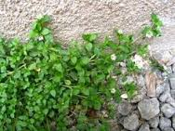
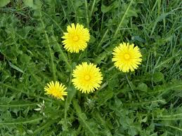
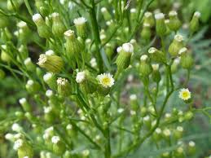
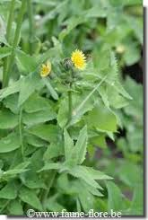
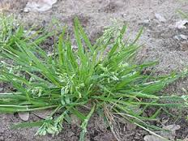

In the nineteenth neighbourhood we found 55 species out of 139 samples, here is a list of the Top Five :
- Poa annua L.
- Taraxacum
- Sonchus oleraceus L
- Plantago major L.
- Capsella bursa-pastoris (L.) Medik.
