TURKISH TEAM
MOBİL İMAM HATİP SECONDARY SCHOOL
MOBİL İHO/DR NESİBE BATIYOL STREET/NO:2/BAYRAMPASA/ISTANBUL

GREETING AND INTRODUCING YOURSELF IN RELATION TO OTHERS

Lesson Plan
Lesson Topic
Greeting and Introducing Yourself In Relation To Others

Subject | Class | Curriculum Links
English  Music  ICT  Cultural Heritage | 5th Grade  (10-11 year old students) | English ICT  Music

Context
Project Name | Creating an Innovative Platform of Communication and Teaching in a Digital Society
Links with previous lesson(s) | Grammar: am/is/are, Wh questions, like and dislike
Links with future lesson(s) | Greeting and introducing yourself in relation to others  Vocabulary related to asking opinions  The importance of İstanbul city for people from different cultures  Preparing poster about interview
Cross curricular links before the lesson | Computer Skills,  Musical Awareness,  Communication Skills,  The Awareness of Cultural Heritage  The Ability of Producing Visual Product
Cross curricular links after the lesson | Students need to have computer skills to use different applications and musical skills like musical rhythm, word harmony and body percussion

Learning Objective:
Students will be able to greet people.
Students will be able to meet and introduce themselves.
Students will practise and focus on the use of the language through music
Students will ask tourists to introduce themselves
Students be able to ask opinions about cultural importance of İstanbul
Students will make a visual poster related to their interview with tourists

Learning Outcomes:
1-Students will be able to ask and answer basic questions related to introducing themselves
2.Students will be able to have an awareness of cultural importance of İstanbul for tourists
3.Students will be able to interview with tourists through guided questions
4. Students will be able to design posters
5. Students will learn how to form password how to answer/solve questions on Learning Apps.
6. They will learn to add new words to familiar melodies and singing with body percussion.

Pre Lesson Preparation | ICT Resources
Student’s book (World Quest 1), notebook, pen, pencils, rhythm instruments instructions for facilitators, role play cards, visiting touristic attractions | Smart board, computers(for each student)  LearningApps.org

Prior Learning / Assessment to inform planning
For example:
Using Orff Schulwerk : Using that method effectively in English, making all the students be eager to learn a language other than their mother tongue.
Natural born ability for rhythm of language and inventing games has helped us to permanently remembering new things that we learn

Key Vocabulary
English: Introduce, country, nationality, favourite, job, name, surname
Cultural Heritage: importance, dislike, like, historical artifacts, special
ICT: Learning apps, download, account.
Music: Rhythm, song, harmony.

Key competencies development:
At the end lesson, students will develop following basic skills:
Speaking and Listening: they will be able to introduce herself/himself, greet foreign, get to know them, ask their opinion about specific topic,
Reading: Understanding giving tasks
Writing:They will design poster by using the photos they take with tourists and by making use of interview

Non-formal methods applied in the lesson:
Orff Schulwerk Music Learning Methods
(see appendix1)
Ice-Breaker (see appendix1)
“Role play cards” game (see appendix3)
“Ask me ” game (see appendix4)
Learning Apps (see appendix5)

LESSON STRUCTURE & DETAILED PLAN OF ACTIVITIES
Time | Link to  Learning  Outcome number | Teacher Activity  Objectives & Outcomes,  Teaching Activities, Revisiting Outcomes & Consolidation | Learner Activity  Identify the techniques used to differentiate for ALL Learners | Assessment Strategies  Used to Ensure Progress of All Learners | Resources  e.g. TEL, Other Adults, Materials and Equipment
5 | 6 | Ice breaker “Singing song with rhythms game” | With Orff Schulwerk method, student sing | Asking the whole group what the main guestion is in the song | *Appendix 1
10 | 1 | Presentation of basic questions with wh- question words | Students will listen and take notes | Repetition | Smart board
8 | 1 | Lead in  Giving keyword about introducing oneself and tell them what can be asked | Using keyword students will try ask questions | Group work and reporting results (questions they form) to whole class | Teacher writing,  brain storming  *Appendix 2
8 | 1-3 | “Role play cards”  Cards will be about different nationalities, people and jobs | Choosing card randomly and introduce yourself | Reporting the whole class different people from different nationalities | Role play cards  *Appendix 3
9 | 1-2-3 | “Ask me” Game  Teacher gives information about informal outdoor game which will take place out of lesson hours | Groups are formed and the location that the game is going to be played is defined | Defining vocabulary, sentences, structures they use | Repetition  Act out  “Ask me” Game *Appendix 4
40 | 5 | Learning Apps  Teacher will manage /observe students while they use Learning Apps | Students will answer the questions that were prepared by the teacher | Learning Apps give feedback at that moment | Learning Apps  ICT class  *Appendix 5

Home Learning/Homework
They are asked to complete two tasks
Students will prepare a poster that highlights their interview, with tourists. They will use the photos that have been taken with tourists and information they get from their interview.

Lesson Evaluation
Lesson Topic | Subject
Greeting and Introducing Yourself, Wh- questions, To be verb, | English

Evaluator
English teacher

Evaluation
Pupil Learning & Progression
We can understand the progression of students with different kinds of activities and games
Most of the students achieved the learning outcomes. Through learning app program, we can evaluate learning outcomes. We can get feedback whether students understand and produce the related language structures that we teach. During the lesson teacher can also observe students’ performance. Progress can also be observed from the posters that students are expected to prepare.
Teaching & Classroom Management
Teacher creates a learning environment .She presents games and activities for each step of lesson that students can be active. At the beginning of the lesson, teacher guides the students, corrects mistakes, encourages peer working. Throughout the lesson, students get free step by step with each activity. The lesson ends with producing concrete product using what they have learned during whole lesson.
Planning & Subject Knowledge
Orff Schulwerk method provides creativity in the branches that are used. We did not make use of that method during the whole course session. With that method they will get the basic structure of asking questions. With role play cards, they will be encouraged to speak and communicate with others. Through “ask me” they will be in a relaxing environment where they will introduce themselves, ask questions about importance of touristic attractions of İstanbul

Next Steps in Learning,
For next steps, students are expected to search and write about İstanbul as a joining point of cultures.

APPENDİX 1

What is Orff-Schulwerk?
Music, speech and dance are the means of self-expression. Every person, whether child-young, old or disabled, has the ability to express himself / herself artistically. Based on this principle of Carl Orff and Gunild Keetman, they developed Orff Schulwerk. It is the most used music pedagogy of the 20th century.
Orff-Schulwerk provides an environment for human beings to unleash the already existing creative forces. The basis is rhythm, movement and speech. It allows people to make music, dance and improvise as they come from. It is an understanding of education that offers people an environment of learning, discovering, experimenting and creating by combining all artistic fields.
In this understanding of education, people of all levels and abilities experience an interactive process of creativity and self-expression within a group. Learning through group work is much easier for a person who is basically a social being.
Ice Breaker ‘Meeting song’
Students make a circle. In music lesson, they mumble Turkish words and the introducing oneself song that they learn and play it with body percussion (look ‘meeting song’ notes). English teacher put the words related to introducing in body percussion one by one
For example; x x x
Knee clap snep
My name is Mark
All English words are put in the song. After students learn English song, they make groups of two. Students stand on face to face. They sing the song again and they realize that body percussion turn into hand game. For each repetition of the song, partners change. In this way, all students meet and greet each other each other while playing hand game. They become ready for the lesson..
The game video’s link;
(https://www.youtube.com/watch?v=G7tEoEpO-C4)

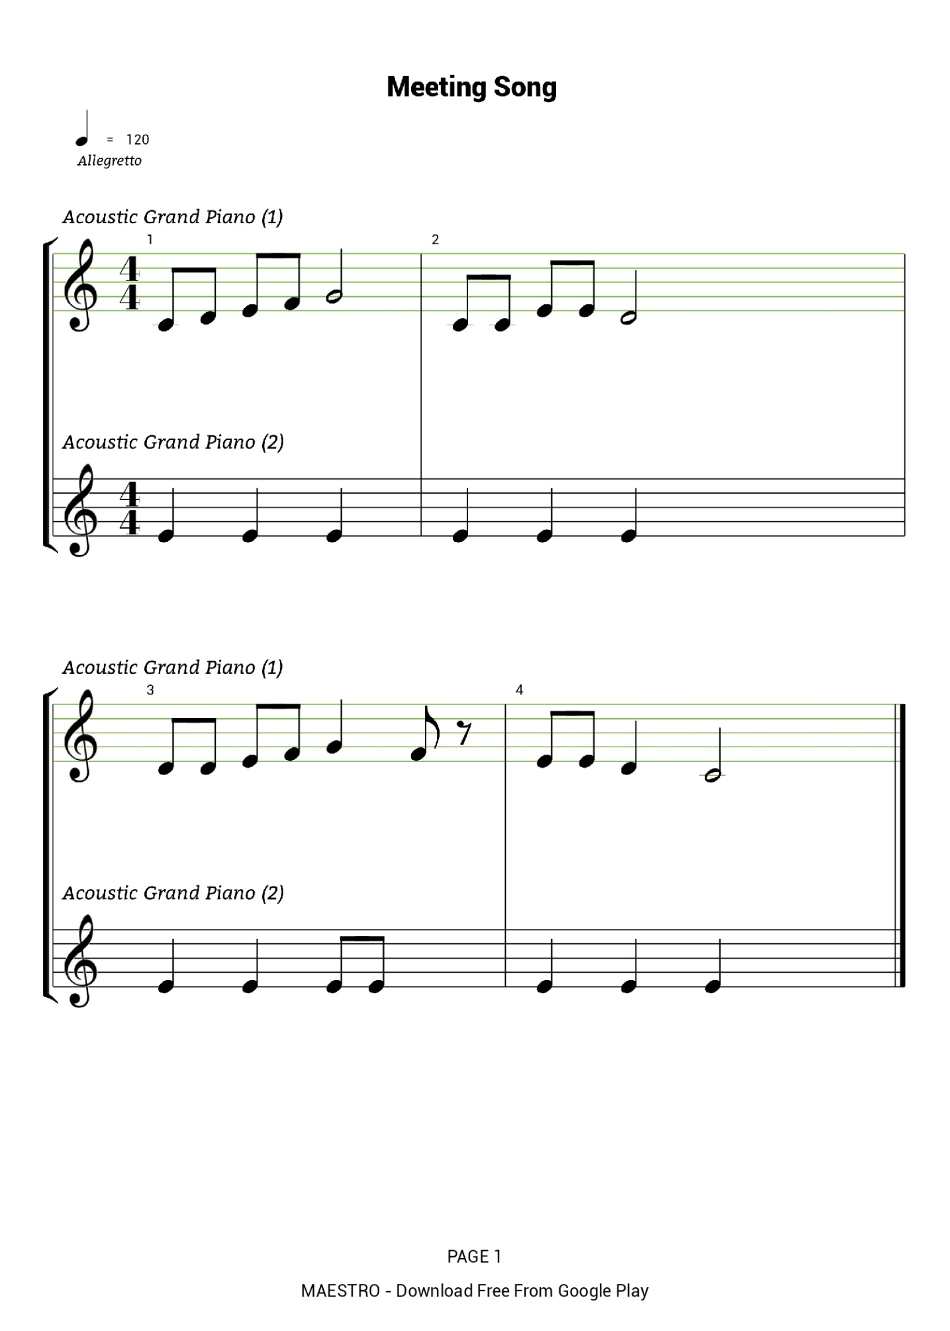
Meeting song notes;
My name is____ ecename is my name is____ ece
My name is____ ece______name is what is your name?
Your name is____ canname is my name is____ can
Your name is____ canname is what is your name?
Knee clap right snap knee clap left snap

Knee clap snap snap knee clap snap (both hands)

APPENDİX 2
Teachers write keyboards on the board. The words will be about basic “introduce yourself” questions. Teacher will ask students to form questions about introducing “oneself”. Students will try to produce basic language patterns related to introducing yourself context.
During that phase of the lesson, teacher will guide students. Teacher will make the students produce the language patterns correctly. She will guide students and enable them to learn on their own. While she is prompting students, she will make use of the basic question in the song “What is your name”. That basic question will give students have an idea how to form other different questions.
-What is your name?
-Where are you from?
-What is your nationality?
-How old are you?
-What is your job?

APPENDİX 3

ROLE PLAY CARDS
Teacher folds all role play cards and put them in a bag. Teacher shakes the bag and go around the class and allows each student to select one piece of paper. According to selected card, they introduce themselves. Cards include knowledge about people from different nationalities, different genders and different ages.
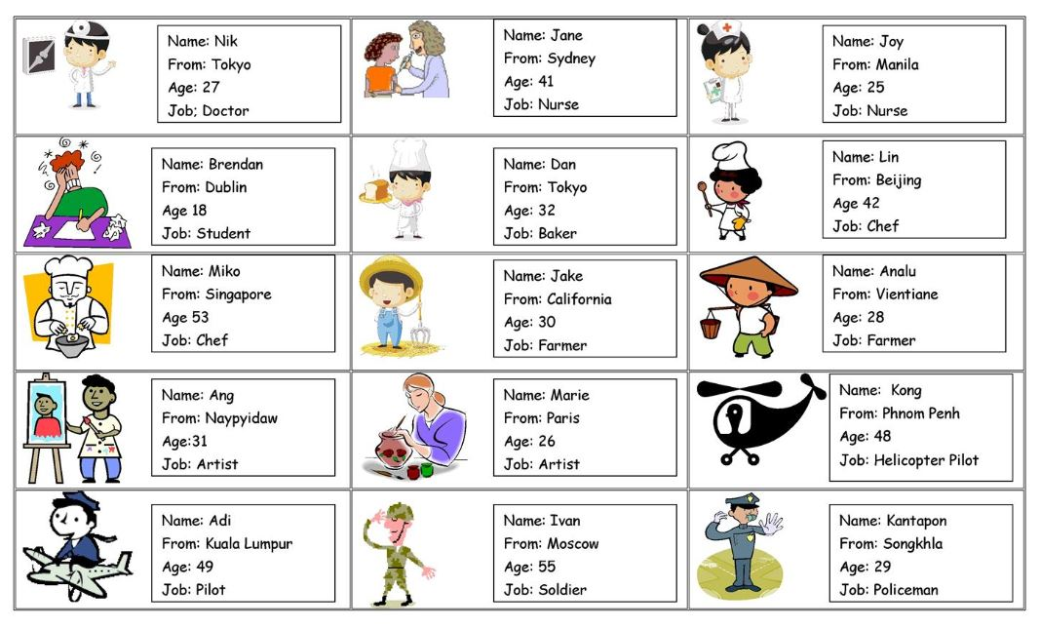
Through that game, students will imitate of someone who is different from themselves. Students will have to communicate with each other and use the language to introduce themselves. That game is fun and motivating because students will get a chance to express themselves and include the outside world into the classroom atmosphere. When role play starts, students will feel “armed” with appropriate language. As for the teacher, she will watch the students, their performance and offers comments at the end.

APPENDİX 4

“ASK ME” GAME
Daily communication is often based on the exchange of current events. It doesn’t take into account the deepest feelings and desires. “Ask me game” is an opportunity to touch these feelings in an original and cheerful way.
For that game, students wear their “ask me” t-shirts. The place are famous historical attractions of İstanbul; Blue Mosque, Galata Tower, Taksim The students are expected to walk in square of Blue Mosque. They stop tourists randomly and ask their questions to tourists. The questions have been prepared before so they don’t have limitless number of questions. They are supposed to ask questions they have learned in the lesson. A part from those language patterns, they are expected to ask questions about historical and cultural importance of touristic attractions in İstanbul.

LANGUAGE PATTERNS
- What is your name?
- What is your surname?
- How old are you?
- What is your job?
- Where are you from?
- What is your nationality?
QUESTIONS ABOUT CULTURE
- Do you like Blue Mosque/ Hagia Sophia/ Galata Tower/ İstanbul?
- Do you think İstanbul has an cultural importance? Why?
- Why is İstanbul important?
- What makes İstanbul special?
- What do you like / dislike about İstanbul?
While students are gathering information about people from different nations; they also have an awareness of cultural importance of İstanbul. Students take notes related to answers.
In the second step of game, they show their t-shirts tourists and tell them to “ask me” questions. In this way, students have a chance to practise language and develop their communication skills.
The purpose of the game is to develop their communication abilities, to understand cultural importance of touristic places of İstanbul.

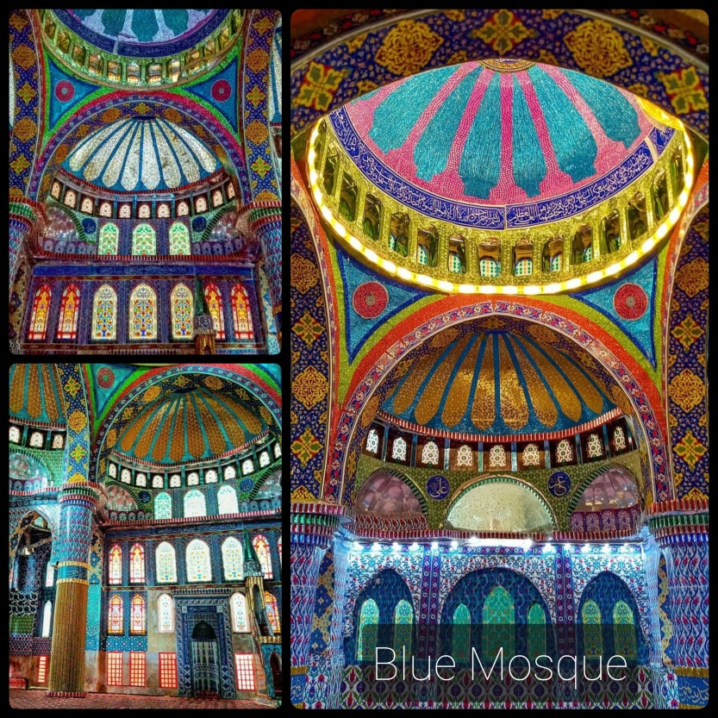
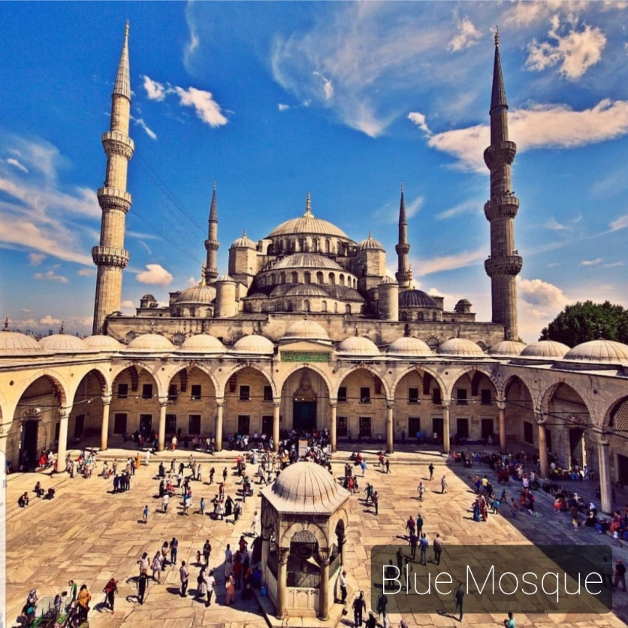

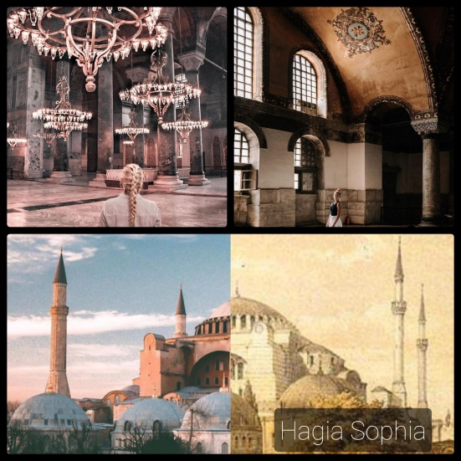
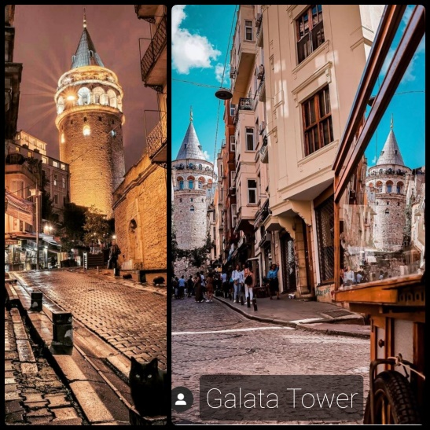
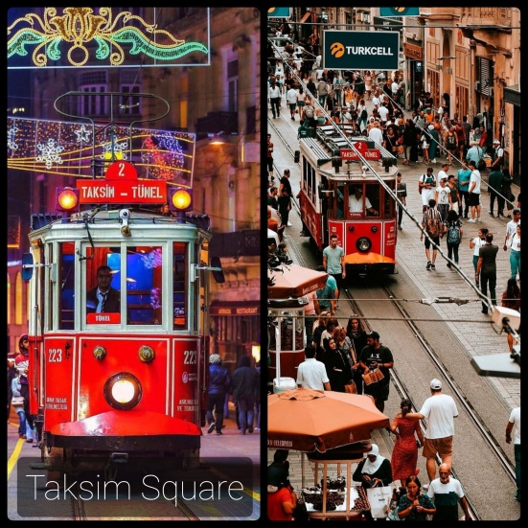

APPENDİX 5

WHAT IS LEARNING APPS?
“LearningApps.org” is a versatile tool for learners, teachers and teacher trainers who want to use or create a variety of different activities to practise the full range of language systems (grammar, vocabulary and pronunciation) and language skills (reading, listening, speaking and writing). There is a range of templates for simple language or skills focused activities. There are games and quizzes such as matching, identifying, categorising, gap-filling, crosswords, filling in answers, ordering, putting things on a line and multiple-choice tasks. You can also upload self-made or authentic texts, pictures, audio or video when creating or adapting activities. There’s a feature for typing in text to create audio content-helpful if you want to provide learners with models for pronunciation. Feedback and hints can be added to help learners to get the right answers and to understand why their answer is right or wrong.
In the second hour of the lesson, students go to computer room. Teacher gives information about learning app program .

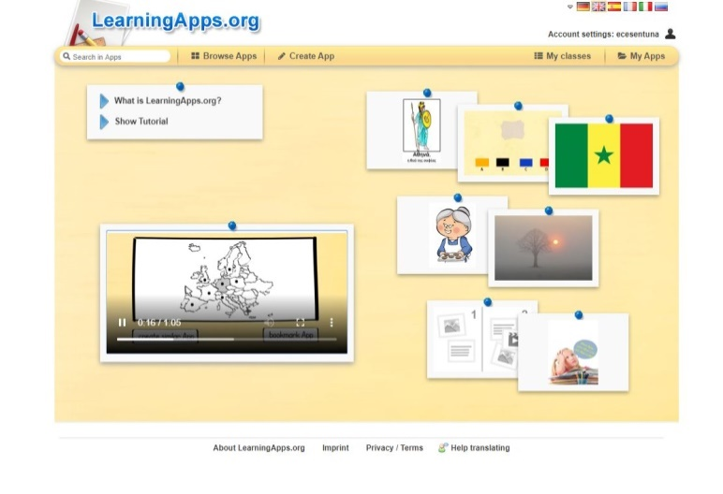

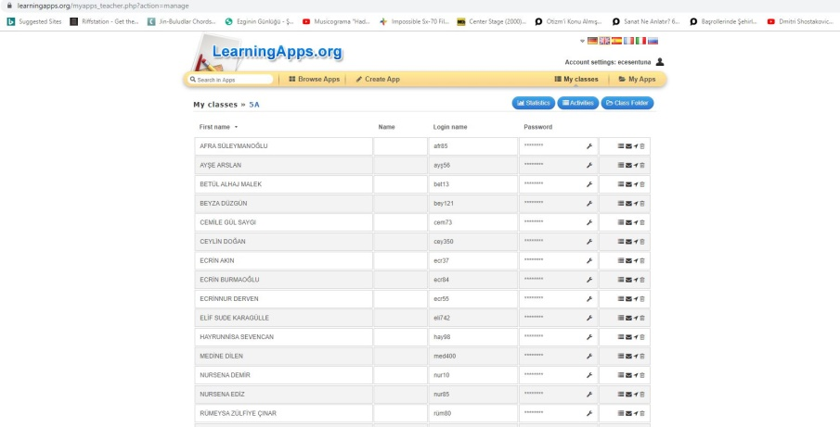
Students open learning app program on their computer. Teacher distributes passwords to students and helped students to log in Learning app.

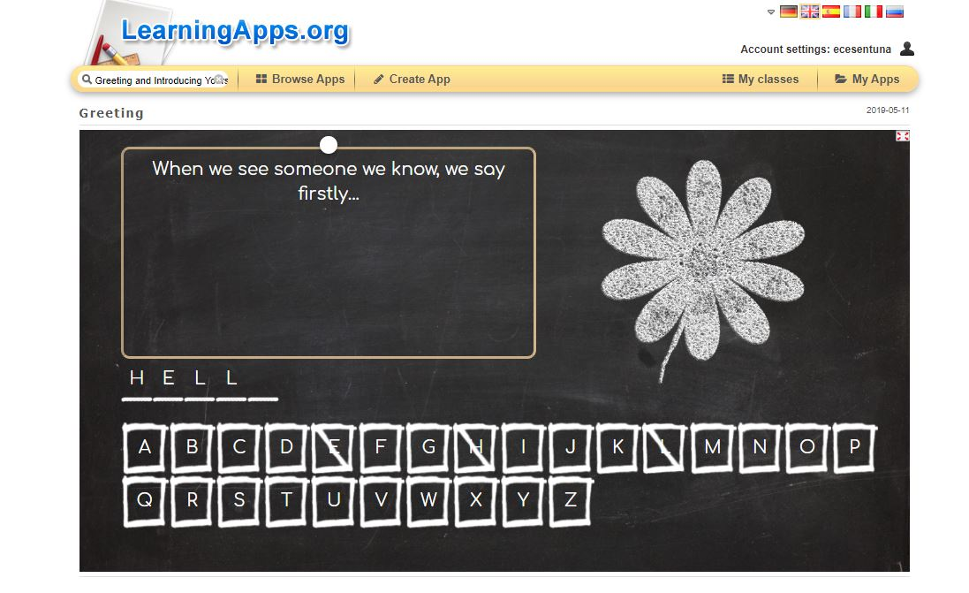
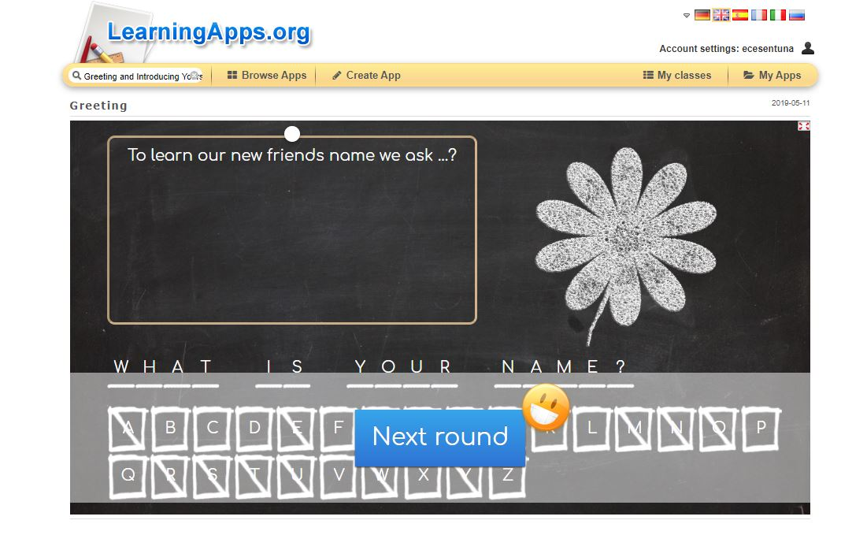
Then, students answer the questions that have been prepared by the teacher.

After that students will prepare their questions on his/her account. After that the students will share their questions with their friends.

