ICT TOOLS FOR EVALUTION

MATCHING GAME
In general we use Learningapps platform actively. We and our students like this. It is an active e-assesment tool.

Matching Game is one of them.
In this game students have to match the items with the right image.after the matching. they click on the button and they see if their answers are right or not.Thus they learn the which one is right it is something like feedback.In this game we chose renewable and nonrenewable energy sources matching related to the topic of environmental problems.By the end of this game ,they will be aware of environmental problems and they will learn new vocabulary related to the topic

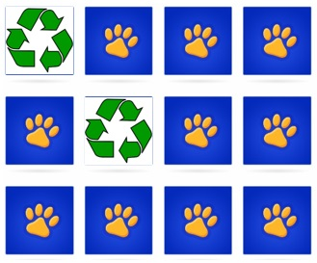
MEMORY GAME

Also,we use this application on h5p site to enhance the students vocabulary acqusition related to the topic.In this memory game teacher finds the topic related images and vocabulary and create the game .Then she explains the game rules.After that ,students have to match the two same images only after that they can see the English meaning of the image.

