TREASURES OF MALTA
A QR-Code Treasure Hunt
is a fun, simple way to get students using their mobile devices to continue learning, that is why we will create a game, using:
Treasure Hunt with Google maps and QR codes
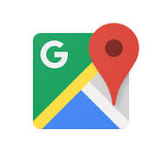
It is an activity we can use to encourage students to get active while discovering QR Codes on a map. These QR Codes would reveal questions that they need to answer or will suggest activities/exercises that students need to complete. The opportunities are endless.
In this game, participants will search for QR codes that have been placed around a map and are connected to the treasure hunt. When a participant finds such a code, they'll scan it and will have to complete an exercise, thus revealing part of a phrase that we have earlier specified. A team will complete the game by finding and scanning all of the codes, and in doing so will reveal the entire phrase until finally the treasure is found.
The QR game
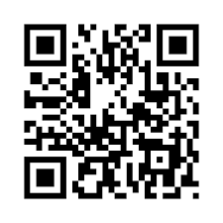
will work best if the players receive a small reward or entry into a larger contest for completing the game. The competitive aspect works to make the game fun, and the potential reward provides motivation to complete the game.
Prior to the lesson
...we will need to encourage students to download a QR Code Scanning app onto their devices. We would recommend the app

I-Nigma,
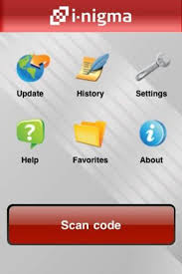
which is by FAR the best FREE scanning tool for all device types. While you don’t necessarily need each student with a device, you will need at least one member of a group with one.
It’s also worth mentioning that scanning the QR Codes generated in this style of hunt requires
NO internet connection.

Students will be put into small teams:
Each of these teams will contain at least one person with a mobile device (e.g. phone, IPod Touch) which could decode the QR codes (note: an internet connection is not required - the QR codes decode as text files).
Each code, when 'read' by the mobile device, will turn into a quiz question relating to the study topic. Some of these will test existing knowledge;
some of them will require further research to obtain the answer.

Through this game, focusing on a treasure hunt, we can encourage our EL learners to practice directional and number words, both orally and in writing, while following clues to find a hidden treasure.

Learning Objectives
As a result of this lesson, students will be able to:
- identify treasure-related vocabulary
- identify numbers and directional words
- use numbers and directional words in writing
- expand their vocabulary through different thematic contexts.

VOCABULARY AND SAMPLES
- crossword COMINO (biodiversity of plants on the islands)
- excerpts from The Count of Monte Cristo
- discussion on 'Would finding a trasure meke you happy?' Aspects of treasure.
- Find out: What do Alexandre Dumas,cumin seeds and the Mediterranean sea have in common?

FINAL DESTINATION
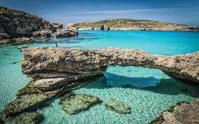

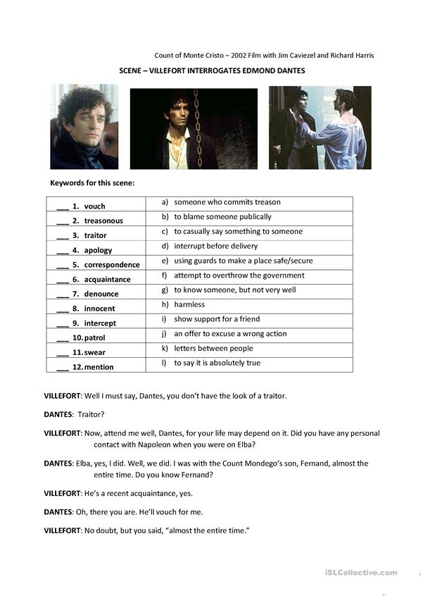1

