Romania is a state located in south-eastern Central Europe, on the lower Danube, north of the Balkan Peninsula and on the north-western shore of the Black Sea. On its territory is located almost the entire surface of the Danube Delta and the southern and central part of the Carpathian Mountains. It borders Bulgaria to the south, Serbia to the south-west, Hungary to the north-west, Ukraine to the north and east, and the Republic of Moldova to the east, and the Black Sea coast to the south-east.
Capital : Bucharest located in the south of country.
National holiday: December 1, 1918
Romania's flag is tricolor ( blue, yellow, red)
The National anthem: ''Wake up, Romanians'' on the lyrics of the poet Andrei Muresanu and the music of the poet and singer Anton Pann.

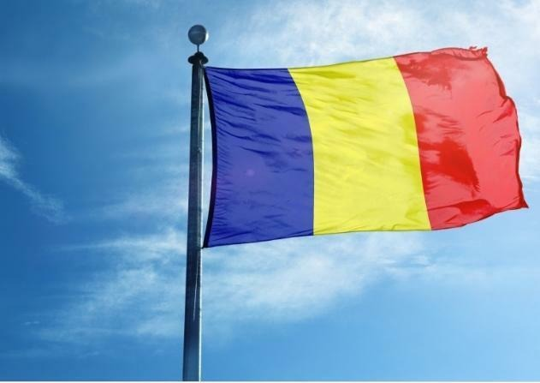 Our flag
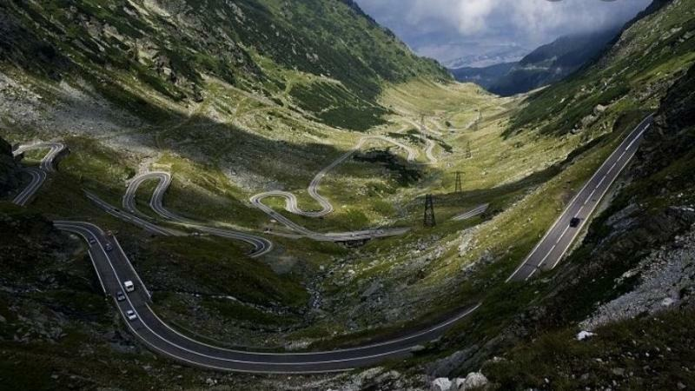 Our mountains

