Name of tool/app | SimpleMind
Homepage | https:// simplemind.eu/
Useful for (subject) | Not subject dependent
Easy to handle  (yes/no/it’s OK) | Yes, create awesome mindmaps very easily
Program must be downloaded (yes, no) | Yes
This additional program is necessary for download | Available for Android and iOS on Google Play and App -Store
Costs | Free
Examples | 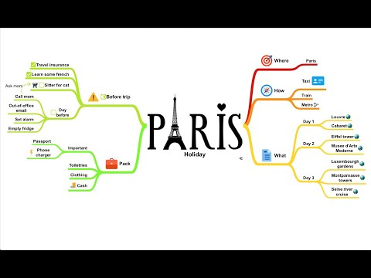  Mindmap

