Name of tool/app | 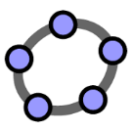  GeoGebra
Homepage | https://www.geogebra.org/
Useful for (subject) | Math
Easy to handle  (yes/no/it’s OK) | yes
Program must be downloaded (yes, no) | No, you don’t have to but if you want so you can download it and use it offline
This additional program is necessary for download | Available for Android and iOS on Google Play and App -Store  Online: https://www.geogebra.org/graphing  PC Application: https://www.geogebra.org/download
Costs | Free
Examples | Mathematical graphics