Name of tool/app | 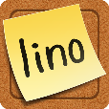  Lino
Homepage | http://linoit.com/home
Useful for (subject) | English and any other subjects
Easy to handle  (yes/no/it’s OK) | Yes, it’s easy to handle.  Just drag and drop the sticker to the place you want it.
Program must be downloaded (yes, no) | No, not necessary, it’s online http://linoit.com/home
This additional program is necessary for download | None, it’s available Online
Costs | Basic version is for free
Examples | 