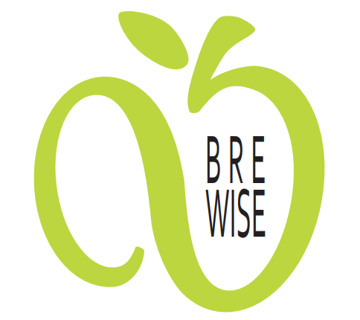
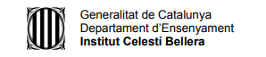

TIMELINE FOLLOW-UP

MONTH | ACTIVITY | COMMENTS
SEPT-OCT/18 | Presentation of the project to school | Done
 | Presentation of the project to families | Done
 | Presentation of the project to students | Done
 | Selection of the teachers lead team | Done
 | Selection of the students lead team | Done
OCT/18 | Local logo contest | Done
 | International logo contest | In November (done)
NOV/18 | Surveys among students | Done
 | Surveys among teachers | Not done and we think we do not need them.
 | Discussion about the results of the surveys | Done in LTTA Poland.
DEC/18 | Transmition of the material of teachers’ training course in Fundació Alicia to each school | Done, transmition among lead team of students and teachers.
DEC/18 | Creation of workshops by students | Done
 | Selection of the best workshops in each partner school | Done
DEC/18 | First Healthy Breakfast «DRESSED FRUITS» | Done
 | Creation of leaflets for the 1st breakfast | Done
JAN/19 | Creation of Healthy posters denying false common ideas about nutrition. | Done
 | Poster exhibition in each partner school | Not in all schools so we will do an exhibition of international posters (done)
 | International poster contest | Done
APR/19 | Workshops selected in LTTA takes place in each partner school | Done
 | Workshops selected in LTTA takes place in nearest schools of partner schools | Done except Portugal, Poland and Latvia. Octobre 2019 done everywhere.
APR/19 | 2nd Healthy breakfast «RUN OUT OF SUGAR» | Done
 | Creation of leaflets for the 2nd breakfast | Done
MAY/19 | Teachers write down the workshops lesson plan. | Done
MAY/19 | Creation of the first magazine | Half done in Croatia. FINISHED IN EACH COUNTRY. (done)
 | Translation of the magazine to local languages | Done
 | Delivery of magazines to families | Done
JUN/19 | Dissemination day for families | Done in Catalonia, Portugal, Latvia and Poland. In Croatia it will take place at the end of October. (done)
 | 3rd Healthy breakfast «BREAKFASTS AROUND THE WORLD» | Now postpone to 8th October. Done
JUL/19 | Teachers’ evaluation of the first year. | Done
SEPT/19 | Creation of a multilingual dictionary | It will be done from 22/10 to 22/11. Done in December.
SEPT/19 | Plantation of seeds | Done everywhere except in Catalonia. Done in January.
OCT/19 | Writing of healthy breakfasts recipes | LTTA Portugal
 | Healthy breakfasts videos | Postponed to December – January (youtube channel). Done
DEC/19 | Creation of the second magazine | Postponed to LTTA in Granollers. (done)
 | Translation of the magazine to local languages | We think this is not necessary because we are going to use them in English classes for the youngest students.
 | Delivery of magazines to families | Done after Granollers meeting.
JAN/20 | 4th Healthy breakfast | All partners did except Catalonia, they are doing at the end of February.
 | Creation of leaflets for the 4th breakfast | Done
FEB/20 | Public campaign to disseminate the recipe-blog and youtube channel | Done except Croatia.
MAR/20 | Creation of video advertisements | Done in October 2020 due to Covid lockdown
APR/20 | Creation of the third magazine  Creation of a small book with recipes of the project | Done in virtual LTTA by students (tales)
 | Translation of the magazine to local languages | It’s not necessary, we are not going to do that. We will use the magazine for English lessons in our schools.
 | Delivery of magazines to families | Virtualy due to COVID.
MAY/20 | Survey among students and families regarding the impact of the project | We decided to do it to tachers and students in our virtual meeting.
JUN/20 | 5th Healthy breakfast «OUR OWN RECIPES» | Croatian and Latvia did it in the school and the other teams disseminate it on the web.
 | Creation of leaflets for the 5th breakfast | Done.
JUL/20 | Final evaluation of the project made by teachers | Done in virtual meeting.

