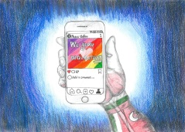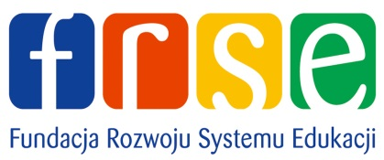

Marki, 12.05.2021r.

Letter of Invitation

Whitin the framework of ERASMUS+KA229 Project application 2018-1-IT02-KA229-048037_4 titled "Cresciamo digitalmente-We grow digitally", we are glad to invite the representatives of the project partners from the Bulgarian Institution, IV Osnovno Uchilishte Dimcho Debelianov - Bulgaria, to the Polish online meeting in Marki which will be held from 17th of May 2021 to 21st of May 2021.

Teachers:
- Iliyan Georgiev Chapkanov
- Elena Dimitrova Malinovska
- Rosica Severinova Chausheva
- Sashka Liybenova Karlikova
- Monika Plamenova Petrova
- Nina Vaskova Nedkova-Vodenicharova
- Elena Georgieva Popova
- Kamelia Sasheva Krasteva
- Tsvetomira Antova
- Anna Borislavova Tsvetkova
- Spas Atanasov Gegov
- Desislava Kostadinova Aleksandrova
- Tanya Ivanova Filipova
- Mihaela Stamboliyska
- Daniela Boeva
- Tanya Valentinova Tagareva

Students:
- Angel Alexander Garkov
- Biliana Svetlinova Spasova
- Valentin Stanimirov Kostadinov
- Valentina Assenova Velinova
- Ventsislav Nikolaev Nikolov
- Victoria Viktorova Urdarska
- Gergana Evgenieva Ilieva
- Denis Ivaylov Novoselski
- Denislav Stoyanov Vachkov
- Denitsa Nikolaeva Ivanova
- Dimitar Rosenov Petrov
- Joanna Ivanova Trencheva
- Joanna Vladimirova Rizova
- Kristina Ivanova Yaneva
- Lyubomir Andreev Kremicharski
- Melanie Vladimirova Vitanova
- Nadia Vladimirova Vladimirova
- Stefani Borisova Mitova
- Asya Deshlieva
- Kiril Ravnachki
- Maria Maerkova
- Blagovest Ivanov
- Kamelia Trencheva
- Borislav Vagalinski
- Mihaela Trencheva
- Stefani Borisova
- Dragomir Trenovski
- Nicole Panova
- Ivana Kitanova
- Ivana Maleshevska
- Natalia Assenova
- Ralitsa Velkova
- Vasilena Stoycheva
- Mario Yordanov
- Alexandra Samardzhieva
- Daniel Rumenov
- Dimitar Rumenov
- Stefan Kitanov
- Marina Pencheva
- Joanna Ruzina
- Martin Zabunov
- Lyuboslav Georgiev
- Stilyan Tasev
- Angela Angelova
- Ventsislava Grancharova
- Victoria Stoilkova
- Desislava Stamenova
- Dimana Daleva
- Katerina Bezhanska
- Konstantin Velichkov
- Albert Voyvodov
- Valentin Stankov
- Ivan Dimitrov
- Stephanie Petrova
- Georgi Ravnachki
- Eva Jen Barkley
- Gabriela Angelova
- Georgi Novoselski
- Monica Valeova
- Simona Davuliyska
- Stella Stoyanova
- Hristian Bukodolski
- Joan Danov
- Alexander Blagoychov Georgievski

Headmaster: Danuta Pazikowska

