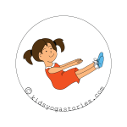 | LADJA:  (Balance on your buttocks with your legs up. Then rock in the water like a boat.)
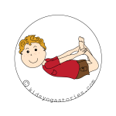 | RIBA:  (Lie on your tummy, bend your knees, lift your chest, reach your arms back towards your toes, and hold onto your feet.)
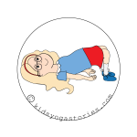 | MOST  (Lie on your back with your knees bent and your feet flat on the ground. Rest your arms down alongside your body, tuck your chin into your chest, and lift up your buttocks and back to create a bridge.)
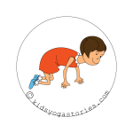 | MUCA:  (On all fours, round your back, and tuck your chin into your chest.)
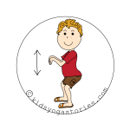 | STOL:  (Stand tall in Mountain Pose with your feet hip-width apart, bend your knees, and hop like a kangaroo.)
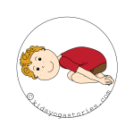 | OTROK:  (Sit on your heels, slowly bring your forehead down to rest in front of your knees, rest your arms down alongside your body, and take a few deep breaths.)
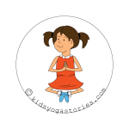 | METULJ:  (Sit on your buttocks with a tall spine, bend your legs, place the soles of your feet together, and gently flap your legs like the wings of a butterfly.)
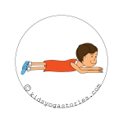 | KOBRA:  (Lie on your tummy, place palms flat next to your shoulders, press into hands, lift head and shoulders off ground, and hiss like a snake.)
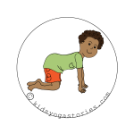 | KRAVA:  (On all fours, look up, arch your back, and open your chest.)
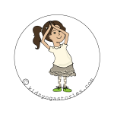 | ŽIRAFA:  (From Mountain Pose, reach your arms up high over your head, bringing your palms together. Tilt your upper body to one side. Come back to center. Tilt your body to the other side.)
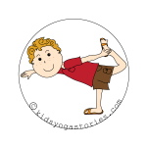 | PLESALEC:  (Stand tall in Mountain Pose, stand on one leg, reach the opposite leg out behind you, place the outside of your foot into your hand, bend your torso forward with your arm out in front for balance, and arch your leg up behind you.)
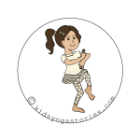 | PLESALEC Ganesha:  (From Tree Pose, release your right foot and take it out in front of you, with a bent right knee. Bring your hands out in front of you and hold your hands like the trunk of Ganesha, the elephant god.)
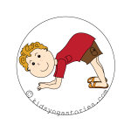 | DELFIN:  (On your hands-and-knees, bend your elbows, rest your forearms on the ground, with your palms flat, lift up your knees to straighten your legs, and look forward.)
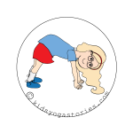 | KUŽA  (Step back to hands and feet, buttocks up in the air, and walk like a bear.)
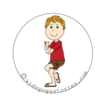 | OREL:  (Stand tall in Mountain Pose, wrap one leg around the other, bring your bent arms out in front of you, wrap your arms together the opposite way, and slightly bend your knees. Perch on a tree like an eagle.)
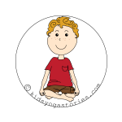 | POČIVANJE:  (Sit comfortably cross-legged, and rest your hands on your knees.)
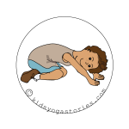 | ŽELVA:  (Sit on your heels, slowly bring your forehead down to rest in front of your knees, place the palm of your hands flat out in front of you, and take a few deep breaths.)
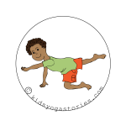 | TIGER:  (Come to all fours, extend one leg out behind you, and look forward.)
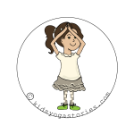 | POZDRAV SONCU:  (Stand tall in Mountain Pose, look up, and reach your arms up to the sky.)
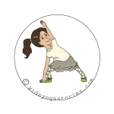 | JADRNICA:  (From Triangle Pose, bend your front leg, rest your front elbow on your thigh, and reach your other arm straight up high to the sky. Look up. Repeat on the other side.)
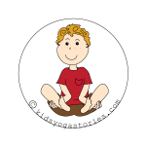 | ROŽA:  (Come to sit on your buttocks with a tall spine, lift up your legs, balance on your sitting bones, touch the soles of your feet together, and weave your arms under your legs.)
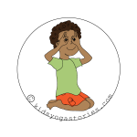 | LISICA:  (Sit on your heels, with both hands in A-Okay sign over eyes to look like the badger’s eyes.)
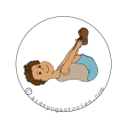 | HROŠČ:  (Lie on your back with your chin tucked in, hug your knees into your chest, then grab the outer part of your feet with both of your hands, and rock like a happy baby.)
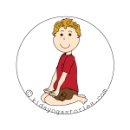 | ČEBELA:  (Come back to rest upright on your heels, and twist your upper body like an owl. Turn your upper body one way and then the other.)
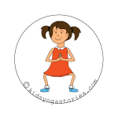 | KONJ:  (Stand with your legs apart, feet facing slightly outwards, bend your knees, and stand firm like a horse.)
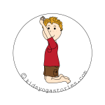 | PINGVIN:  (Stand on your knees, open your chest, look up, and reach up to the moon like a fox.)
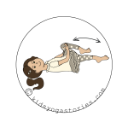 | KOLESARJENJE:  (Lie on your back, with your arms flat alongside your body. Bend your knees and hug them close to your chest. Then circle your legs as if you are riding a bicycle upside-down.)
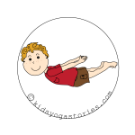 | MORSKI PES:  (Lie on your tummy, lift your chest and shoulders up, look up, clasp your hands back behind you, and glide through the water like a shark.)
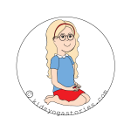 | Lotus Mudra:  (Sit on your heels, stretch fingers out in front of you, and place heels of palms together in mudra to represent spines of hedgehog.)
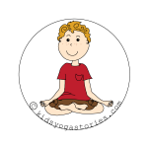 | Lotus Pose:  (Sit with a tall spine, cross your legs, and rest the palms of your hands on your knees. Relax and breathe.)
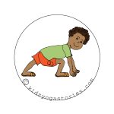 | TEKAČ:  (From Downward-Facing Dog Pose, step your right foot forward to rest on the inside of your right hand. Keep a flat back, and open your chest. Switch sides.)
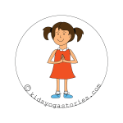 | GORA:  (Stand tall with legs hip-width apart, feet facing forward, and straighten your arms alongside your body.)
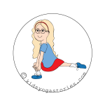 | GALEB:  (From Downward-Facing Dog Pose, bring right knee to rest behind right hand, placing right foot slightly inwards, and perch like a bird.)
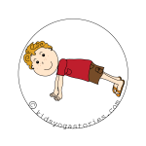 | KROKODIL:  (Balance on your palms and on your bent toes, keeping your arms straight, and your back long. Pretend to be a surfboard gliding through the water.)
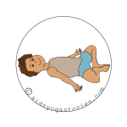 | POČIVAJOČI METULJČEK:  (From lying on your back, bend your legs and bring the soles of your feet together. Take your arms out to rest at your sides. Let your whole body melt into the ground and take a few deep breaths.)
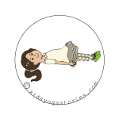 | OBLAK:  (Lie on your back with your arms and legs stretched out. Breathe and rest.)
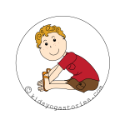 | HOBOTNICA:  (Come to sitting on your buttocks, with your legs straight out in front of you. Bend your torso forward while keeping your spine straight. Dangle your arms in front of you like the tentacles of an octopus.)
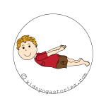 | PLAVALEC:  (Lay flat on your tummy, lift up your shoulders, and clasp your arms behind your back.)
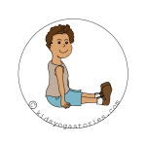 | VLAK:  (Sit with a tall spine with your legs straight out in front of you. Use your hands to mimic the wheels of the train going around and around.)
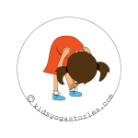 | SLAP:  (From Mountain Pose, bend your upper body, reach for your toes, and sway your arms like a jellyfish.)
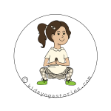 | OPICA:  (Come down to a squat, and waddle like a duck.)
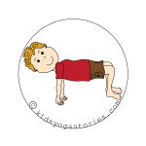 | MIZA  (Come to sitting with your palms flat behind you and the soles of your feet flat in front of you. Lift your buttocks to create a table, then walk like a crab.)
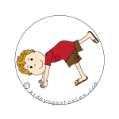 | KUŽA:  (Step back to hands and feet, like an upside-down “V”, and gently lift one leg up at a time.)
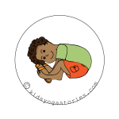 | ŽELVA  (Sit on your buttocks with your knees bent and your feet flat on the floor. Then take your feet out wide and be sure you are sitting with a tall, straight spine. Slide your arms under your knees and place your hands flat on the floor outside your legs. Bend forward, keeping your back and neck straight.)
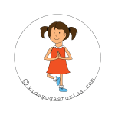 | DREVO  (Stand on one leg, bend your knee, place the sole of your foot on your inner thigh, and balance. Sway like a tree.)
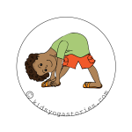 | ZEBRA  (From Mountain Pose, take your right foot back, keeping your ankle bent at a 30 degree angle. Place your hands on your hips, ensuring that your back is flat and that you are looking straight ahead. Then slowly bend forward as if your hips are a hinge, keeping a flat back and a long neck. Lastly, bring your hands to your shins, ankles, or the ground, depending on what feels comfortable, all the while checking that your spine is straight.)
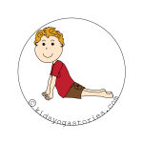 | MORSKI LEV  (Lay on your belly. Place the palms of your hands next to your shoulders and look up. Then straighten your arms and expand your chest.)
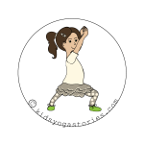 | BOJEVNIK 1  (Come to standing in Mountain Pose. Step one foot back, slightly angling it outwards, bend your front knee, and bring your arms straight up towards the sky, and look up.)
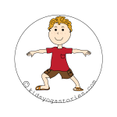 | BOJEVNIK 2  (From standing position, step one foot back, placing the foot so that it is facing slightly outwards. Take your arms up in parallel to the ground, bend your front knee, and look forward.)
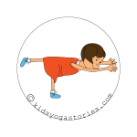 | BOJEVNIK 3  (Stand on one leg. Extend the other leg behind you. Bend your torso forward and take your arms out in front of you to pretend that you are gliding through the water like a submarine.)
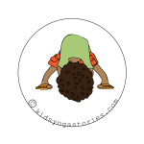 | SLON  (From Mountain Pose, step your feet out wide, bend your upper body, clasp your hands together, and pretend that your arms are the trunk of an elephant.)

