***Wonders of Nature*** - eTwinning project

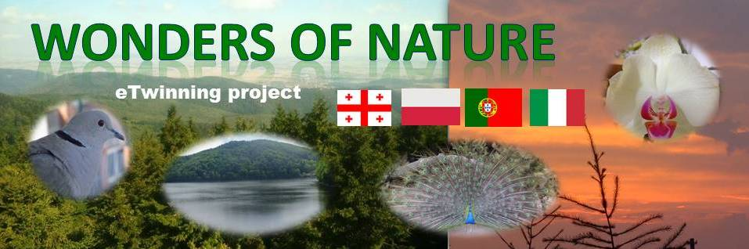

Translate the names of the birds into your language.

|  |  |  |  |  |  |
| --- | --- | --- | --- | --- | --- |
|  | English | Georgian | Italian | Polish | Portuguese |
| kos wiosna.jpg | blackbird |  |  |  |  |
| P1060306.JPG | collared dove |  |  |  |  |
| P1130832.JPG | common raven |  |  |  |  |
| DSCF4961.JPG | jackdaw |  |  |  |  |
| DSCF5291.JPG | owl |  |  |  |  |
| DSCF4393.JPG | sparrow |  |  |  |  |
| DSCF1608.JPG | starling |  |  |  |  |
| P1120013.JPG | swallows, martins |  |  |  |  |
| DSCF6638.JPG | great tit |  |  |  |  |
| DSCF5534.JPG | Euroasian blue tit |  |  |  |  |
| gołąb3.jpg | town dove |  |  |  |  |
| jemiołuszka 5.jpg | waxwing |  |  |  |  |
| dzieciol.png | woodpecker |  |  |  |  |