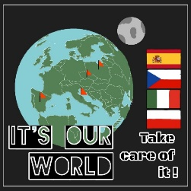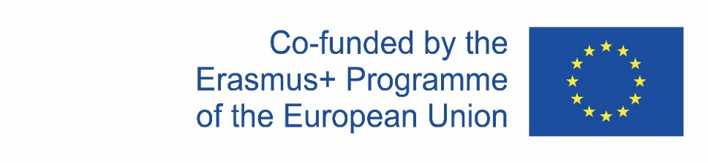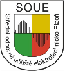
Erasmus+ KA229 - School Exchange Partnerships
Project Nr: 2019-1-CZ01-KA229-061106
Activity Climate action, Zero hunger
November 28 – December 4, 2021 Poland

First day November 28
The journey from Pilsen to Poland, Poznan started in the morning. We travelled by cars. Late in the afternoon we arrived at the hotel in Poznan. After dinner we met other two groups from Spain and Italy.

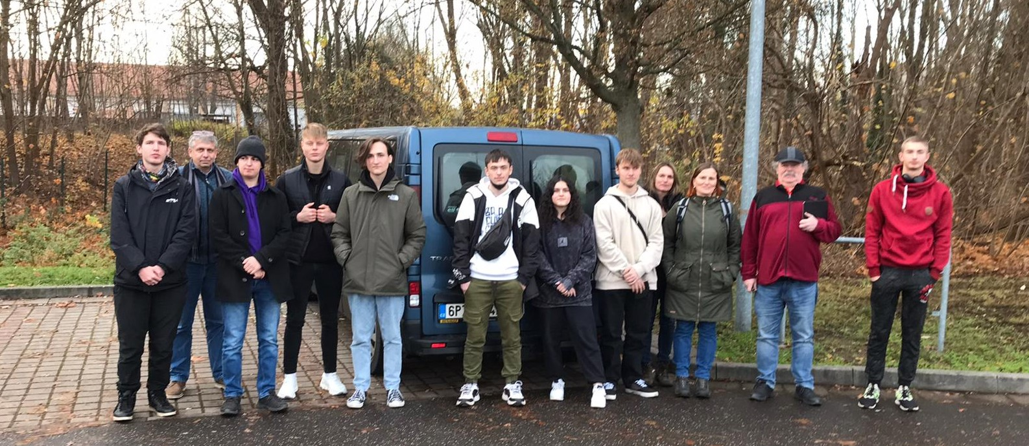
2nd day November 29
In the morning we were welcomed by the teacher from Poland. We all walked to school where we were greeted by the headmaster Lechoslaw Rybka. The program officially started by introducing all teachers. There was also an interview with local TV. Polish teachers prepared some ice- breaking activities for the students to get to know each other better.
While there was the teachers ‘meeting in the headmaster´s office the students were divided into four international mixed groups to work on different tasks.
Then we all had lunch in the school dining hall.
In the afternoon we went to Poznan city centre where students participated in an activity called City Hunting Game. In their mixed groups and with the help of a map they were supposed to complete some tasks about historical sights of the city.
After a short break at Christmas market we were given a guided tour by Polish students to see and admire the most interesting places in the town centre such as Imperial castle, Mickiewisza square, Liberty square and Enigma exhibition.
Then we got back to the hotel. We played kahoot with our Czech students to find out how well they know the Polish vocabulary.
After dinner some students enjoyed their free time in the hotel pool.
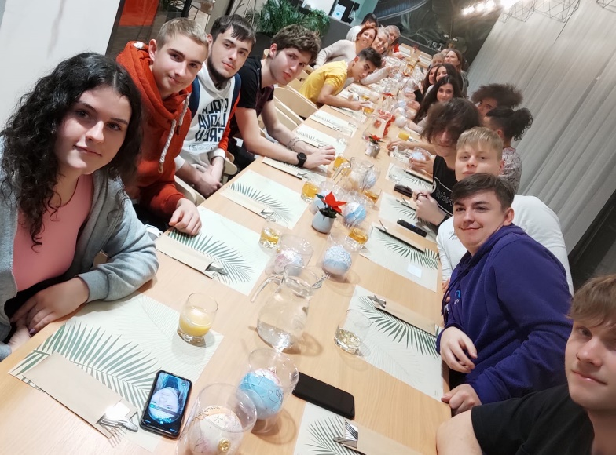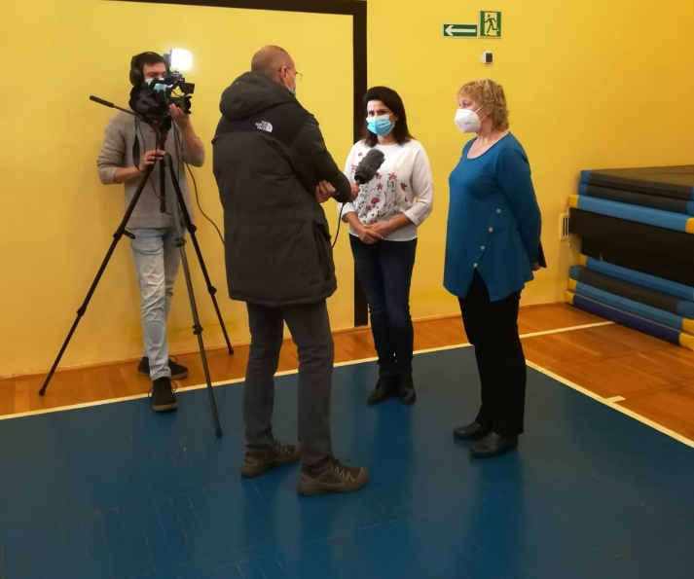
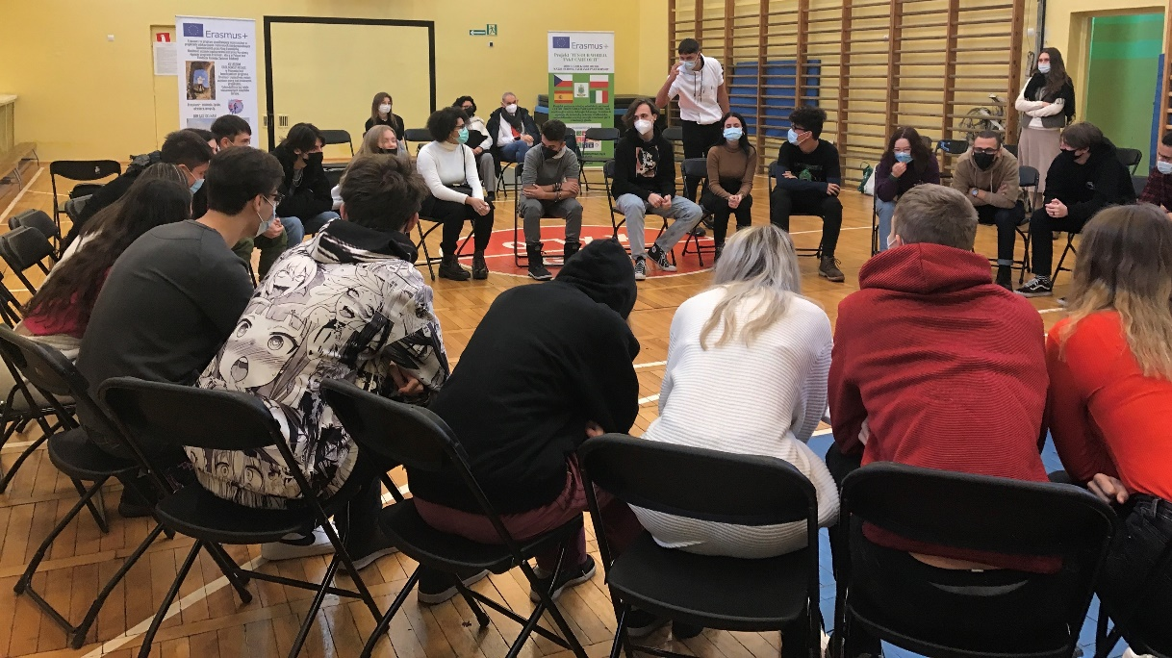
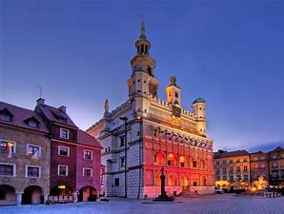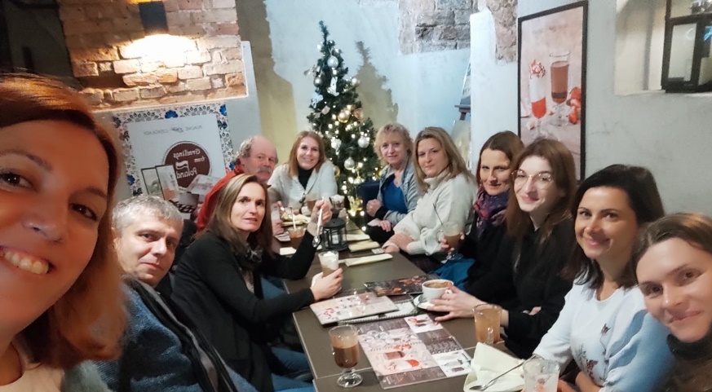

3rd day November 30
We had to get up early to get to Gniezno a town where a traditional Christmas Glass Ball factory is located. After seeing all steps of making glass balls the students divided into mixed groups could also try to make their own Christmas decoration
Then we got on the bus and went back to Poznan to visit Poznan University of Life Science. There we were given an interesting lecture by famous professor Olejnik about climate change and global warming. After that we moved to other parts of the university to see a laboratory with 3D printer and a local plant using methan gases. (renewable energy)
To refresh a bit we stopped at university cafeteria to buy some snack.
Later we walked to Lumina and Dendrological Park. Because of the darkness we could enjoy both the old trees and lighted objects such as fairy-tale characters, animals and scary figures. The connection of wild nature and modern technology made the atmosphere magical.
The day ended with the dinner in our hotel together with Spanish and Italian students. 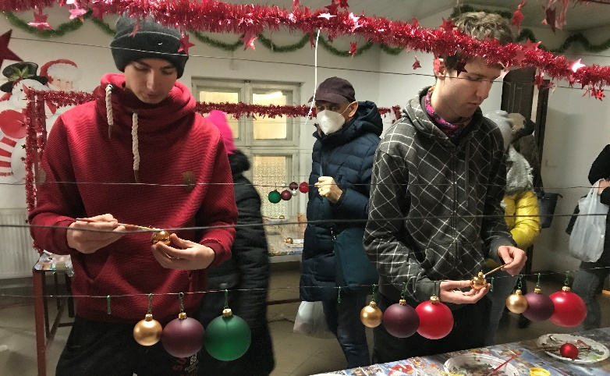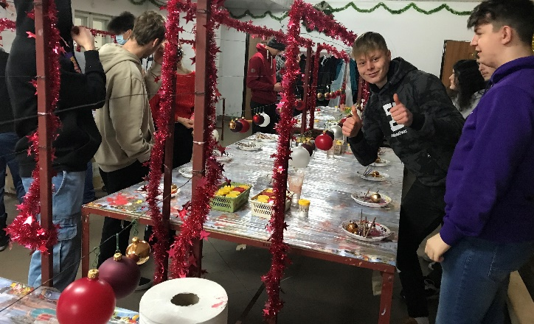
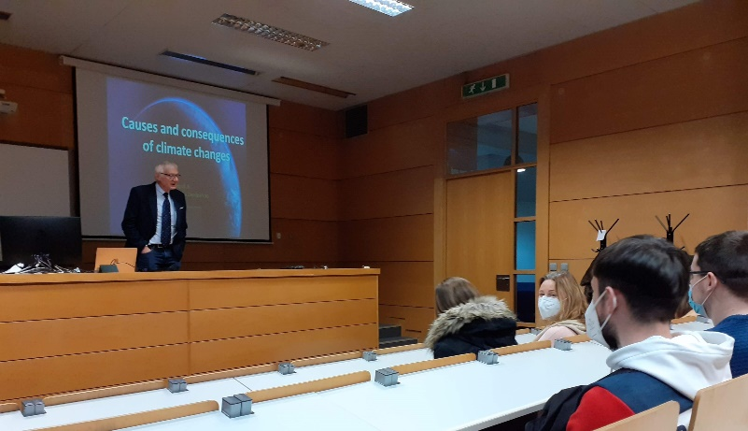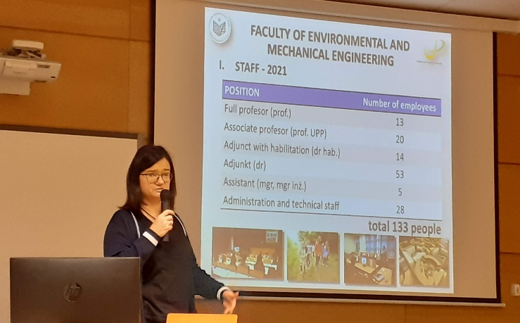
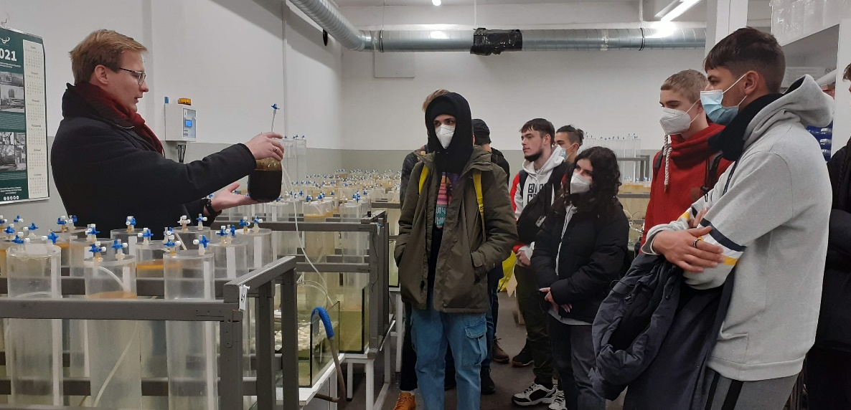

4th day December 1
In the morning we went to school to enjoy the presentations, students made some time ago. All schools presented their regions, their school and their presentations about our project’s topics, such as global warming, climate change, endangered species and zero hunger. All the students from all countries tried to do their best to present their outcomes.

Despite heavy rain, we enjoyed the day in the city centre, visiting Poznan Croissant Museum. In fact, it was an interactive show, where we could learn something about the history of Poznan, about the local dialect and most importantly how to bake the local speciality St. Martin’s Croissants. During this show, from the windows, we could see one of the tourist attractions of Poznań. The mechanical goats' butting display takes place every day at 12:00 on the tower of the Poznań City Hall. At the end of the funny show, everyone could get a certificate and we could taste this sweet pastry.

In the afternoon we all moved to the oldest part of Poznan- Ostrow Tumski Island. There we visited museum Porta Poznania and the cathedral.

On the way back to our hotel we stopped at the biggest shopping centre in Poland.

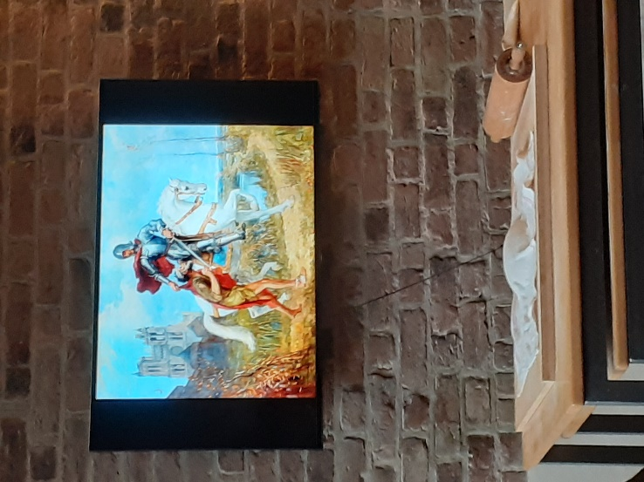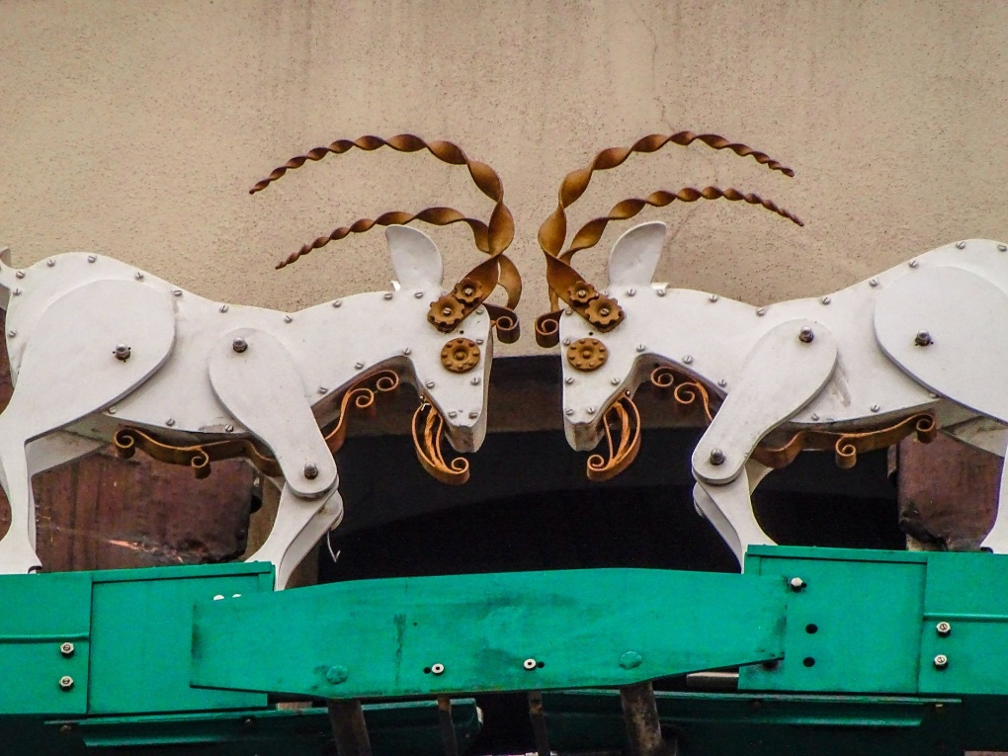

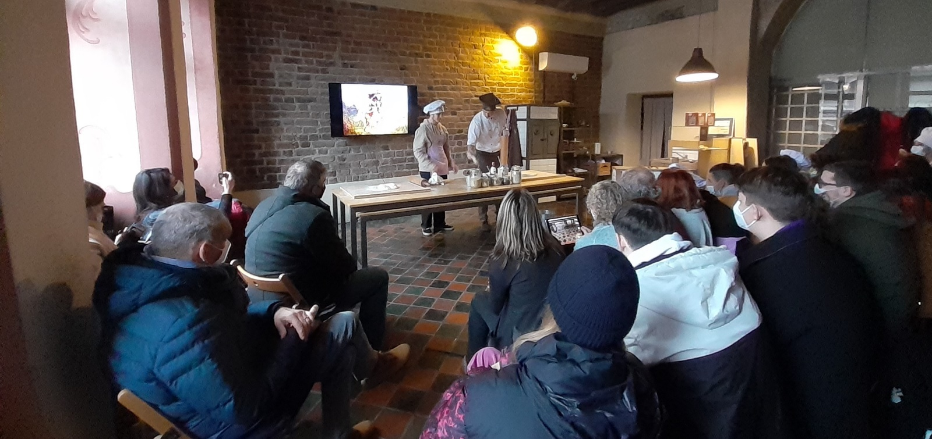

5th day December 2

We woke up at six to get on the bus and go to Torun city. The journey was 200 km long. On the way we made one stop in Strzelno where the oldest church of Poland is located. The church includes historical Roman pillars with sculptures of good and evil.

At about 11.a.m. we finally got to Torun. Our city tour started with the exhibition at the living museum of gingerbread.

In the afternoon there was prepared a visit to Planetarium. We could enjoy three different events there. First, we entered the Geodium with an interactive task about the Earth. Then we moved to Marse base where we could try the simulations of living on Mars. Students used IT to see how life on Mars is going. In the end we went to Planetarium. We watched a film about stars and other planets of the universe.

After that we had some time to do short sightseeing in the historical centre and enjoy the Christmas atmosphere there.

We ended our long day with the dinner in our hotel late in the evening.

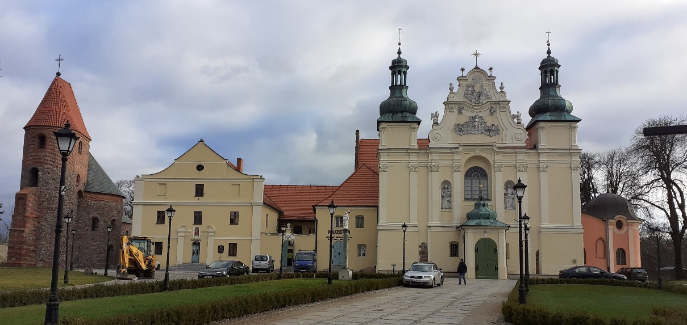

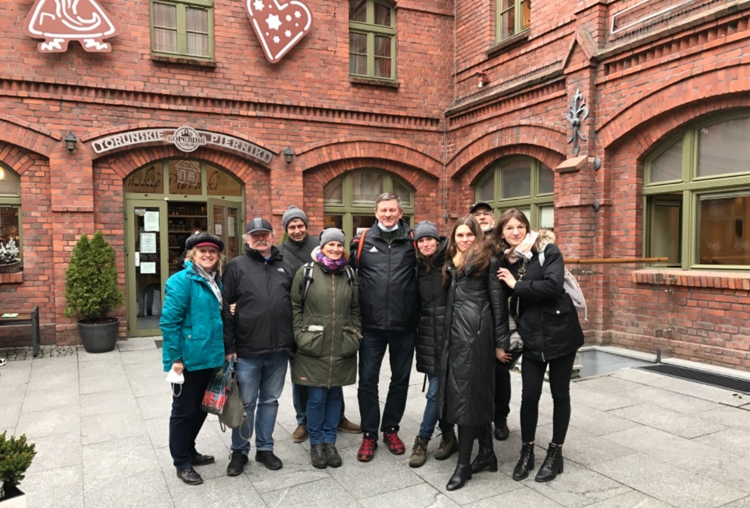

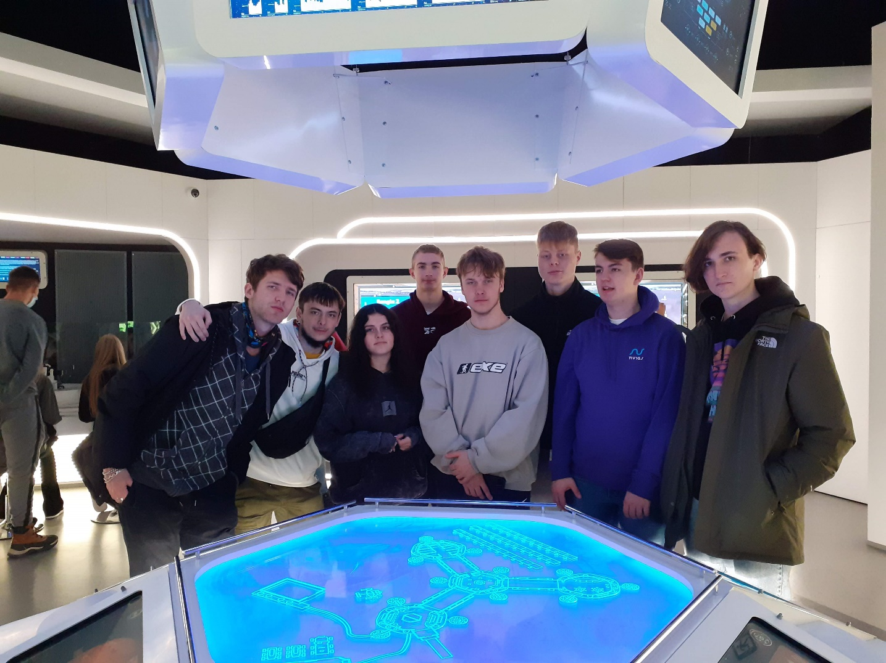

6th day December 3

All students and teachers met at school again. First, we voted to choose the project´s logo.

While there was a teachers´ meeting discussing the next two mobilities students took part in a workshop. They designed their Erasmus shopping bags.

The last part of this mobility was closing ceremony. All students and teachers were given certificates. Then we evaluated the whole week and thanked the organizers.

