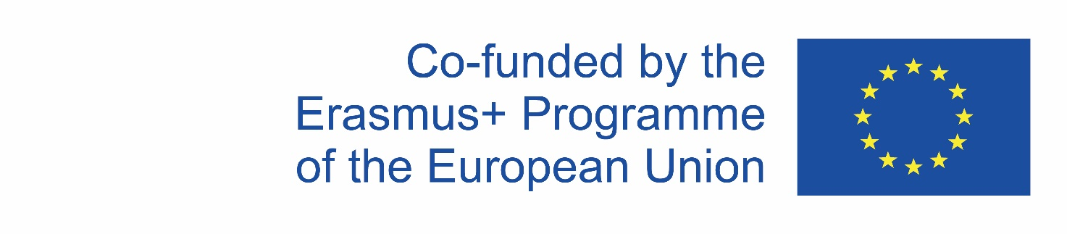

**2019-1-CZ01-KA229-061106 _1     It´s our world - take care of it**

Newsletter No. 1 October 2019

Content:

|  |
| --- |
| **Our project**  Data and facts  Our aims  Partners |
| **Events**  1st meeting in Plzeň, the Czech Republic |
| **Results**  Schools’ webpage  [www.souepl.cz](http://www.souepl.cz)  [www.greguerias.com](http://www.greguerias.com)  [www.itcgtursi.gov.it](http://www.itcgtursi.gov.it)  <http://xxlopoznan.edu.pl/>  Erasmus corners  e-twinning / Twinspace |

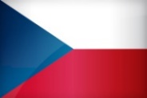  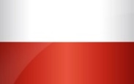 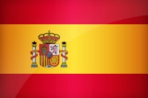

 **2019-1-CZ01-KA229-061106 _1 It´s our world - take care of it**

|  |
| --- |
| Data and facts  In September 2019 started our common Erasmus + Project: “ It’s our world-take care of it”  Partners from 4 schools in Europe (Czech Republic coordinator and Italy, Poland ,Spain) will work together in order to discover the impact of human activity on our planet, and show all participants what they can do to ensure a sustainable future for everybody.  You will find more information about the partner schools in this newsletter. |

|  |
| --- |
| Our aims  For this project we were inspired and motivated by Sustainable Development Goals (further SDGs) which are a collection of 17 global goals set by the United Nations General Assembly in 2015. The SDGs are part of Resolution 70/1 of the United Nations General Assembly: "Transforming our World: the 2030 Agenda for Sustainable Development."  From the 17 goals we chose: Affordable and Clean Energy (Czech Republic), Gender Equality (Spain), Clean Water and Sanitation, Life Below Water (Italy), Zero Hunger, Climate Change (Poland) Action and Partnerships to achieve the Goal.  We'll learn about sustainable development in terms of decisions which can affect the future. We will learn about development, sustainability and sustainable development.  We'll explore the ways in which the future may be different if we act now in the present. |

   

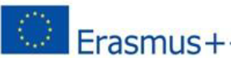**2019-1-CZ01-KA229-061106 _1 It´s our world - take care of it**

|  |
| --- |
| **Partners** |
| Stredni odborne uciliste elektrotechnicke, Plzen, Czech Republic  Our school has about 40 teachers of theoretical subjects and 30 teachers of practical training. School  programmes: 3 - year vocational programs of electrical engineering, 4 - year secondary branches -  electrical engineering, telecommunication and information technology. In school curriculum you can  find theoretical and practical special subjects which lead to their future professions but also general  subjects like languages, mathematics, history etc. which form student general education and  knowledge. Our students study at least one foreign language - English or German. |
| ITSET “Manlio Capitolo”Tursi Italy  It was founded in 1973, since then it has been a driving force in the social and economical life of Tursi and of the rural surrounding area. It is a technical school that covers four fields: -Administration, Finance & Marketing - Tourism -Building & Environment –Information Technology. Teachers team is composed of lawyers, engineers, architects, consultants who bring their updated advanced training as professionals in this school and, depending on the subject, they can manage any international project with their expertise. |
| Liceum Ogolnoksztalcace Poznań Poland  The school gathers students (15-19). There are about 450 students and 60 teachers. There are different profiles of the classes, such as: sports, IT, art and drama, journalistic, language/psychological. Sports classes master their profession in football, handball, volleyball and have been awarded many top prizes especially in basketball. Students are taught four different languages : English, German, Spanish and French. After lessons students can choose among 10 different clubs in which they can develop their interests. |
| Centro de Enseñanzas Greguerias Sociedad Cooperativa Andaluza, San Sebastian, Spain  Greguería is a Secondary School in a rural area near the capital city of Córdoba. The school has a  lot of facilities for pupils, such as a library and a playground, each lesson is taught in a well-equipped  classroom. The school tries to engage students into the school’s projects to induce their motivation broaden their horizons and diminish social exclusion. Numerous school events are organized every year to help pupils such as :Eco-school, Coeducation, Library program, Chess program |

   

**2019-1-CZ01-KA229-061106 _1 It´s our world - take care of it**

|  |
| --- |
| **Events**  1st meeting in Plzen, Czech Republic 14th-18th October 2019 |
| The first transnational meeting took place in Plzen at the coordinator’s school.  One of the aims of this meeting consisted in knowing each other, to become acquainted to the project and to discuss important issues of the project. Presenting Sustainable Development Goals (SDGs) C:\Users\x\Desktop\goals.png  Ways of producing energy in the CR with a lecturer from CEZ (energy company).  Discovering ways of producing energy in project partner countries.  Workshops on affordable and clean energy, saving energy, writing a common dictionary related to energy.  Visiting small power plant on the  river Vltava – Štvanice and the water power plant Vydra  During the meeting there were a lot of working sessions but there was also the time to visit cultural sites  castle Velhartice - Unesco heritage and Prague  Eventually, there was the evaluation of the first mobility and it was planned the next learning activity in Poland. Partners decided to start an etwinning project so students can get in touch on the common TwinSpace platform. |

