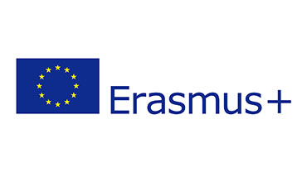

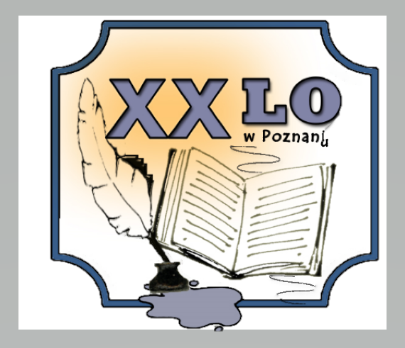
Project Number : 2019-CZ01-KA229-061106
Project Name : “It’s our world, take care of it”
LTT Dates : 29th Nov -3rd Dec 2021

Event host organization: XX Liceum Ogólnokształcące
Os. Wichrowe Wzgórze 111, 61-699 Poznań, Poland
Tel. +48 61 820 82 03

THE WORKING PLAN OF LEARNING TEACHING TRAINING ACTIVITIES

Sunday,  28 of Nov 2021 |  | Arrival of Participants | Poznań
Monday,  29th November | 9:00 -  12:00 | Meeting at the school  Opening activities, speech of headmaster, presentation of the school | Poznań,  XX LO
Students - Ice Breaking Activities in mixed international groups
Students give their presentations about climate change and zero hunger topics

 | 12:00 | Lunch at the school canteen
 | 13:00-  16:00 | Poznań city tour – a visit to the oldest part of Poznań – Ostrów Tumski Island, museum Porta Posnania, the catherdral | Poznań  https://bramapoznania.pl/en/
 | 16:00- 18:00 | Sightseeing Old Market Square | Poznań
 | 19:00 | Dinner at the hotel
Tuesday,  30th November | 8:00 | Trip to Christmas Glass Ball Factory | Poznań
 | 12:00 | Meeting at school. Students give their presentations about climate change and zero hunger topics  Lunch at the school canteen | Poznań, XX LO
 | 14:00  17:00 | A visit to Poznań University of Life Sciences – lectures and workshops | Poznań University
 | 17:00-18:30 | Lumina Park Poznań – a visit to the Dendrological Park | Poznań University
 | 19:00 | Dinner at the hotel | Poznań
Wednesday,  1st  December | 10:00-  13:00 | Poznań Croissant Museum  Old Market Square | Poznań
 | 12:00 | Goats at Poznań City Hall | Poznań
 | 12:30-17:00 | Poznań City Hunting Game  A visit to Imperial Castle Poznań, Enigma exhibition, Mickiewicza Square, Liberty Square | Poznań
 | 18:00 | Dinner at the hotel
 | 19:00 | Integration - Bowling Game
Thursday,  2nd December | 7:30 | Departure for Toruń City – sightseeing  A visit to Planetarium | Toruń  www.planetarium.torun.pl
 | 13:00 | Lunch at the city centre | Toruń
 | 14:00-17:00 | The living museum of gingerbread | Toruń www.muzeumpiernika.pl/en
 | 20:00 | Dinner at the hotel | Poznań
Friday,  3rd  December | 9:30-  12:30 | Art workshop at the school – designing your Erasmus shopping bag | Poznań  XX LO
 | 12:00 | Lunch at the school canteen | Poznań
 | 13:00 | Closing Ceremony, Certificates, LTT report, evaluation of the mobility | Poznań
 | 14:30-  18:00 | A visit to Stary Browar Cultural and Shopping Centre, Półwiejska Street, Stary Marych | Poznań
 | 19:00 | Farewell dinner

Headmaster of the school: ____________________________________________
Lechosław Rybka

Remark: The schedule might be prone to some changes, due to waiting times in the museum, transport situations or some other organizational circumstances so slight changes to the schedule should be therefore taken into consideration.

