My Name is BERKO
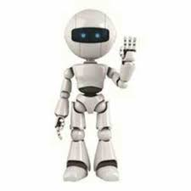
My robot can do everythings
His name is BERKO
Becaouse I did it.
And I love it

