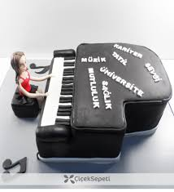

I like play piano.
My dear freind is my piano.
When I need its , it always with me.

