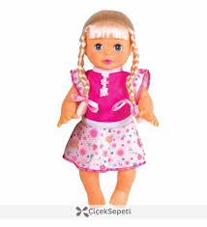

MY SWEEY DOLLY
I LOVE YOU VERY MUCH
YOU ALLWAYS WİTH ME…….

ELA NİDA YARIM
ATATÜRK PRİMARY SCHOOL

