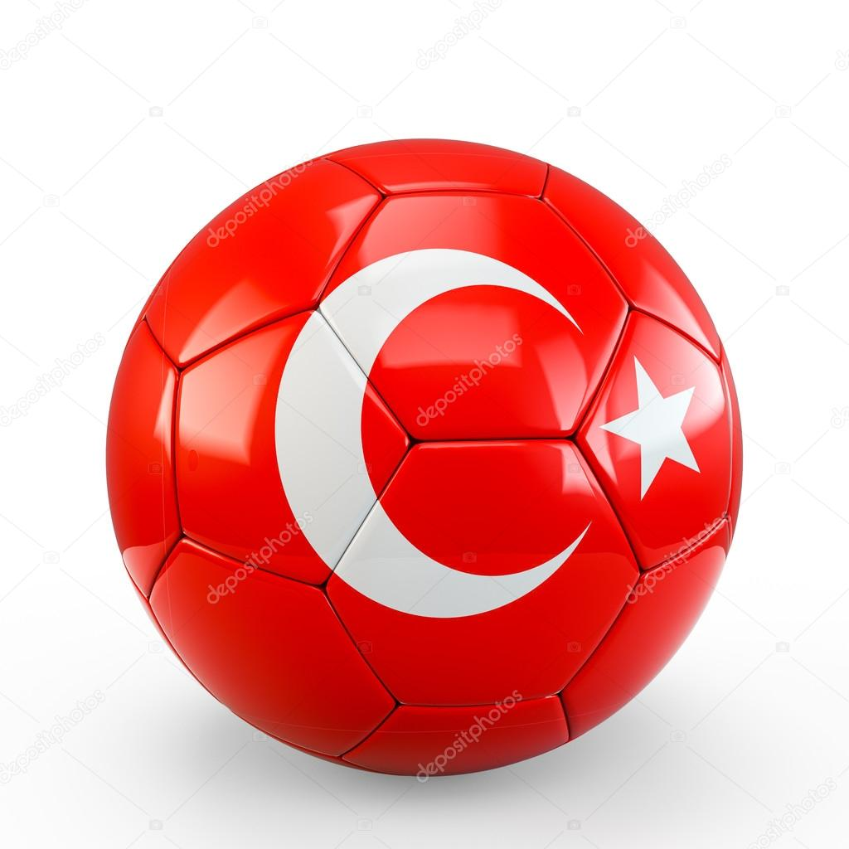

Ball
All my life is football
Love football
Love my ball

