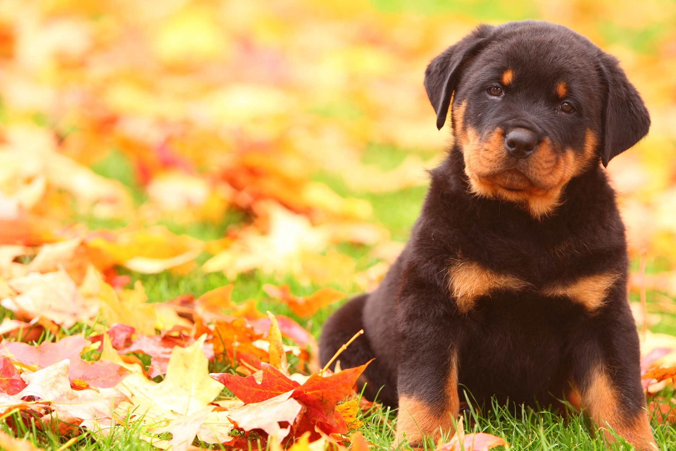

IN LOVE
Two jewells are two tres
Close each other
I feel the breeze
Around our arms
To mix the shadows
In the air
To kiss
To embrace
To be
Green , brown
In love

