MY PET
My dog is BEATIFUL!!!
And she is careful
Her name is TON
And it is small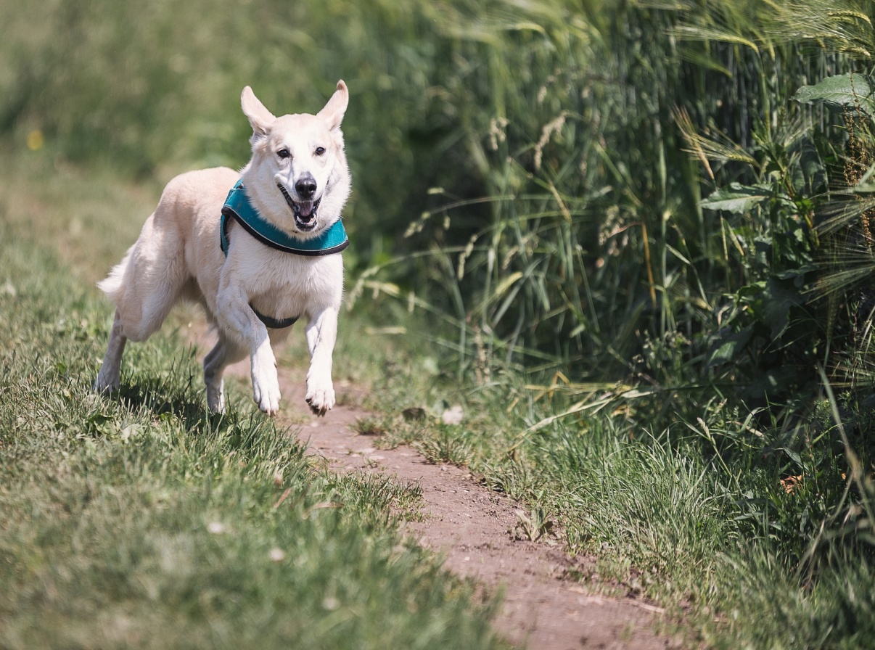
My pet plays in the garden
And he likes to play with my father
And likes eat apples
My pet runs.

AT THE MORNING
At morning
Everything is possible
At the morning
My dream are waiting for me
My morning
Is a new challenge!!!

