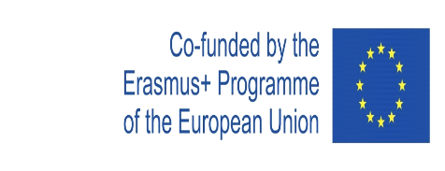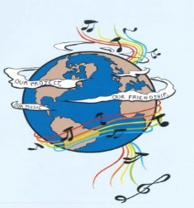
MUSIC: A MELODIC METHODOLOGY INTO TEACHING AND LEARNING
2018-1-ES01-KA229-050761
SCHOOL EXCHANGE PARTNERSHIP

The Evaluation Report for the First Year of the Project’s Implementation
This questionnaire aimed to assess the activities that were carried out during the first year of the project. The questionnaire was conducted by the five partner schools.
The answers were, as follows:
1. In which activities did you participate during the first year of the project’s implementation? ? You may choose more than one variant.
Doing research for the final products -125 respondents | Participating in the dissemination activities-  639 respondents
Devising the final products – 125 respondents | Popularising the project-121 respondents
Participating in the learning, teaching and training activities - 100 respondents | Accessing the information on the project website, Facebook, Twinspace- 489 respondents
Participating in the activities for Erasmus Days- 395 respondents | Reading the information about the project in the school magazine-886 respondents

2. What are the aspects that you considered very important for you, during the project’s first year, as a member of the target group? You may choose more than one variant.
Research-100 respondents | Cooperation and communication between different social groups and ethnicities-639 respondents
Making presentations, posters, charts a.s.o-100 respondents | Learning through inter-disciplinary approaches- 516 respondents
Contributing to the process of making the final products-127 respondents | Improving the participants’ social skills- 616 respondents
Organising activities-113 respondents | Improving the participants’English skills- 608 respondents
Participating in the presentations, workshops with the project results- 619 respondents | Enhancing the participants’ knowledge of the other cultures- 615 respondents
The project targeting at making participants continue their education and diminish social exclusion-639 respondents | Making our school, region and country be known-598 respondents
3. What are the final products from the first year of the project that you consider most interesting and useful for you? You may choose more than one variant.
’Project Logo’-211 respondents | 'Landscape in songs'.- 480 respondents
'Story of music'- 511 respondents | 'Lanscape and Traditional Songs, Dances and Clothing'- 585 respondents
'Songs:not only tunes, but the mentality of a nation'- 620 respondents

4. Taking into account your experience in the project activities during the first year of its implementation, do you think that the activities that were carried out during the first year of the project were interesting?
Yes-  584 respondents | Quite a lot-  65 respondents | Slightly- | No-

5. Taking into account your experience in the project, do you think that through the project’s activities during the first year of the project the participants raised their cultural awareness?
Yes-  580 respondents | Quite a lot-  22 respondents | Slightly-  1 respondent | No-

6. Taking into account your experience in the project, do you think that through the project’s activities during the first year of the project the participants developed their English skills?
Yes- 579  respondents | Quite a lot-  29 respondents | Slightly-3 respondents | No-

7.Taking into account your experience in the project’s activities, do you think that through the project’s activities during the first year the participants developed their ICT skills?
Yes-  521 respondents | Quite a lot-  43 respondents | Slightly-3 respondents | No-1 respondent

8. Taking into account your experience in the project, do you think that through the project’s activities during the first year, the participants acquired the skills and competences that are relevant for
their present and future lives and careers?
Yes-  443 respondents | Quite a lot  22-respondents | Slightly-  5 respondents | No-

9. Were the activities during the first year organised to achieve the project goals?
Yes-  619 respondents | Quite a lot-  19 respondents | Slightly- | No-1 respondent

10. Do you think that students can acquire high and relevant skills for their education and life through a topic like music?
Yes-  543 respondents | Quite a lot-  30 respondents | Slightly- | No-

11. Do you think that the project will have a positive impact on the students and teachers from the five schools?
Yes-  583 respondents | Quite a lot-  48 respondents | Slightly-5 respondents | No-3 respondents

12. Taking into account your experience in the first year of the project, do you think that it important for students and teachers from your school or for schools in general, to implement Erasmus projects?
Yes-  546 respondents | Quite a lot-  25 respondents | Slightly-1 respondent | No-

Taking into account the respondents’ answers, there can be seen that the activities during the first year of the project’s implementation had a positive impact on the participants through their acquisition and development of the high and relevant skills that the project’s objectives targeted at.

"This project has been funded with support from the European Commission. This publication reflects the views only of the author, and the Commission cannot be held responsible for any use which may be made of the information contained therein."

