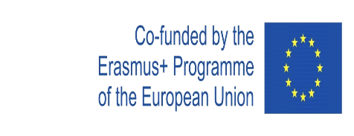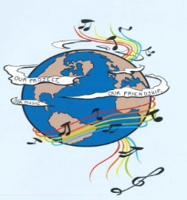
MUSIC: A MELODIC METHODOLOGY INTO TEACHING AND LEARNING
2018-1-ES01-KA229-050761
SCHOOL EXCHANGE PARTNERSHIP

The Evaluation Report for the Second and the Third Year of the Project’s Implementation
This questionnaire aimed to assess the activities that were carried out during the second year of the project. The questionnaire was applied to 65 respondents, both students and teachers from IES Pablo Ruiz Picasso
The answers were, as follows:
1. In which activities did you participate during the second and the third year of the project’s implementation? You may choose more than one variant.
Doing research for the final products -11 respondents | Participating in the dissemination activities-  65 respondents
Devising the final products – 11 respondents | Popularising the project- 25 respondents
Participating in the learning, teaching and training activities that were held physically at the partner’s schools and the in the last virtual meeting that was organised by the Romanian school - 25 respondents | Accessing the information on the project website, Facebook, Twinspace- 25 respondents
Participating in the activities for Erasmus Days- 60 respondents | Reading the information about the project in the school website- 65 respondents

2. What are the aspects that you considered very important for you, during the project second and the third year, as a member of the target group? You may choose more than one variant.
Research-15 respondents | Cooperation and communication between different social groups and ethnicities- 65 respondents
Making presentations, posters, charts a.s.o-15 respondents | Learning through inter-disciplinary approaches- 60 respondents
Contributing to the process of making the final products-15 respondents | Improving the participants’ social skills- 61 respondents
Organising activities-10 respondents | Improving the participants’English skills- 60 respondents
Participating in the presentations, workshops with the project results- 51 respondents | Enhancing the participants’ knowledge of the other cultures- 55 respondents
The project targeting at making participants continue their education and diminish social exclusion- 50 respondents | Making our school, region and country be known-65 respondents
3. What are the final products from the second and the third year of the project that you consider most interesting and useful for you? You may choose more than one variant.
’My musical instrument'- 20 respondents | 'Music unites people'- 51 respondents
'Friendship through Music' -45 respondents | 'Let’s teach our mother tongue to our partners through music'- 61 respondents
’Traditional instruments’- 43 respondents | 'Intercultural communication through music'- 60 respondents
'Music- what and why I listen to'- 35 respondents | 'Songs in the English class' -42 respondents

4. Taking into account your experience in the project’s activities, do you think that the activities that were carried out during the second and the third year of the project were interesting?
Yes-  50 respondents | Quite a lot-  13 respondents | Slightly-  2 respondent | No-

5. Taking into account your experience in the project, do you think that through the project’s activities during the second and the third year of the project the participants raised their cultural awareness?
Yes-  61 respondents | Quite a lot-  3 respondents | Slightly- | No-

6. Taking into account your experience in the project, do you think that through the project’s activities during the second and the third year of the project the participants developed their English skills?
Yes-  52 respondents | Quite a lot-  11 respondents | Slightly-  2 respondents | No-

7.Taking into account your experience in the project activities, do you think that through the project’s activities during the second and the third year the participants developed their ICT skills?
Yes-  59 respondents | Quite a lot-  6 respondents | Slightly- | No-

8. Taking into account your experience in the project, do you think that through the project’s activities during the second and the third year, the participants acquired the skills and competences that are relevant for their present and future lives and careers?
Yes-  54 respondents | Quite a lot-  10 respondents | Slightly-  1 respondent | No-

9. Were the activities during the second and the third year of the project organised to achieve the project’s goals?
Yes-  50 respondents | Quite a lot-  15 respondents | Slightly- | No-

10. Do you think that students can acquire high and relevant skills for their education and life through a topic like music?
Yes-  60 respondents | Quite a lot-  5 respondents | Slightly- | No-

11. Do you think that the project will have a positive impact on the students and teachers from the five schools?
Yes-  50 respondents | Quite a lot-  12 respondents | Slightly-  3 respondents | No-

12. Taking into account your experience in the second and the third year of the project, do you think that it is important for the students and the teachers from your school or for schools,in general, to implement Erasmus projects?
Yes-  51 respondents | Quite a lot-  10 respondents | Slightly-  2 respondents | No-  2 respondents

Taking into account the respondents’ answers, we can see that the activities during the second and the third year of the project implementation had a positive impact on the participants through the acquisition and the development of the high and relevant skills that the project’s objectives aimed at.

"This project has been funded with support from the European Commission. This publication reflects the views only of the author, and the Commission cannot be held responsible for any use which may be made of the information contained therein."

