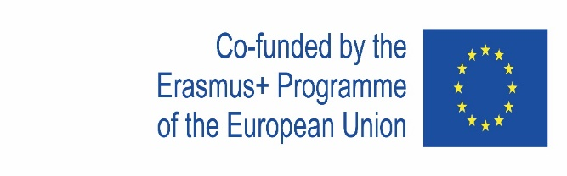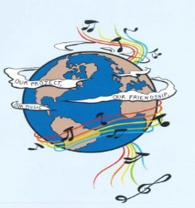

MUSIC: A MELODIC METHODOLOGY INTO TEACHING AND LEARNING
2018-1-ES01-KA229-050761
SCHOOL EXCHANGE PARTNERSHIP

The Evaluation of the 4th LTT Activities organised at Agrupamento de Escolas Penafiel Sudeste, in Penafiel, Portugal,
17th-21st February 2020

This evaluation questionnaire was intended to assess the way the 4th LTT Activities had been unfolded, if the project objectives had been reached, what the participants had learnt, if the teams had prepared the work for the meeting according to what it was supposed to.

1.What did you learn about the partner countries during the project meeting in Penafiel?
I learned that their languages ​​are totally different from each other, and have different customs.
I have Learnd New words and New routines
Their music, their perspective about important things in life, their culture
About their music and the students hobbies
I learnt about all the coltures and also I tried new types of food and liked them. I visited new places and I fell in love with the city of Porto. I learnt some words in Portuguese too.
During the project meeting, about the partner countries I learnt that MUSIC UNITES DIFFERENT PEOPLE
I learnt that we are different
I learned about their authentic culture that has improved the understanding of my own
A new routine, different points of view, different ways of working.
I have learnt new words,some culture and to socialize
I learned that there are many different types of languages ​​and I found the experience to be very interesting
we are all human being who want to improve their knowledge in a friendly atmosphere
I have learnt new words and also how they live and their routines.
During this experience I learnt that despite the differences between all the countries, we can unite with the music.
I learned new usefull piece of information about each country and their taste in music
I learned that we are the same as much as we are different
I learnt that there are many difference between our countries,the food is not so bad,people are cool and that the english will save ourself!
I learnet a lot of things about the european music, about the people and their feelings
I have learnt new words and some culture.
I have learnt new words in different languages, different cultural customs, different ways of thinking, working and most important of all I have learnt to appreciate everyone’s ways of living.
No mundo todo existen diferentes culturas
I learnt that students from different countries have very similar musical tastes in term of English pop music and international bands and
For music, culture and musical tastes
They are nice and kind
we are happy when we can share our cultural heritage and when we can learn from the others
In this meeting I learnt about the others way of living and some things about their countries.
I learnet a lot about the people' s way of express themselves through music
the participants from each country are friendly, tolerant and they want a better future for Europe
I learnt a lot about their music and culture
I learnt that the countries have different musical tastes.
The world have different cultures
I have learned new words and some culture
Their musical preferencies, and that we all feel the same.
For their culture, their music
We are more or less similar. We are all nice people who want the other people' s best.
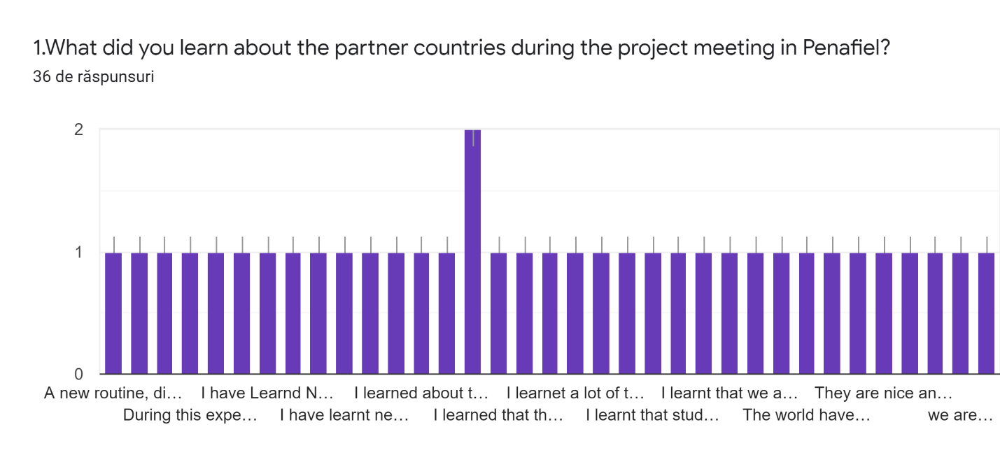
2. Do you think that the five project teams prepared the work for the meeting well ? ( 5- maximum, 1 minimum) *
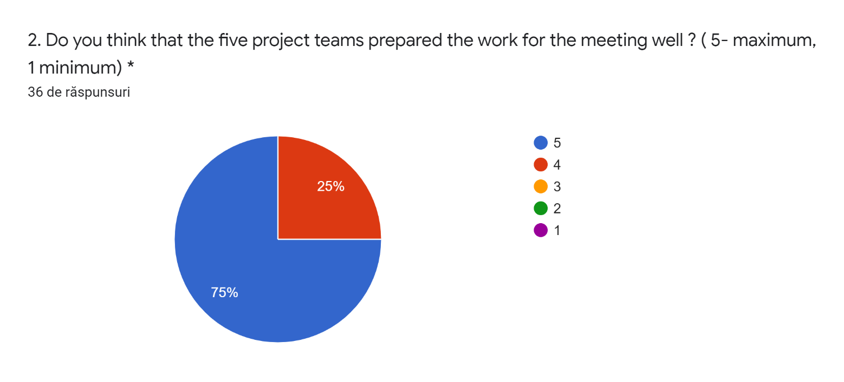
5 -27 answers
4- 9 answers
2-
1-

3. How relevant were the activities for the achievement of the project meeting objectives? ( 5- maximum, 1 minimum)
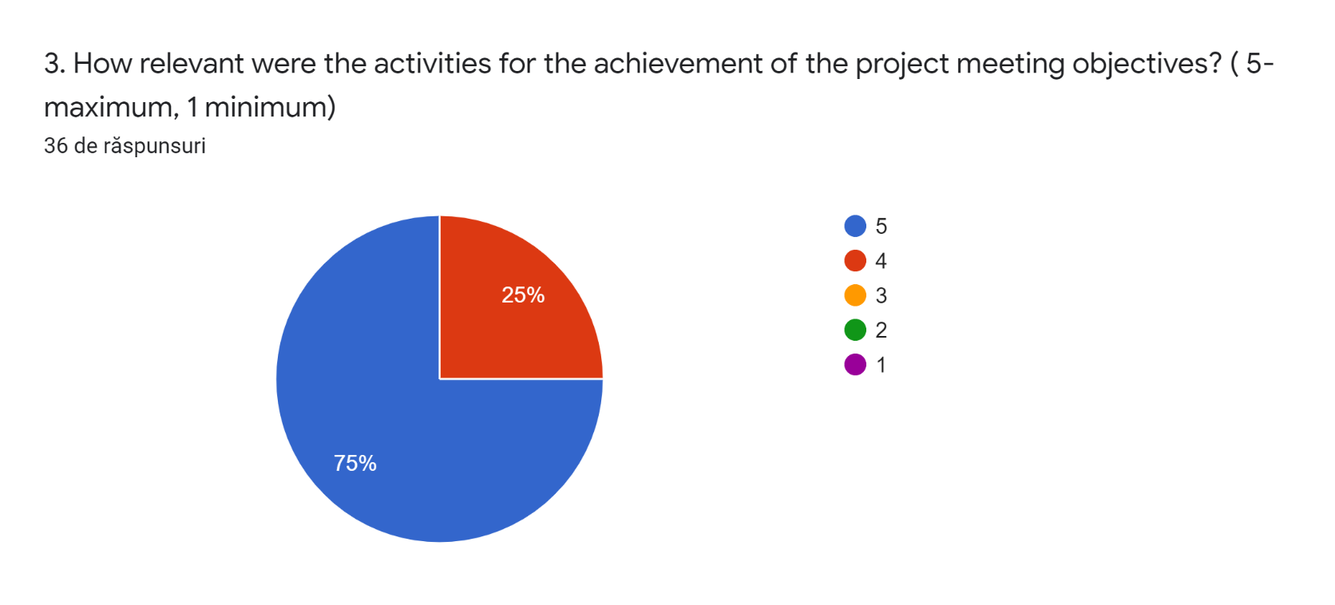
5 -27 answers
4- 9 answers
3-
2-
1-
4. Do you think that the participants achieved the results that the project objectives had targeted at?( 5- maximum, 1 minimum)
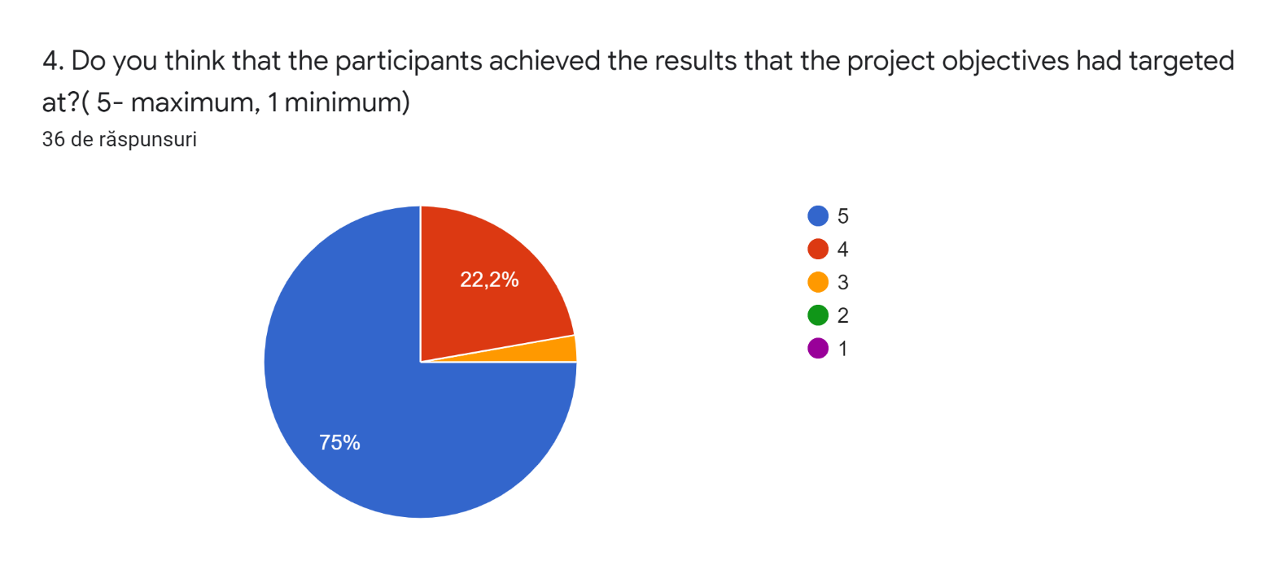

5. How was the general working atmosphere during the meeting? ( 5- maximum, 1 minimum)
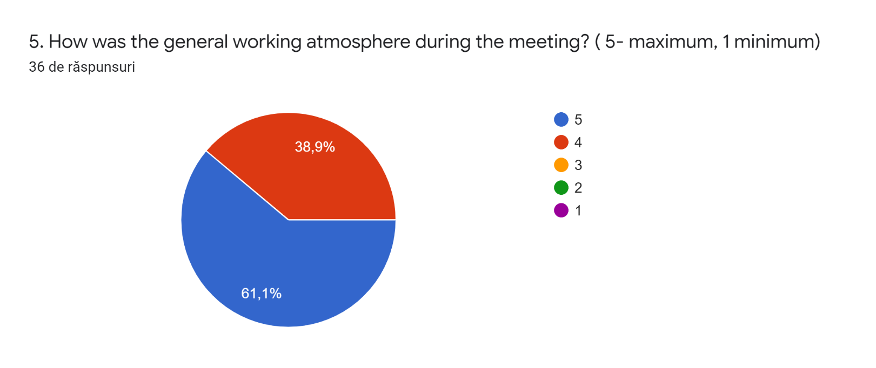
6.Were you satisfied with the accommodation and the facilities? ( 5- maximum, 1 minimum)
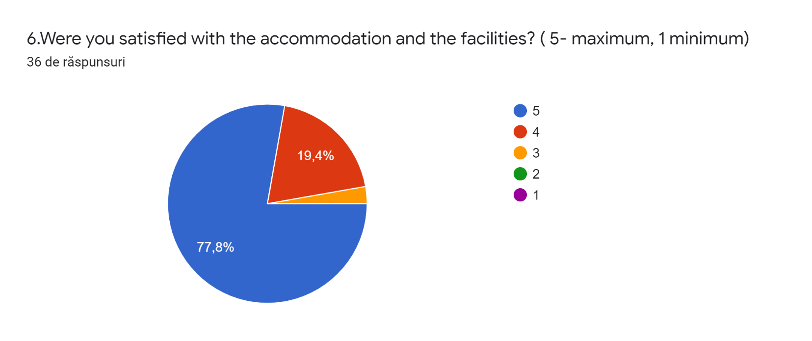
7. What aspects from the meeting did you like most? Explain.
L iked it when all the countries went to sing the songs of their countries and the study visit.
The food and the trips.
The cooperation and the atmosphere between the partners
Communication, sharing competences
I learnd new musics
I liked the most the speaking activities and the trips.
The common activities, the songs, the work team
A parte das Apresentações
I liked students adaptation and flexibility in every occasion in the project
I do liked that I had the chance to communicate and stay with people from a different country
Met new people
The music processing of each group and the way it is presented
I liked that people were friendly
I liked most: the food, the atmosphere and the speak English daily.
The aspect I liked the most was the music workshop.
The communication and the organization of the meeting
The interaction with the rest of the people, the trips and the food.
Having the possibility to know different cities, food, ways of working and people.
The food and the trips
The food and the trips
The City,the family and the interaction with the other countries
I really enjoyed our visit to Porto
I love the work team, the music, the activities with students, the songs' s analyses. I discovered that we are all the same, not very different.
I liked the trip in Porto.
The aspects, from the meeting, I liked most are: the school and the lessons of music.
In this meeting I really liked the places we visited because I have never seen them before and I was impressed by their beauty.
The communication, the whole organization and the warm and friendly atmosphere
I liked it when we all sang
Very good all
I have most liked the relationship created with my host family.
The interactions
the cooperation, activities and the fact that we have learnt a lot about one another
the cooperation in teams and the trip
the interaction, the groupwork, the activities
8. What aspects from the meeting could have been better? How?36 de răspunsuri
None
In the graphics part. Some countries had too much information.
Everything was very well organized
They were all great
Maybe we could have been more time togheter.
The time we spent with the teams was short
A hora de entrar podia ser mais tarde não ser tão cedo.
The hosting and communication at home
More time
They were all very well prepared
I think that it would be better if we could visit more things
I think that was all great, except the time spent by all the countries together, it could have been more.
We could have gone on more trips and worked in mixed groups more.
Everything was fine
Nothing.
Too much time inside the school.
The time spent at school (inside the building) has felt a little bit too long in my opinion
More trips with the family and school
Nothing
Stay less hours at school to see more monuments.
The food of school
It could have been warmer
I think that we should have much time to talk, to work, ten days minimum
It was all ok, but I think that we could stay much together.
The aspects, from the meeting, could have been better are: going out more always and see more places and meet students outside and families
I think that everything was fine exept the weather.
Everything was excellent
I think everything was very good and fun but I think there is a little lack of communication between us all
The meeting with my classmates and the excursions
I think that we could have stayed more with people from other countries.
it was okay
not the case
the activities were well organised

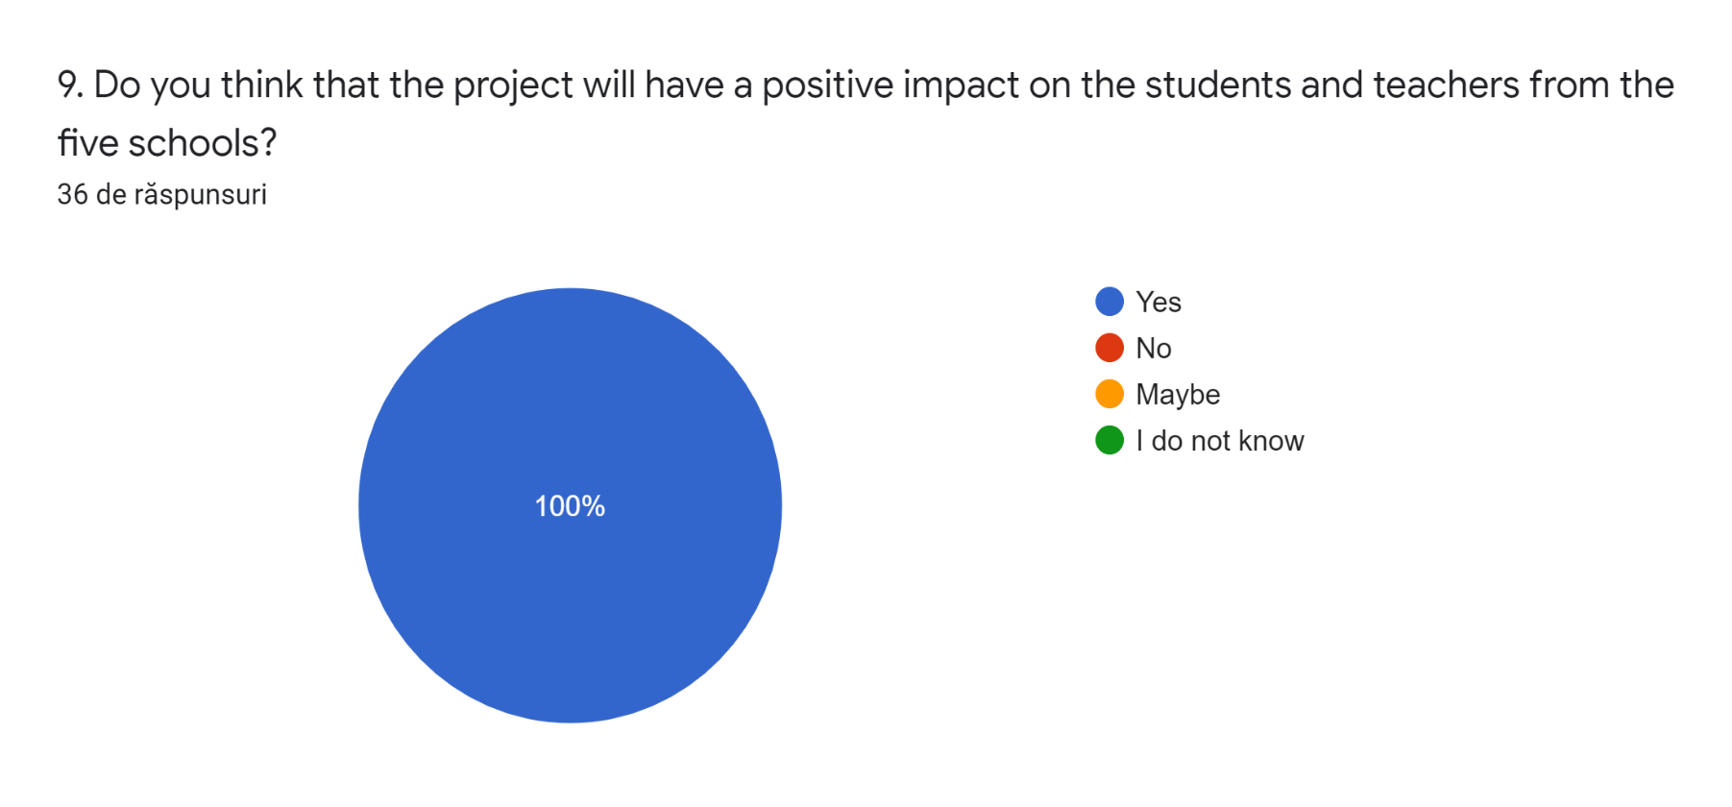
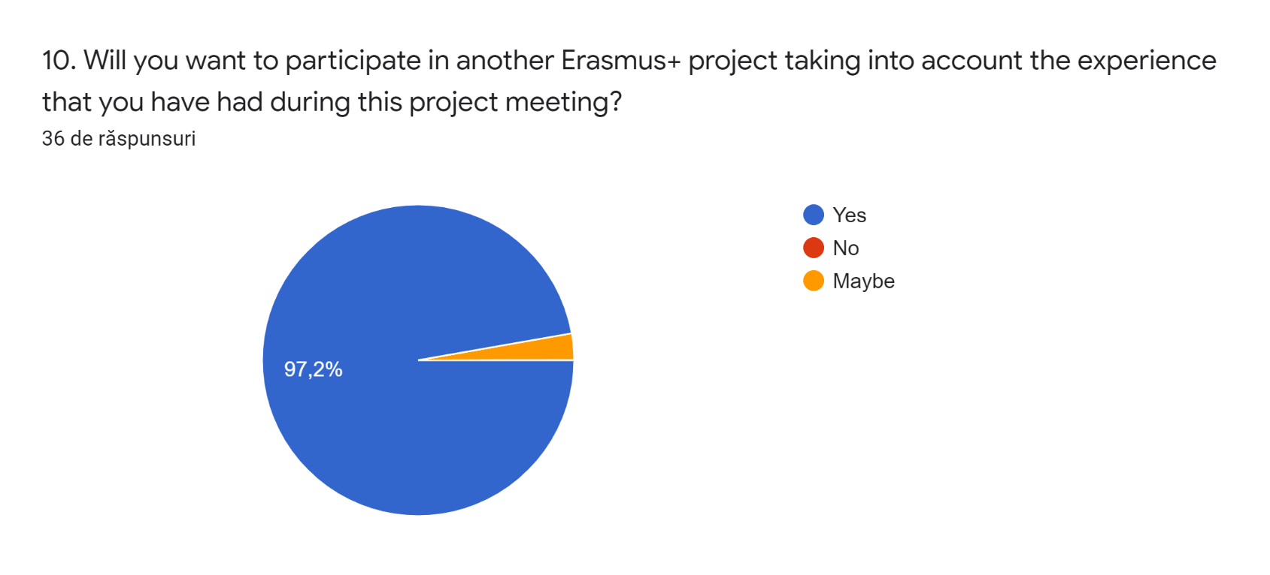
"This project has been funded with support from the European Commission. This publication reflects the views only of the author, and the Commission cannot be held responsible for any use which may be made of the information contained therein."

