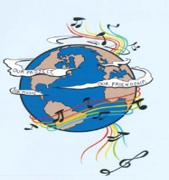

MUSIC: A MELODIC METHODOLOGY INTO TEACHING AND LEARNING
2018-1-ES01-KA229-050761
SCHOOL EXCHANGE PARTNERSHIP

The Evaluation of the 5th LTT Activities (ONLINE MEETING) organised by Colegiul Național 'Ion Luca Caragiale' from Moreni, Romania, 11th-13th May 2021

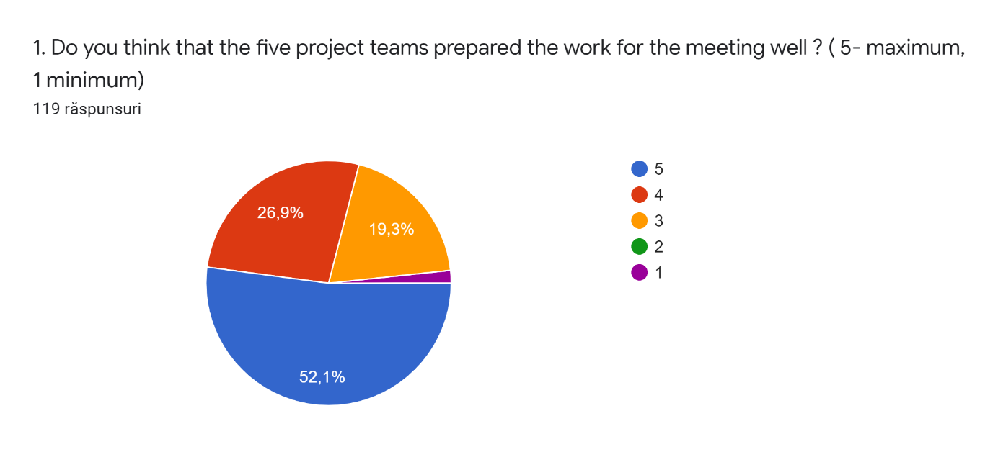

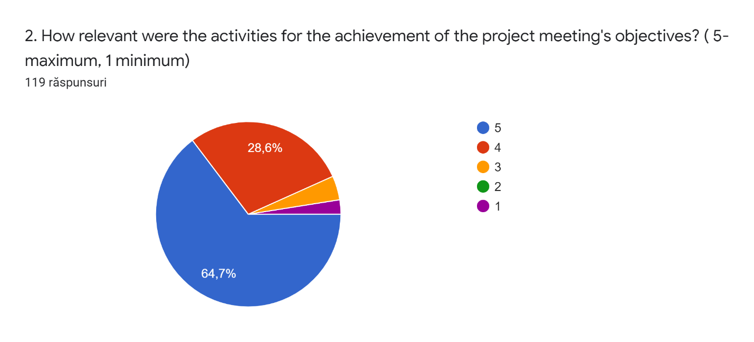

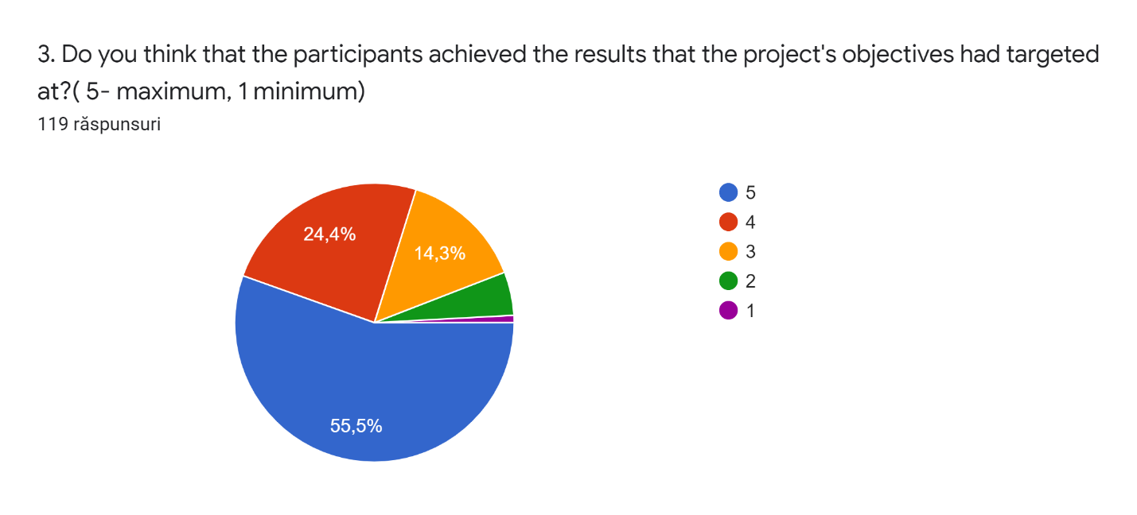

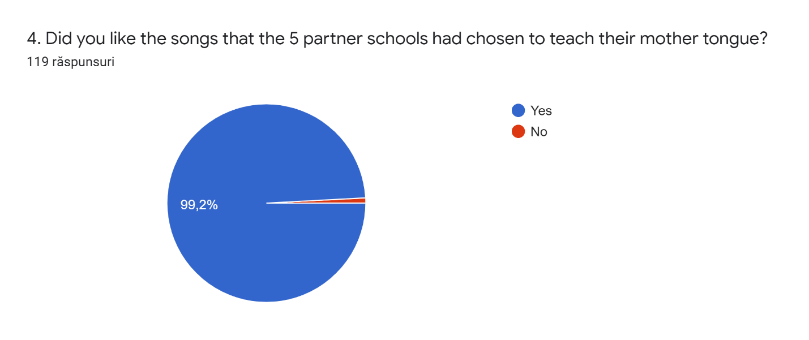

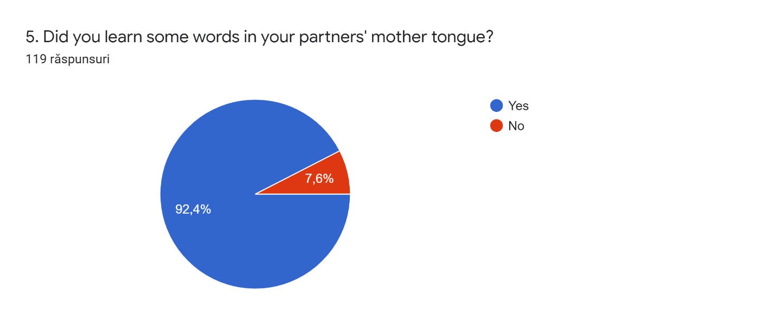

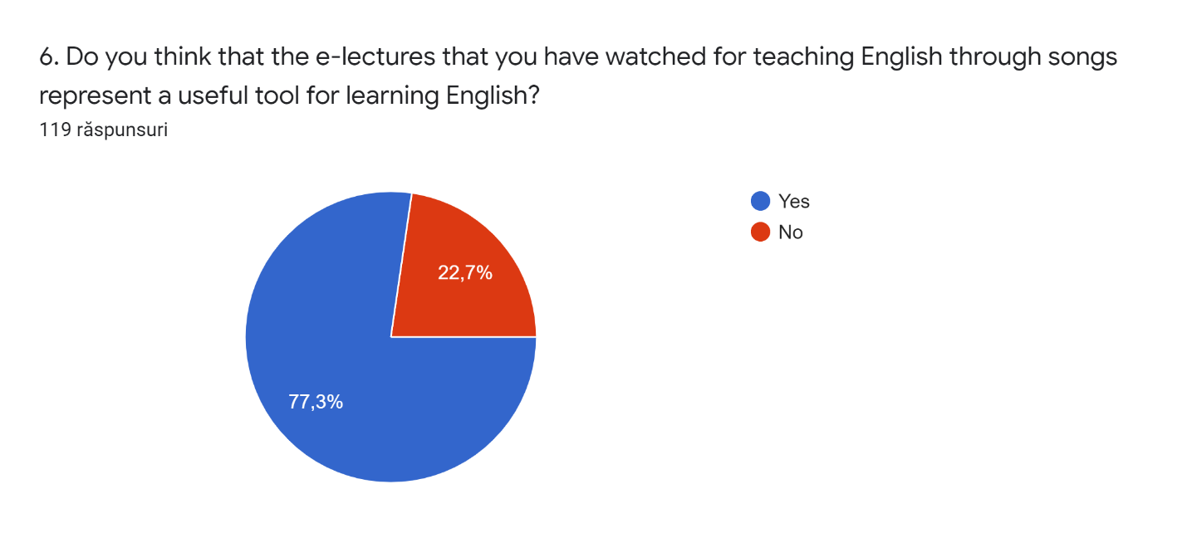
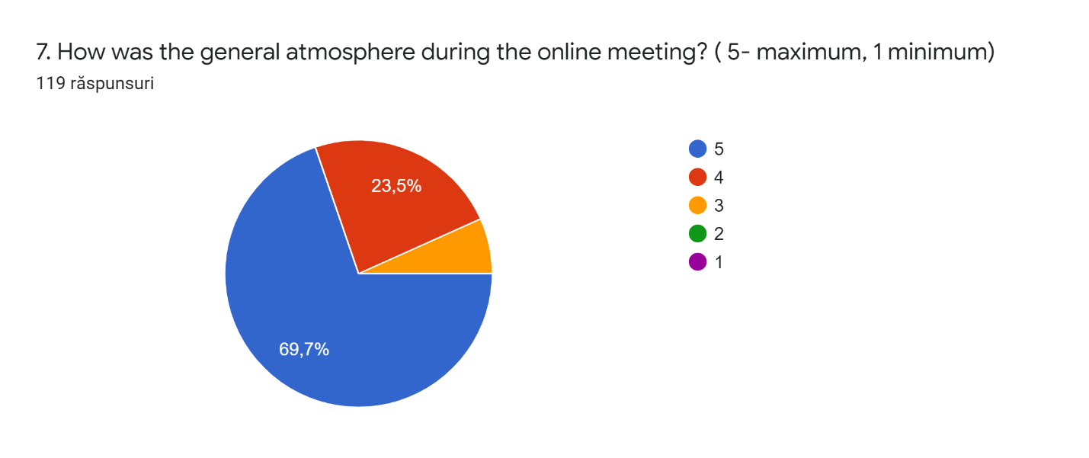
8. What aspects from the meeting did you like most? Explain.
The songs
I like it
The music
The songs
Meeting new students
Interact with students from different countries.
The songs and the videos
Meeting people from different countries
Meeting students from other countries
I like the most the fact that I learned new words in different languages.
I really enjoyed the cooperation of the students despite the distance
Pretty much everything, but I think the best was like the atmosphere, everyone laughed a lot and they we're very friendly.
The interactive activities that we had.
We meet new people and talk wiht him
Song and music
meeting new student
The fact that we manage to finish the project even if we couldnt t meet face to face
all, beacuse i love larn new things and because i met a lot of people
I liked the fact that i got to learn about other cultures through music, i love music, music is an universal language and it connects people, it was nice to understand foreign countries lifestyle through music.
The music, the communication and lerning words of the other countries languages
The games, because I learned a few words în other languages
The fact that every meeting is an opportunity to improve our language skills regardless the conditions we met in. I always enjoy learning to express myself in other languages and I like getting to know our partners.
New students for differents countries
meeting people for different countruies
The music the communication and learning words of the other c
I like all
The music and the videos
I like all songs because they are so beautiful and engaging
I really liked how encouraging and friendly the participants were. Even if you made a mistake, they wouldn’t laugh at you , so I felt really comfortable.
That I have the opportunity to learn the mother tongue from the others countries through music and I can see the other students once again even was through video call.
I especially liked the fact that I could learn new words in various languages
Interact with students from diffrente countries
👍🏻
1
Learn about anothers cultures
Connections
meet people from other countries and learn their languages
Meet people from others countries
Meet new student from different countries
The atmosphere
I really liked the activities, interaction between teams and the general atmosphere
I really liked to learn to pronounce words in other languages
Practising English and meeting new people
Meting new people
The opportunity to meet other people from other countries.
Interact with from diffente coutries
The interactive games because they reached us other languages through games
Meeting with other people of differents countries
The fact that I saw my friends, even like this
meeting new people
The interaction with the others students
Music
It´s good and I know the culture and other things from countries.
Music
Spain
Songs
The whole meeting was interesting, but what I liked most was that I learnt new words.
That we could see each other, even if the situation isn't as well as we want. They were very sociable and friendly.
meeting new students from different countries
Everything,new experiences,new cultures that gave me great knowledge
The other students were very friendly.
The other students were very sociable and open to new things.
The songs of the different teams
The atmosphere in between pupils and teachers
meeting new students
Meeting students from other countries
Idk
Songs
The meeting with new students from diferents countries

meet different people
I liked most the musics
I liked a lot the songs of all the participants
The communication
Meet different people
I like the most when we were learning the new words in our mother language
I really enjoyed talking and exposing our knowledge.
The song of the diferent team
Everything!!
Everything
The music and communication
The music the communication and lerning words of the c
I don't know
Meeting New student
The music videos that each country presented.
The community was very cool
It was amazing
The music
I enjoyed learning through songs i liked.
Learning words from our partners’ mother tongues
meet new students
Meeting other people and listening to their songs
Meeting new students for diferent countrys
Meet new students from different countries
The interaction, communication and exchaging ideas
all,because I knew more new people and then because I like the languages and different cultures.
Having the chance to get to know people from different countries, learn their language and their culture in general .
Meeting with other people of different countries
I really liked the fact that the children from Portugal were drawing or writing messages on some paper and after they were showing us what they made:). It was funny!
The music and the songs

9. What aspects from the meeting could have been better? How?
More interaction
I like everything
Nothing
more interaction
More interaction
Perfect
The sound is good
I wish the sound was better
Nothing
👍
👍🏻
Technological problems
Apresentations
I don't know
The internet
More interaction with the gr
The meeting was great, although we weren’t together.
the organization of the video call
Don't know
A face-to-face meeting.
Maybe the program should be shorter
we could be together but we can’t so, nothing
The connection, microphone quality,
I liked everything
The acoustics
It would have been a lot better if we were able to see and talk to eachother in real life
The sound
Obviously a face to face meeting would have been better but under the circumstances, we were perfect
The presentations time
I think it could be better more interaction
nothing
I wish the communication is better
The exercise on kahoot because they are engaging
The communication
Unfortunately, because of the actual pandemic we could not get together in person and that was a little disappointing as we were really looking forward to seeing each other face to face.
Nothing everything was pretty good
for me nothing because everything that was said, was explained very well and involved all.
tecnological problems
The activities and participations
I really enjoyed learning other languages ​​and being with people from other countries
more student interaction
More interaction
The music sound
What I missed was the face-to-face interaction
The meeting was actually so interesting and I have nothing to complain about but I would have liked to see the others face to face
None
The organization
Nothing, I love everything
Audio quality because there were often problems with Google classroom
Internet connection, sound
more time
The duration of the presentation
More interaction.
Sound
It would have been nicer if we were all together in one country.
The fact that we wanted to see each other and also the quality of the sound wasn't so good..
I think we managed to do everything, notwithstanding Covid-19 was appearantly an impediment
Connection, The quality
Conection, microphon, quality.
The audio. It would be heard better with a better quality microphone
less dead times
more interaction
Idk
The acoustic
the internet and more time to present
I think it was all perfect, maybe if it had been done face to face it could have been better
Maybe the interactions for the exercises,but with the videocall is really difficult
Technological problems.
Internet
It was great for the current situation.
The organization of the audio can be better .
More interaction for the presentation
The communication
Internet
Not one
The technological problems
Nothing everything was ok for me
The internet :,)
I think it would have been better if we were all in the same room but that was unfortunately not possible.
We strongly hope to be able to meet and see each other in the near future.
It was really hard sharing the songs and the internet was slow.
More interaction with the other countries
Everything went well
because we could be together
As far as I'm concerned I think that making some online groups including students only , would result to making a more friendly and less formal atmosphere as a result the students would be able to get to know each other better .
The meeting was fine being online,but everyone wanted a meeting face to face,because it would have been more beautiful!
I wish the sound is better
none
it was more than okay for an online meeting

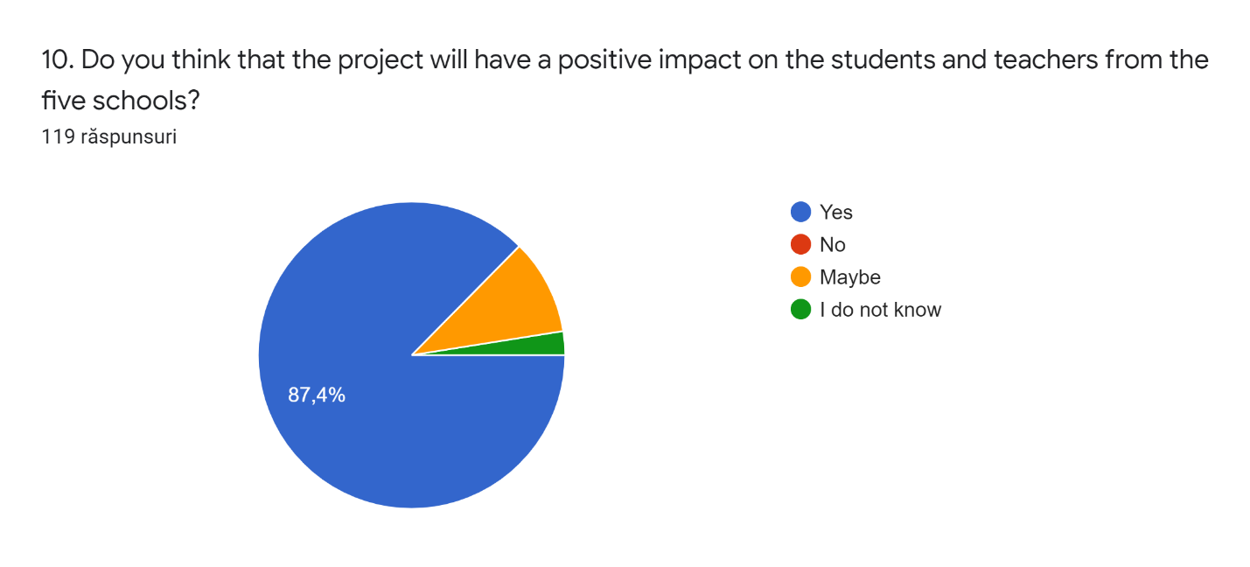
"This project has been funded with support from the European Commission. This publication reflects the views only of the author, and the Commission cannot be held responsible for any use which may be made of the information contained therein."

