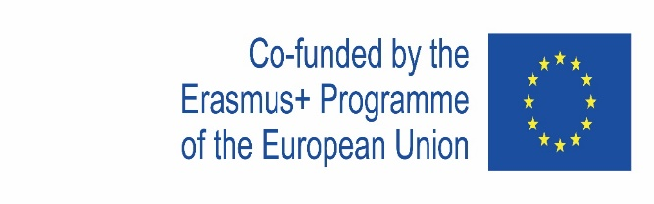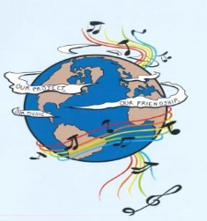

MUSIC: A MELODIC METHODOLOGY INTO TEACHING AND LEARNING
2018-1-ES01-KA229-050761
SCHOOL EXCHANGE PARTNERSHIP

The Evaluation of the 3rd LTT Activities organised at Convitto Nazionale Regina Margherita- Scuole Annesse, from Anagni, Italia, 10.11.2019-16.11.2019

1.What did you learn about the partner countries during the project meeting from Anagni?
I learn some words in other languages
I learnt so much from this meeting. I had the opportunity to confront with different cultures and I met so much friends to talk about the things that I like with. In the end, I think that even if we come from different countries, we are all humans.
A lot, new languages, new cultures
I learnt about the tradicional instruments from other countries. I have also learnt about other traditional things from the contries as we have interacted a lot, and finally I learnt about the italian education system.
I learnt about traditions, traditional instruments, how good is to have a friend and things about every culture.
I learned new instruments and many curiosities about other countries, about their culture, music, .... I also made new friends!
I learned traditions, music and food of italy, also instruments from the countries that have participated.
During the project meeting in Anagni, I learn about the partner countries" traditional instruments and their opinions about friendship , teaching English through songs.
During the project I learned other languages, deepened and managed to practice my English and fraternized with other cultures.
I learnt that any problem can be solved by cooperation and interaction. I learnt about typical instruments of each country and how to teach English with songs.
I learnt a plethora of things during my participation in Erasmus programme.Some of them are their traditional instruments and songs
I improved my englesh and Spanish and I did learn some words andAnd I discovered their habits
I learnt that Portouguese is so difficult than Spanish.
I learn about the traditional instruments,and the friendship throught songs.
I have learned many new words and their habits
I get to know instruments and learned curiosities about the instruments of each partner country: how to play, the sounds, the traditional songs in which they are used.
Eatch country is very different, we have different accents, different ways to understand things but all are friendly people who loves music
I learned that you can be taught through music and this is a very enjoyable way
During this project I learnt a lot about the others countries like their music,their culture,their languages.
Yes a little
I learnt a lot of things about all the countries and I learned how to relationship with people from other countries
I have learn a lot of words and the culture
I learned many curiosities about the various instruments of each country and made new friends. From this I also learned about their cultures, music and ect.
We learned the traditions of songs and instruments
Nothing
I learned many intruments i didn't know about, I saw that different countries have different styles of music and that every country have amazing music
I learnt to talk better in english and interact with young people. I also liked a beautiful spanish percussion instrument (cajón flamenco).
I learned that relating to other people from other countries could be the most interesting and beautiful thing in the world, especially when a special bond is established.
During the project meeting from Anagni, I learned about how music can change your mood. What is more, I learned how to speak my english better and that the cooperation is very important in projects like these.
We learnt about musical instruments which are traditional, about the fact that friendship is important
i learnt the traditional music instruments from other countries and also i learnt new culture
The languages, names of musical instrumemts and the cultures.
I did learn some words and i did learn some habits of foreign habitants
I learnt a lot about the history of Italia and its music, also the culture.I also learnt about the other countries instruments and culture
I learned a lot of their culture, about the music and the friendship.
I learnt about different musical instruments in each country like: Italy, Romania, Spain, Greece and Portugal. It is really important to have a good knowledge about instruments that are very different in each country. Apart from this, having more information about musical history and having a good communication between students and teachers. It is a good way to develop our skills and to improve the ability of speaking specially with teenegers who are shy. Moreover, I have learnt about education system in Italy.
I learned a bit of Greek words and cultures
Different languages, ways of expression and different ways to think. But most of all, it opens your mind and reminds you how big the world really is.
I learnt about the traditional music instruments from the different countries participating: Italy, Greece, Romania, Portugal and Spain. I learnt some history about them, their materials and how they sound and look. I have also learnt about many other traditional things from the countries as we have interacted a lot, sharing customs and teaching techniques. Finally I learnt about how education is dealt with in Italy as I have experienced some lessons.
I learned the various cultures and customs and a lot of their languages.
I learned new words and learned to socialize even with pardons that do not speak my language
I learn some words in other language and I understood that in Europe there are some different culture
I learnt about theirselves and their countries.
With this experience I learn other and also languages and respect other cultures.
This project increased my self estieem,my mind maturity, my ability to speak English,I also learned new coltures, new lenguages and new competencies.
As a teacher, every mobility is a different one, no matter how many schools you have been to. Anagni was a great surprise, took us back in time and through music the students were motivated more than usual
I have learnt a lot of words and culture
I learn new things like culture and I have learn about new places
That we can have great cooperation,even if we have different mentality
that friendship is important
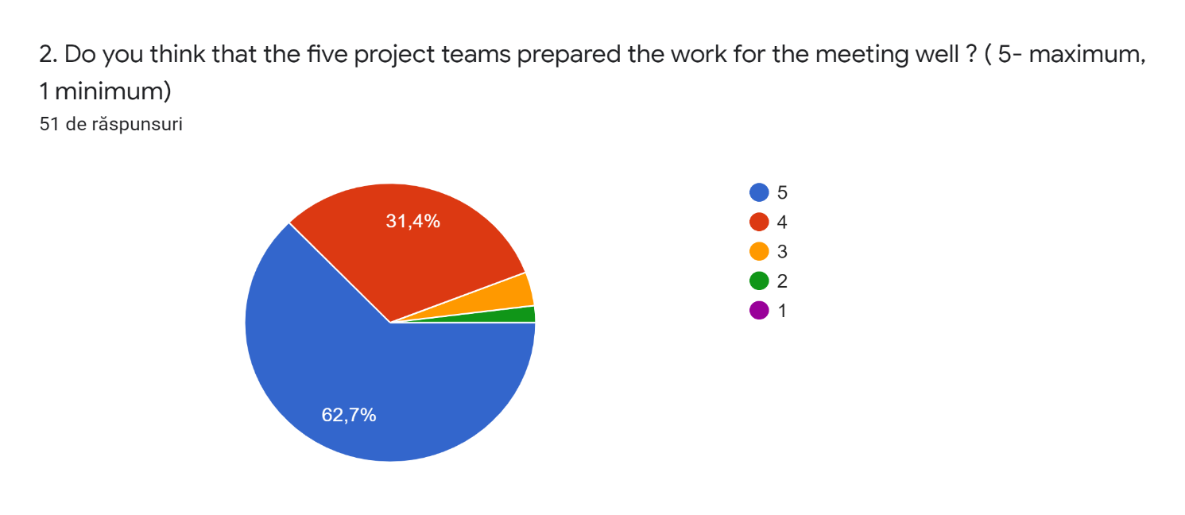

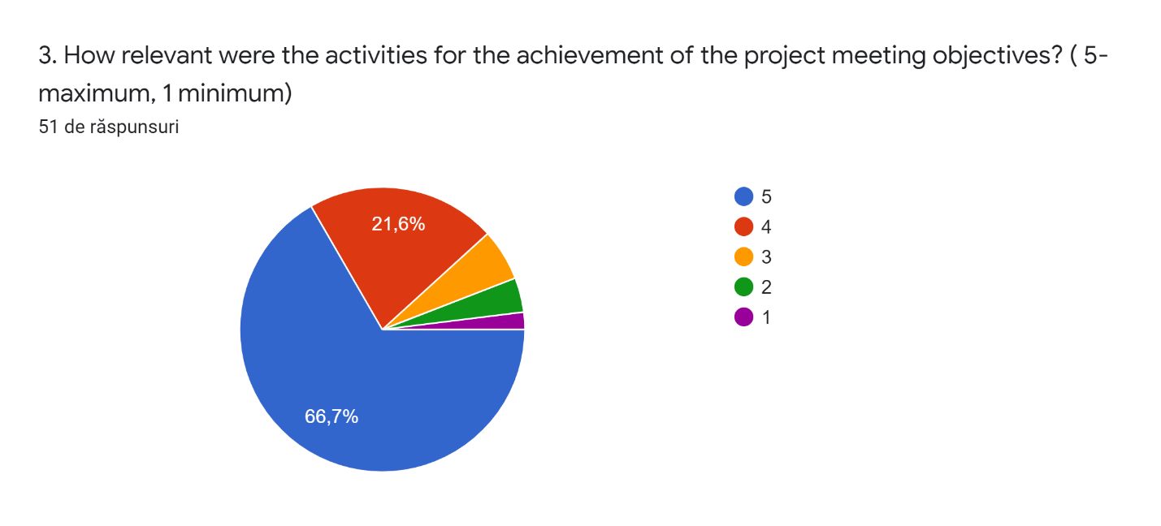

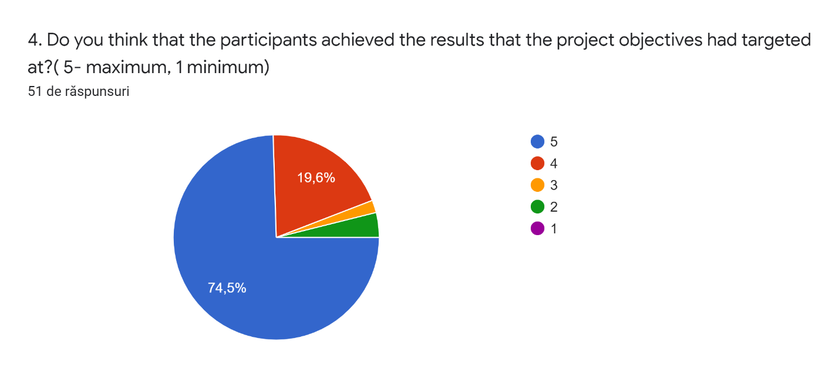
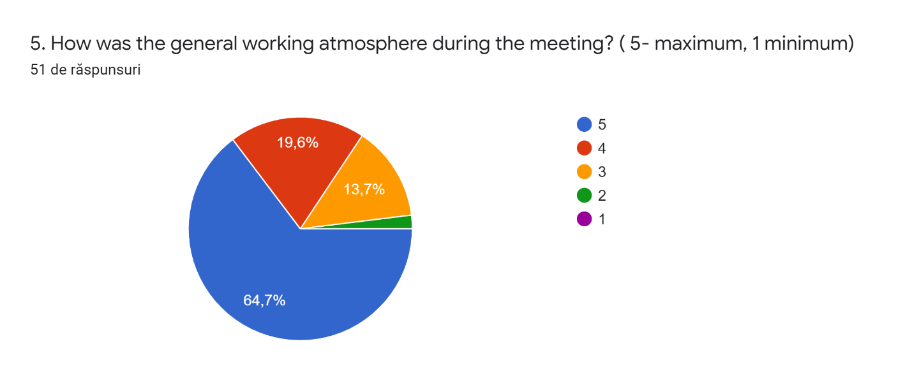
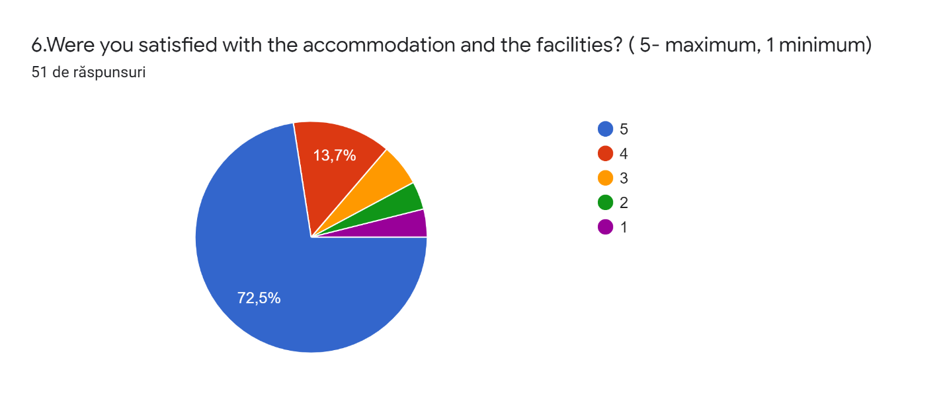
7. What aspects from the meeting did you like most? Explain.
I liked it when we did group work because we were with kids of other nationalities and so we could talk more
I really liked the way the project was organised and the principal topic: music. It caught up everyone's attention! For example, during the breaks, we passed our time singing every county's most famous songs.
Friendship, new competences I learned
The family was very nice, the people I have met. I have shared many experiences.
I liked the most the fact that we communicated a lot and that we visit a big part of Italy
I enjoyed meeting new people because I like to make new friends
I met new people and we had enough time to make friends
From the meeting, I like that almost all children were sociable and they were very friendly.
I loved the trip to Rome, it helped a lot in cultural knowledge and I also enjoyed the resolution of the exercises together I felt we were in tune with the other countries.
Singing songs together and doing the concert with the instruments students inventedper
One of the aspects that I liked the most is the opportunity to learn about other beliefs and way or living in other countries.Furthermore,I had the chance to my practice my English
When occurred and we have create the groups, instruments and we have play the instruments together
I loved that i knew lots of lovely people and we could match our different cultures.
I LIKED THAT I LEARNT MANY THINGS ABOUT THE PARTNERS,THE ARE COMMUNICATE WITH THEM.
nearly every day
The coexistence and knowledge sharing
I liked when we work together because we learnt a lot of new things and we built a true friendship
I liked that I met new friends from different countries,I practised my English and I was taught words and phrases from other countries.
From this experience I liked everything.It was very organized and we were all in harmony.
The promotion of friendship
The aspect that I liked most was the trip in Rome
I like a lot the rapport of friendship whit others and
I liked the part of knowing new places and new friends because I improved the wisdom line about culture.
Proper implementation of the program
I liked when we chattino in the free time
I liked that we all become a big familly, becouse we got along very well
The aspect which i liked most was the trip to Rome at Castel Sant' Angelo, San Pietro e Parco della Musica.
In my opinion all the project was great, but I loved singing all together, to overcoming shiness.
Well, doing exercises to fraise our english with the help of our partners, suprised me a lot.
the cooperation, communication, friendship that united us
talkto other people and learn
I liked talking whit the others participants and discovering that we are very similar. The only really difference is the language.
When we have play the instruments and have sing the songs together to the accompaniment of piano
The family was really, really good with me / I played music with the students from the other countries, I saw Anagni and the town where it was living the family, I ate in some restaurants...
I liked all of activities because they gave me the opportunity to learn a lot about the language and culture of the partner countries.
The most important it is the good atmosphere between students and teachers and also it is crucial to improve our english and the culture of Others countries.
I liked the afternoons the most, because we went out and we had a lot of fun together
I loved the fact that everybody was very polite and kind and families were very hospitable.
I liked the fact that kids can interact a lot between them and learn many different things not only related to the project but with the different ways education and life in general is understood in different countries.
The aspects that I liked the most was the presentation, because I like meeting new people
I enjoyed being together with people I didn't know Emma who became my friends
When we sang the song togheter
I liked the most going out togheter and also going to Rome.
I enjoyed meeting new people, I liked the food and I even liked meeting Italy
I liked to meet new people, I also socialized with a lot of new friends and I was happy to speak English with them
The hospitality was great, the Italian partners did their best. Additionally, we got ideas to use in classroom and we also learned about the educational system.
I like most the new friendship
That I met new people and new places
I liked when we sang all together and we had an English lesson through songs

8. What aspects from the meeting could have been better? How?
Nothing
I think that arrivals could be better. Some people arrived 2 hours late and I was really anxious!
None, all was great
The organisation could have been better. I felt that the products were not so important and that we lost time. We have not done many extra activities so we were bored sometimes.
Nothing
The project organization because sometimes a lot of organization was needed
The lack of extraactivities (we only went to Rome, the other activities were made by the family), a lot of deadtimes, nule organisation. They should had made more activities to complete the experience of the meeting.
I think that the children could talk more English, like when they were talking they were talking in their language and for some children it was weird because they didn"t undersand.
The organization of the calendar of activities.
Perhaps there could be more free activities planned
I literally have nothing negative to say.Everything was just perfect!
We could be more days in Rome and visit more monuments.
Maybe the teachers had to choose better the people to could partecipate to the project.
NOTHING
When we were in Rome. We could have done it slower and more relaxing, so instead of being one day there we could have been there two days.
More time to do the exercices.
Nothing, it was really beautiful
For me everything was perfect.
Maybe we could have visited more cities but it's ok.
In this meeting there was a lots of time to do anything
Everything was good
I wanted to do more trips
The organization was not always the best and with that it became a little boring but otherwise everything was fine.
I think everything was very good
the organization with more trips could have been better
Everything was perfect for me and my classmates
For me, was only perfect, and nothing have been better!
All the aspects from the project were beautiful.
As fas as I am concerned, all the aspects from the meeting were satisfactory.
no aspects could have been better
family and friends
I really don' t know, I think that everytining was perfect.
When we were in Rome. Instead of being only one day staying at Rome, we should have been two days visiting it because it’s less tiring.
There has been no organization, NONE , I think we should do more extra activities, too many breaks when we are not doing activities, they were improvising all the time, the activity to travel to Rome wasdecepcionant and incomplete.
Everything was great.The hosts did their best to organise everything well and all the teams did their job,
Doing more extra activities like visiting different museums. The meeting should improve the organisation of the activities and explain very well what the students have to do it during the class.
I think that the meeting could have been better with more trips.
We could have made more trips and more activities to complement the objective of the Erasmus project.
The organisation. Everything should have been planned in a more precise way. The programme wasn’t followed with precision so I felt we lost some valuable time doing nothing, some hours felt like wasted. Time could have been more useful and we could have finished earlier the compulsory products and still have time to do complementary activities to add context and meaningful experience to the project.
The aspects that I think could be better was the presentation of the instruments being better organized.
More trips
Nothing aspect
Maybe we could stay more togheter, like in the afternoons.
I think the wait time should have been less, but other than that it was fine.
I would like more trips, but for the rest it was amazing
I don't think that there was something missing. The warmth and the smiles of the students make up for anything that could be evaluated less
more trips
Everything was perfect.
i personally had difficulty in adjusting away from home, but I think that the organization of the Italian hosts was great

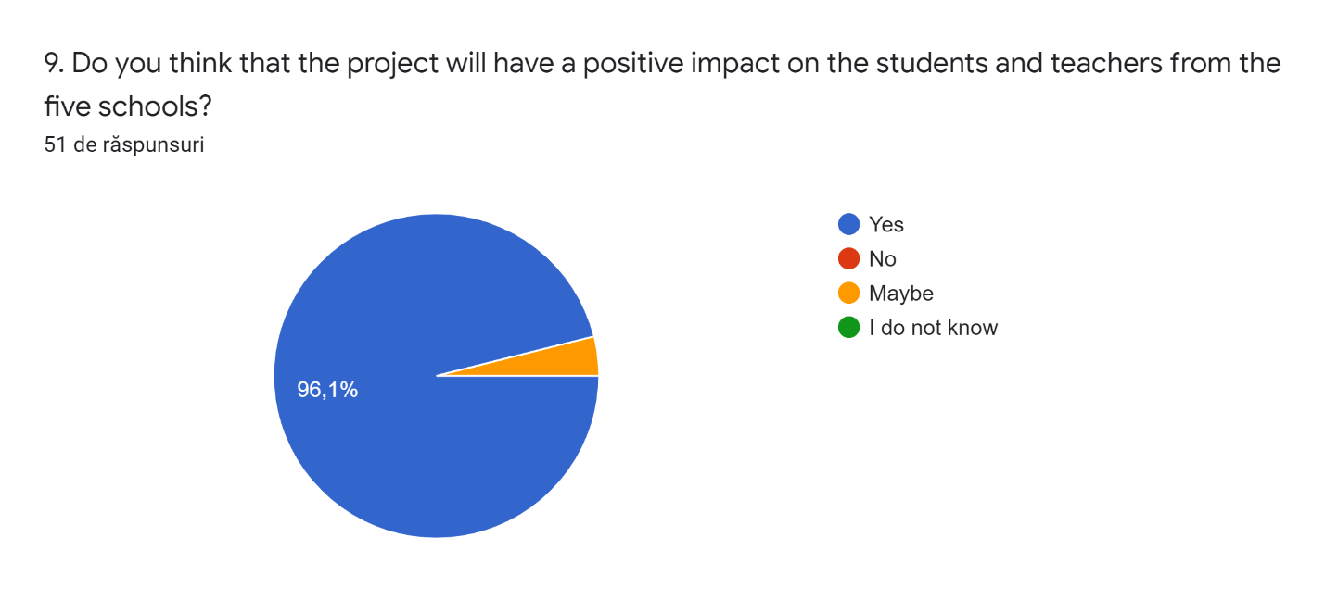
10. Will you want to participate in another Erasmus+ project taking into account the experience that you have had during this project meeting?
Yes
Yes
Of course I will want. During the project I hosted a guy and my family had fun, too. They had the opportunity to socialize with a foreign
Definitely
Yes because I can meet new people and I can learn about other countries
Yes because it was a great experience and all learnt interesting things about the others country
Yes, I would like to repeat this experience as it is very interesting and beneficial for all students!
Yes, because it's a very enriching experience where yoyu learn a lot.
Yes, I would love to , because it was a wonderfull experience and other students can learn things from the children who participated.
Yes I want, I think it is a unique experience that helps us to know other cultures and also helps us grow and value certain mundane things with our parents.
Of, course! It's always a motivating and growing experience despite some difficulties to face
I totally enjoyed this experience and I am willing to do it again .
Yes,i want to take part in another Erasmus+ project because i think it's a fantastic experience and i have enjoyed the project in Italy.
YES,OF COURSE BECAUSE I HAVE LEARNT SO MANY THINGS.
Yes, I want to participe în another Erasmus project because it was a great experience, I meet new people and I learned new things
I am not sure but I think that I would.
Yes,I want to participate in another Erasmus project because in this one like in the other one in Greece that I did I was amazed and I learnt a lot of important things.
No
Yes, I will
Certainly
I would love to repeat again because it is an unforgettable experience and never too much. Know new cultures.
Yes,I want partecipate another time
I will want to participate în another Erasmus Project, becouse it was a very relaxing and i had a great time.
Yes, of course. I like very much the Erasmus project and i participate to another Erasmus + project
Yes, of course. I can't wait for another project.
Yes, I would like to participate in another Erasmus+ taking into account the experience that I have had.
Yes, because it is an enriching experience
yes ofc because its cool learn new languages and its nice to meet new people and new culture
Yes, I want to participate in another Erasmus+ project becouse I loved it.
Yes it is a very cool experience but they ruined the experience with the bad organisation
yes, I want to participate in another project because we learn so many things..
I think so but all teachers must have a goog information about the project .
Yes, of course
Yes.
I would like to say yes without hesitation but it is not the case as like a teacher in charge I had a huge amount to do with the students, spending my free time in the afternoon working with them to get the best results possible and I almost had no help at all. I don’t get any kind of benefit from it, no money or better conditions in my school so it is a lot of responsability and work and almost nobody appreciates. I like the experience because you obviously learn a lot but I’ not sure if it really worth the huge amount of work and pressure.
Yes, I wanted to participate in another Erasmus +
Si because I like very much this project
Of course!
yes I would like to participate again because I found it very fun and educational for students.
I'd really love to take part in another Erasmus project, it was the best experience of my life.
It is undoubtedly a unique experience. No matter what the difficulties are, the bottom line is that the positives outweigh any negative aspects that may arise.
Yes of course!
Yes,of course
I do not think that I will participate in the future, maybe when I am a bit older, because I really missed my parents and I could not adjust
Absolutely yes

"This project has been funded with support from the European Commission. This publication reflects the views only of the author, and the Commission cannot be held responsible for any use which may be made of the information contained therein."

