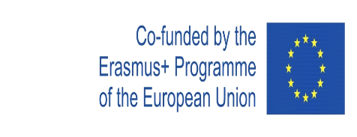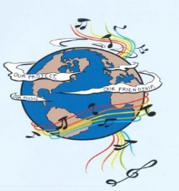
MUSIC: A MELODIC METHODOLOGY INTO TEACHING AND LEARNING
2018-1-ES01-KA229-050761
SCHOOL EXCHANGE PARTNERSHIP

The Evaluation Report for the Second and the Third Year of the Project’s Implementation
This questionnaire aimed to assess the activities that were carried out during the second year of the project. The questionnaire was applied to 187 respondents, both students and teachers from Colegiul Național ‘Ion Luca Caragiale’.
The answers were, as follows:
1. In which activities did you participate during the second and the third year of the project’s implementation? You may choose more than one variant.
Doing research for the final products -30 respondents | Participating in the dissemination activities-  187 respondents
Devising the final products – 27 respondents | Popularising the project-28 respondents
Participating in the learning, teaching and training activities that were held physically at the partner’s schools and the in the last virtual meeting that was organised by the Romanian school - 27 respondents | Accessing the information on the project website, Facebook, Twinspace- 172 respondents
Participating in the activities for Erasmus Days- 183 respondents | Reading the information about the project in the school magazine-174 respondents

2. What are the aspects that you considered very important for you, during the project second and the third year, as a member of the target group? You may choose more than one variant.
Research-28 respondents | Cooperation and communication between different social groups and ethnicities-175 respondents
Making presentations, posters, charts a.s.o-27 respondents | Learning through inter-disciplinary approaches- 180 respondents
Contributing to the process of making the final products-27 respondents | Improving the participants’ social skills- 172 respondents
Organising activities-30 respondents | Improving the participants’English skills- 168 respondents
Participating in the presentations, workshops with the project results- 142 respondents | Enhancing the participants’ knowledge of the other cultures- 162 respondents
The project targeting at making participants continue their education and diminish social exclusion-162 respondents | Making our school, region and country be known-180 respondents
3. What are the final products from the second and the third year of the project that you consider most interesting and useful for you? You may choose more than one variant.
’My musical instrument'-82 respondents | 'Music unites people'- 165 respondents
'Friendship through Music' -152 respondents | 'Let’s teach our mother tongue to our partners through music'- 185 respondents
’Traditional instruments’- 83 respondents | 'Intercultural communication through music'- 182 respondents
'Music- what and why I listen to'- 143 respondents | 'Songs in the English class' -184 respondents

4. Taking into account your experience in the project’s activities, do you think that the activities that were carried out during the second and the third year of the project were interesting?
Yes-  172 respondents | Quite a lot-  14 respondents | Slightly-  1 respondent | No-

5. Taking into account your experience in the project, do you think that through the project’s activities during the second and the third year of the project the participants raised their cultural awareness?
Yes-  184 respondents | Quite a lot-  3 respondents | Slightly- | No-

6. Taking into account your experience in the project, do you think that through the project’s activities during the second and the third year of the project the participants developed their English skills?
Yes-  172 respondents | Quite a lot-  14 respondents | Slightly-  1 respondent | No-

7.Taking into account your experience in the project activities, do you think that through the project’s activities during the second and the third year the participants developed their ICT skills?
Yes-  169 respondents | Quite a lot-  18 respondents | Slightly- | No-

8. Taking into account your experience in the project, do you think that through the project’s activities during the second and the third year, the participants acquired the skills and competences that are relevant for their present and future lives and careers?
Yes-  176 respondents | Quite a lot-  11 respondents | Slightly-  1 respondent | No-

9. Were the activities during the second and the third year of the project organised to achieve the project’s goals?
Yes-  175 respondents | Quite a lot-  12 respondents | Slightly- | No-

10. Do you think that students can acquire high and relevant skills for their education and life through a topic like music?
Yes-  180 respondents | Quite a lot-  7 respondents | Slightly- | No-

11. Do you think that the project will have a positive impact on the students and teachers from the five schools?
Yes-  177 respondents | Quite a lot-  10 respondents | Slightly- | No-

12. Taking into account your experience in the second and the third year of the project, do you think that it is important for the students and the teachers from your school or for schools,in general, to implement Erasmus projects?
Yes-  178 respondents | Quite a lot-  9 respondents | Slightly- | No-

Taking into account the respondents’ answers, we can see that the activities during the second and the third year of the project implementation had a positive impact on the participants through the acquisition and the development of the high and relevant skills that the project’s objectives aimed at.

"This project has been funded with support from the European Commission. This publication reflects the views only of the author, and the Commission cannot be held responsible for any use which may be made of the information contained therein."

