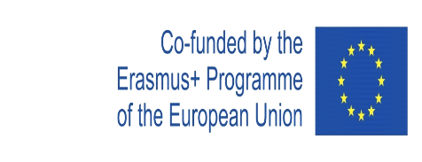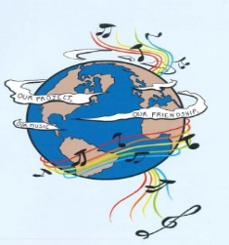
MUSIC: A MELODIC METHODOLOGY INTO TEACHING AND LEARNING
2018-1-ES01-KA229-050761
SCHOOL EXCHANGE PARTNERSHIP

The Evaluation Report for the First Year of the Project’s Implementation
This questionnaire aimed to assess the activities that were carried out during the first year of the project. The questionnaire was applied to 174 respondents, both students and teachers from Colegiul Național ‘Ion Luca Caragiale’.
The answers were, as follows:
1. In which activities did you participate during the first year of the project’s implementation? ? You may choose more than one variant.
Doing research for the final products -27 respondents | Participating in the dissemination activities-  174 respondents
Devising the final products – 27 respondents | Popularising the project-26 respondents
Participating in the learning, teaching and training activities - 14 respondents | Accessing the information on the project website, Facebook, Twinspace- 174 respondents
Participating in the activities for Erasmus Days- 125 respondents | Reading the information about the project in the school magazine-172 respondents

2. What are the aspects that you considered very important for you, during the project’s first year, as a member of the target group? You may choose more than one variant.
Research-25 respondents | Cooperation and communication between different social groups and ethnicities-174 respondents
Making presentations, posters, charts a.s.o-27 respondents | Learning through inter-disciplinary approaches- 170 respondents
Contributing to the process of making the final products-27 respondents | Improving the participants’ social skills- 168 respondents
Organising activities-27 respondents | Improving the participants’English skills- 166 respondents
Participating in the presentations, workshops with the project results- 172 respondents | Enhancing the participants’ knowledge of the other cultures- 173 respondents
The project targeting at making participants continue their education and diminish social exclusion-174 respondents | Making our school, region and country be known-174 respondents
3. What are the final products from the first year of the project that you consider most interesting and useful for you? You may choose more than one variant.
’Project Logo’-72 respondents | 'Landscape in songs'.- 158 respondents
'Story of music'- 163 respondents | 'Lanscape and Traditional Songs, Dances and Clothing'- 153 respondents
'Songs:not only tunes, but the mentality of a nation'- 172 respondents

4. Taking into account your experience in the project activities during the first year of its implementation, do you think that the activities that were carried out during the first year of the project were interesting?
Yes-  170 respondents | Quite a lot-  14 respondents | Slightly- | No-

5. Taking into account your experience in the project, do you think that through the project’s activities during the first year of the project the participants raised their cultural awareness?
Yes-  171 respondents | Quite a lot-  3 respondents | Slightly- | No-

6. Taking into account your experience in the project, do you think that through the project’s activities during the first year of the project the participants developed their English skills?
Yes-  171 respondents | Quite a lot-  3 respondents | Slightly- | No-

7.Taking into account your experience in the project’s activities, do you think that through the project’s activities during the first year the participants developed their ICT skills?
Yes-  168 respondents | Quite a lot-  6 respondents | Slightly- | No-

8. Taking into account your experience in the project, do you think that through the project’s activities during the first year, the participants acquired the skills and competences that are relevant for
their present and future lives and careers?
Yes-  170 respondents | Quite a lot  3-respondents | Slightly-  1 respondent | No-

9. Were the activities during the first year organised to achieve the project goals?
Yes-  170 respondents | Quite a lot-  4 respondents | Slightly- | No-

10. Do you think that students can acquire high and relevant skills for their education and life through a topic like music?
Yes-  169 respondents | Quite a lot-  5 respondents | Slightly- | No-

11. Do you think that the project will have a positive impact on the students and teachers from the five schools?
Yes-  169 respondents | Quite a lot-  5 respondents | Slightly- | No-

12. Taking into account your experience in the first year of the project, do you think that it important for students and teachers from your school or for schools in general, to implement Erasmus projects?
Yes-  168 respondents | Quite a lot-  6 respondents | Slightly- | No-

Taking into account the respondents’ answers, there can be seen that the activities during the first year of the project’s implementation had a positive impact on the participants through their acquisition and development of the high and relevant skills that the project’s objectives targeted at.

"This project has been funded with support from the European Commission. This publication reflects the views only of the author, and the Commission cannot be held responsible for any use which may be made of the information contained therein."

