Fiche 2 4èmes anglais

PREVENTIVE ACTIONS AGAINST CORONAVIRUS

1. Protect yourself and the others . Match each sentence with a picture .

(relie chaque phrase à un des dessins)

1.Wash your hands with soap and water. ►A

2.Avoid touching your eyes, nose and mouth.

3.Avoid contact with people who are ill.

4.Stay home when you are sick.

5.Cover your cough.

6.Sneeze in a tissue.

7.Throw the tissue into a bin.

8.If you are sick, wear a facemask.

9.Put distance between yourself and people.

10.Use an alcohol-based hand sanitizer if there is no water.
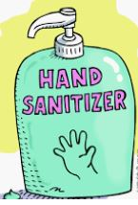
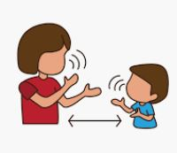
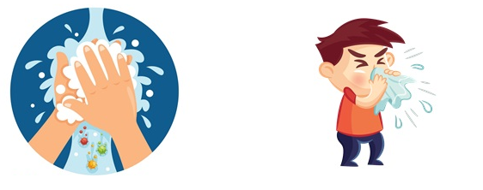

A B C D E
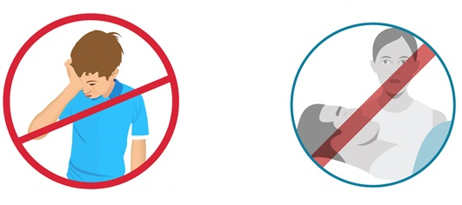
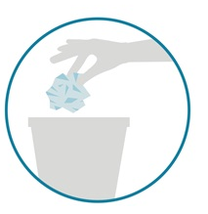

F G H I J

II Using the modals seen in class create a poster explaining what you MUST do, What you MUSTN’T do, what you SHOULD do, what you CAN do or DON’T HAVE to do in order to protect yourself and others from the virus .

(En utilisant les auxiliaires modaux vus en classe, crée un poster expliquant ce que l’on doit faire, ce que l’on ne doit pas faire, ce que l’on devrait faire, ce que l’on peut faire , ce que l’on n’est pas obligé de faire…)

Ex : You must wash your hands regularly / Your shouldn’t hug an elderly person .

Ce poster peut être fait sur word ou un autre outil informatique (ex postermywall / Canva ) ou manuellement . Format A4

Wordbank :
sick= malade cough : tousser sneeze= éternuer
If= si Avoid= éviter

