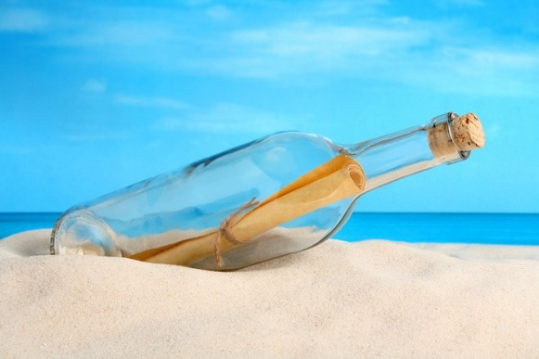
ETWINNING PROJECT
2019-2020
WORLD INVESTIGATION
COLLABORATIVE STORY
CHAPTER 1 ARSAKEIA TOSITSEIA SCHOOLS GREECE

Mary was so happy she was at one of the top eco schools in Greece. The Principal and the teacher’s board was into environmental issues and Mary and her team were committed to finding a way to eliminate pollution. That is what she was thinking about as she was walking along the beach that sunny autumn morning.
“There must be a way! There must be a magical solution that will help save the planet!” she was thinking.
“What is that on the sand? A bottle? More pollution? Wait a minute! There is something inside it!” She picked up the bottle and read the message.
“Be the change that you wish to see in the world.”

M. Gandhi

“This cannot be a coincidence”, Mary thought. “This is a message from the universe”.
She knew exactly what she had to do.
The very next day she woke up really early in the morning. She couldn’t wait to meet her eco team. As she had found the bottle with the message in the sea, she had understood that the most important problem in Greece was pollution.
Mary informed her team about Greek seas getting polluted and fish dying from the plastic bags which are thrown in the sea. Mary was so enthusiastic and persuasive, so all members of her team, agreed to put water pollution as their first priority.
Without thinking, Mary and her friends grabbed their bikes and headed for the beach. When they arrived, they were shocked from what they saw. Bottles, tins, plastic, straws, cigarettes … everywhere. They started collecting them in huge recyclable bags. Some of them even dived in the sea and collected 500 pounds of plastic.
After an exhausting day at the beach , they sat on the beach and starting talking to each other enthusiastically about how they have enjoyed themselves doing something actually helpful for the planet.
“Why don’t we organize a clean-up beach campaign with all our classmates?” Mary thought.
“Why don’t we tell all the world to clean up the beaches and stop water pollution?” shouted Tom.

The next day at school, they placed banners at the entrance of their school presenting pollution problems.
They formed small groups of students to inform the school community about water pollution.
They organized fund-raising events and donations.
They made posters and they spread them in the neighbourhood.
Mary also gave a speech in a public place. She said “Young people like me make plans for the future. We will not have time to live our life because of POLLUTION”. Her speech touched everyone. After a couple of months they had raised awareness and they finally spread the message to the whole country. Everyone wanted to help protect the environment.
The message in the bottle had inspired not only Mary and her team but the whole Greek community. After a while, they met at the same beach where it had all started.
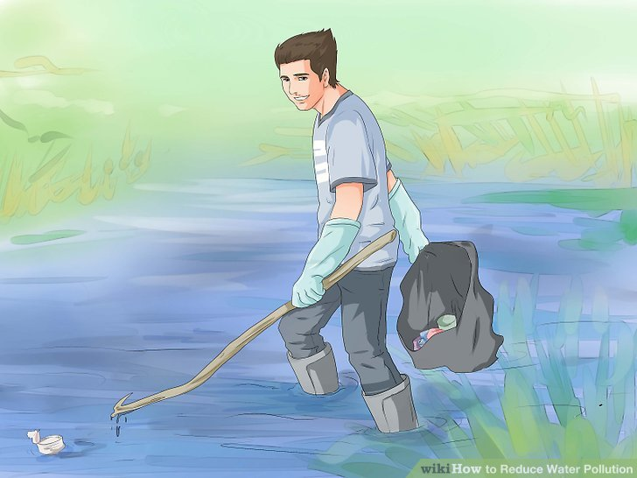
Mary and the eco team put the message in the bottle again and sealed it. They threw it in the sea hoping that other people from other countries would take over and help make the difference.

