COVID 19- What we have been through and what we need to do to stay safe and healthy!!

Jungwon Girls’ Middle School
Seoul, South Korea

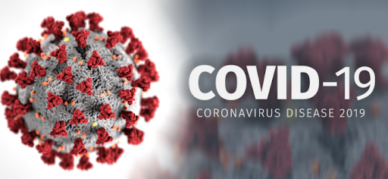

Kim, Yunjoo
Koreans have to always wear masks because of COVID 19.
Also, I am in the middle of studying online without going to school. The way to stay healthy is to wash your hands often.
Online studying is to take classes by subject to subjects and do homework.

Shin, Seoyoung
When I received the disaster text, I became increasingly anxious because it was a matter of COVID 19 every day. Now people without wearing mask look strange . Some businesses don't accept customers who don’t wear masks. I'm so sad that I can't go to school even though I'm in the same class with my close friends. I wear a mask every day when I have to go out. I do hand sanitize whenever a hand sanitizer is seen. I wore a mask at home when I had suspicious symptoms, I didn't allow anyone enter my room. Stay as far apart as possible when facing people who are not wearing masks. I had a big problem with the Internet because I had classes online . But I didn't have to get up early. And the class ended earlier than usual.

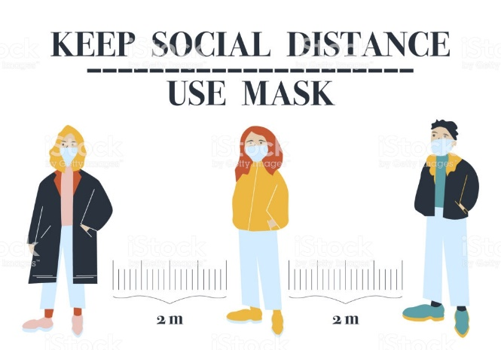

Lee, Haewon
COVID 19 is spreading around the world, and a lot of people’s main priority is to stay healthy during this pandemic. These are a few tips that can help avoid the virus. First, wash your hands. After coming home you should always wash your hands with soap for at least 30 seconds. Using soap is crucial for cleaning all of the bacteria. Bacteria can get into the body even when you rub your eyes or nose. Secondly, wear a mask. When you or somebody sneezes, the salvia can fly a long way, which can spread a virus. You can never be too careful! Third, have a balanced meal. Eating various nutrients like vitamin, protein, and minerals are very important, especially when you’re going out less. It’s crucial for a strong immune system, which will help you fight back bacteria.

Cha, Seohyun
Changes in our lives caused by COVID 19
Because I don't go to school, I don't need time to go to school, so I can sleep more.
I try not to go out as much as I can.
So I don't meet many friends.
Our online classes is about watching movie clips on EBS and working on workbooks, and it seems like a school class.
The online classes seem like to actually take classes at school.

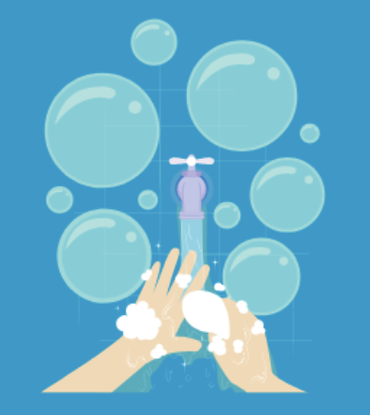
Choi Seung-hee
In order to stay healthy in daily life, you have to wear a mask when you go outside. And you’d better not go to crowded places. Our online classes are conducted through a program called “ebs online class.” Thanks to the efforts of the teachers and students, the classes are going smoothly.

Hwang, Bowon
I think Covid-19 made nature clean and better than before. I saw the news that the sea becomes clean because people don’t go to the sea. Also, I always have a cold in at this time of year, but I didn’t have a cold this time. I think the reason I didn’t get a cold is that I wear a mask. So I think Covid-19 has a good effect on us.

Kwon, Hyerin
COVID19 changed a lot of things.
First, in South Korea, we use various platforms to do the on-line classes. Some schools use video chatting but in my school, we watch videos after teachers upload them.
Second, I think we wash our hands more often to keep ourselves in good health.
Lastly, Air pollution is improved by social distancing, In many country, quantity of fine dust is decreased.

Lee, Ga-eun
We have to wear masks because of Covid 19. Also, I have a class without meeting my friends and teachers. Many say they want to go back to their daily lives, but it will be difficult to go back to their daily lives. But seeing so many people fighting against this Covid 19 seems to make us feel much more hopeful.

Kim,Seoyun
By COVID 19 our life have been changed a lot. We have to wear mask everywhere and wash our hand when we came back from outside. We have very hard time right now but our small effort can make situation better. Let's try a little harder and get through it ! 😉

Image reference :
http://bitly.kr/akvdobGjV
http://bitly.kr/JyEpKKAt7F
http://bitly.kr/vW94FxpWsF

